

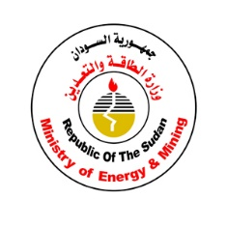

United Nations Development Programme
Project Document template for projects
financed by the various GEF Trust Funds

Project title: Sudan, National Child Project under the GEF Africa Minigrid Programme
Country: Sudan | Implementing Partner (GEF Executing Entity): Ministry of Energy and Petroleum |  |  |  | Execution Modality: Full NIM
Contributing Outcome (UNDAF/CPD, RPD, GPD):
Relevant SP outcome statement and the relevant indicators as used in CPS linking. By 2021, people’s resilience to consequences of climate change, environmental stresses and natural hazards is enhanced through strengthened institutions, policies, plans and programmes.
Relevant SP output and the relevant indicators as used in CPS linking. Output 1.5: Inclusive and sustainable solutions adapted to achieve increased energy efficiency and/or sustainable energy solutions targeting undiscovered communities/groups and women.
- Indicator 1.5.1: Number of new development partnerships with funding for improved energy efficiency and/or sustainable energy solutions targeting underserved communities/groups and women.
- Indicator 1.5.2: Extent of change in: a) energy efficiency and/or b) modern energy coverage by users and specific sectors
Relevant UNDAF/CPD outcome statement and the relevant indicators as used in CPS linking. Output 3.1. Access to clean energy for the poor enhanced.
- Indicator: 3 1.1: Number of households supported to access clean energy (IRRF 1.5.2)
UNDP Social and Environmental Screening Category: Substantial Risk |  |  | UNDP Gender Marker: Gen2
Atlas Award ID: 00135331 |  |  | Atlas Project/Output ID: 00126615
UNDP-GEF PIMS ID number: 6321 |  |  | GEF Project ID number: 10827
LPAC meeting date: 22 February 2022
Last possible date to submit to GEF: 19/06/2021
Latest possible CEO endorsement date: 19/12/2021
Project duration in months: 48 months
Planned start date: 04/07/2022 |  |  | Planned end date: 4/07/2026
Expected date of Mid-Term Review: 04/05/2024 |  |  | Expected date of Terminal evaluation: 4/02/2026
Brief project description:
As part of the UNDP-supported, GEF-financed Africa Minigrids Program (AMP), this project seeks to increase access to clean energy by increasing the financial viability, and promoting scaled-up commercial investment, in low-carbon minigrids in Sudan with a focus on cost-reduction levers and innovative business models. The project’s main objective is to develop solar PV minigrids as a major avenue for rural electrification in Sudan’s rural energy landscape, which is currently an underdeveloped market in which private sector involvement and appetite has been very limited in the past. To achieve this, the policy and regulation component work and proposed activities is set to play a key role, as Sudan has not developed any off-grid legislation or policy framework. A simple registration process for LV mini-grids is recommended as one of the first project’s activities to stimulate bottom-up proposals.
The proposed Solar PV minigrid pilots could be key to Sudan’s target to achieve 80% electrification rate by 2030, yet the current experience is almost non-existing in the country. This child project proposes to piggyback on existing rural brown infrastructure (i.e. diesel based minigrids) operated by the thermal generation company to deploy MW-scale solar PV power plants in order to “green” these sites as one of the first intervention, identified as a low-hanging fruit. This will result in reducing diesel expense and avoid CO2 emissions, while also boosting new connections (as a result of reducing OPEX).
Complementary to the pilot project intervention and in order to achieve this objective, a series of technical capacity trainings and activities for the public and the private sector to strengthen their capacities are proposed.
Digitalization is also propose as one of the key areas that will help Sudan in its energy transitioning through a more sustainable and accountable system in the off-grid sector, a digital minigrid platform is proposed to collect data for not only M&E purposes, but also to increase the market visibility in Sudan.
Financing Plan
GEF Trust Fund grant |  |  | 2,637,246 USD
UNDP TRAC resources |  |  | 300,000 USD
Confirmed cash co-financing to be administered by UNDP |  |  | USD
- Total Budget administered by UNDP |  |  | 2,937,246 USD
- Total confirmed co-financing to this project not administered by UNDP |  |  | 5,250,000 USD
- Grand-Total Project Financing (1) + (2) |  |  | 8,187,247 USD
Signatures:
Signature: |  | Agreed by Government Development Coordination Authority |  | Date/Month/Year: within 25 days of GEF CEO endorsement
Signature: |  | Agreed by Implementing Partner |  | Date/Month/Year: within 25 days of GEF CEO endorsement
Signature:  Resident Representative, UNDP |  | Agreed by UNDP |  | Date/Month/Year: within 25 days of GEF CEO endorsement
Key GEF Project Cycle Milestones:

Project document signature: within 25 days of GEF CEO endorsement
First disbursement date: within 40 days of GEF CEO endorsement
Inception workshop date: within 60 days of GEF CEO endorsement
Operational closure: within 3 months of posting of TE to UNDP ERC
Financial closure: within 6 months of operational closure

Table of Contents
I. Table of Contents 4
List of Figures 6
List of Tables 6
List of Box Inserts 6
List of Acronyms 8
II. Development Challenge 10
General Overview 10
Covid-19 11
Energy Situation Overview 12
Energy Policy Baseline and Institutional overview 12
Electricity Pricing 13
Minigrid current status 14
III. Strategy 16
Minigrid market and opportunity 16
AMP Areas of opportunity in Sudan 17
Mini-grid Delivery models 18
Digitalization 20
Productive Use 22
Covid 19 opportunities 22
Linkages with the AMP Regional Project 23
Summary of changes from the Concept Note to the CEO Endorsement Request (CEO ER) 24
IV. Results and Partnerships 26
V. Project Results Framework 56
VI. Monitoring and Evaluation (M&E) Plan 62
VII. Governance and Management Arrangements 66
VIII. Financial Planning and Management 70
IX. Total Budget and Work Plan 73
X. Legal Context 78
XI. Risk Management 79
XII. Mandatory Annexes 82
Annex 1: GEF Budget Template 83
Annex 2: Project map and Geospatial Coordinates of project sites 86
Annex 3: Multi Year Work Plan 90
Annex 4: Monitoring Plan 93
Annex 5: UNDP Social and Environmental Screening Procedure (SESP) 103
Project Information 103
Part A. Integrating Programming Principles to Strengthen Social and Environmental Sustainability 103
Part B. Identifying and Managing Social and Environmental Risks 106
Project Information 106
Part A. Integrating Programming Principles to Strengthen Social and Environmental Sustainability 106
Part B. Identifying and Managing Social and Environmental Risks 108
Final Sign Off 126
Annex 6: UNDP Risk Register 31
Annex 7: 35
Overview of Project Staff and Technical Consultancies 36
Annex 8: Stakeholder Engagement Plan 39
Annex 9: Environmental Social Management Framework (ESMF) and other SES frameworks/plans if required 61
Annex 10: Gender Analysis and Gender Action Plan 62
Annex 11: Procurement Plan 75
A. Process Thresholds, Review and 12 Month Procurement Plan 75
1. Project Procurement Thresholds 75
2. Prior or Post Review 75
Annex 12: GHG Emissions Reductions and Project’s target contributions to GEF-7 Core Indicators 80
Annex 14: Additional agreements 80
Annex 13: GEF Core indicators 81
Annex 14: GEF 7 Taxonomy 82
Annex 15: Principle for allocation of GEF investment (INV) funding 85
Annex 16: Co-financing letters 87

List of Figures
Figure 1: Desert expansion in Sudan: 1958-2013 (Climate Change Risk Profile, Sudan, USAID) 11
Figure 2: Renewable Energy Master Plan targets by technology for 2035, Sudan 12
Figure 3: Institutional structure of Sudan's Energy Sector (adapted by PPG Team Leader from a World Bank repot) 13
Figure 4: Projected Electricity Sector Revenue Gap and Subsidy Needs to 2023 (Source: World Bank) 14
Figure 5: Five towns in Sudan where STGC is operating diesel-based minigrids (map by PPG Team Lead) 14
Figure 6: Minigrid opportunity assessment in Sudan (2020, by PPG Team Leader) 16
Figure 7: Theory of Change, AMP 17
Figure 8: AMP's three key areas of opportunity 18
Figure 9: Conceptual outline of minigrid delivery models 19
Figure 10: Delivery models roadmap for Sudan AMP (Alberto Rodriguez, 2021) 20
Figure 11: Digital and data opportunities for minigrids in the AMP 21
Figure 12: Thee "Key Areas of Opportunity" for AMP to drive minigrid cost-reduction 34
Figure 13; GIS cropland layer of Sudan (2019, Copernicus Global Land Cover Layers: CGLS-LC100 collection 3) superposed with the 5 proposed locations (from left to right: Al-Geneina, Zalingei, Nyala, En Nahud, Kadugli) 35
Figure 14: Sudan's Köppen-Geiger Climate Classification 40
Figure 15: Subsidy Level for LCOE Parity – Sudan Solar PV-Battery-Diesel Genset Hybridization Pilot 1 (Al Ajuanynah) 91
Figure 16: Annual and Lifetime CO2 Emission Reduction (tCO2e) due to Hybridized Solar PV-Battery-Diesel Minigrid compared to Existing Diesel-only Minigrid – Sudan Pilot 1 (Al-Geneina) 92
Figure 17: Subsidy Level for LCOE Parity – Sudan Solar PV-Battery-Diesel Genset Hybridization Pilot 2 (Kadugli) 93
Figure 18: Annual and Lifetime CO2 Emission Reduction (tCO2e) due to Hybridized Solar PV-Battery-Diesel Minigrid compared to Existing Diesel-only Minigrid – Sudan Pilot 2 (Kadugli) 94

List of Tables
Table 1: Human Development Report 2020; OECD The Social Institution and Gender Index (SIGI) 2019 10
Table 2: Electricity prices in Sudan (PPG Team Leader, 2021) 13
Table 3: Summary of changes 25
Table 4: Current Status of minigrid delivery models in Sudan 30
Table 5: Key areas of opportunity for Sudan AMP Pilot project 35
Table 6: Basic information on 5 proposed pilots 37
Table 7: Solar PV hybrid penetration categories (Alberto Rodríguez, TTA) 38
Table 8: List of co-financed activities included as project results 48
Table 9: Delivery models for pilot projects: PPG team lead evaluation 49
Table 10: List of co-financed activities not included as project results 50
Table 11: Project stakeholders and their roles and responsibilities 66

List of Box Inserts
Box 1 The Concept of a Minigrid Delivery Model 19
Box 2 Minigrid Digitalization 21
Box 3 Linkages to the AMP Regional Project –Access to technical and operational support 26
Box 4 Current Status of Minigrid Delivery Models in Sudan 30
Box 5 Pilots and the Project’s Environmental Safeguards Management Framework (ESMF) 31
Box 6 Digital data sharing for mini-grids 39
Box 7 Initial Specifications for the Project’s Digital Platform 46
Box 8 Linkages to the AMP Regional Project – Component 4 – Digital, KM and M&E 47

List of Acronyms
AMDA | African Minigrid Developers Association
AMP | African Minigrid Programme
BOOT | Build, Own, Operate and Transfer
CAPEX | Capital Expenditure
CfP | Call for Proposals
CO2 | Carbon Dioxide
DFI | Donor Financing Institution
DREI | Derisking Renewable Energy Investment
ERA  EPC  ESIA  ESMF | Energy Regulatory Authority  Engineering Procurement and Construction  Environmental Social Impact Assessment  Environmental and Social Management Framework
EoI | Expression of Interest
GDP | Gross Domestic Product
GEF | Global Environment Facility
GIS | Geographic Information Systems
GHG  HH | Greenhouse Gases  Household
IP | Implementing Partner
KPI | Key Performance Indicator
kW | Kilowatt
kWh | Kilowatt-hour
LV | Low Voltage
MFF | Minigrid Funding Facility
MoEP | Ministry of Energy and Petroleum
MV | Medium Voltage
MW | Megawatt
M&E  NGO | Monitoring and Evaluation  Non Governmental Organization
OPEX | Operational Expenditure
O&M | Operation and Maintenance
PA | Practical Action
PCAT  PIF | Partner Capacity Assessment Tool  Project Identification Form
PIR  PMU | GEF Project Implementation Report  Project Management Unit
POPP | Programme and Operations Policies and Procedures
PPG  PV | Project Preparation Grant  Photovoltaics
QAMF | Quality Assurance and Monitoring Framework
RE | Renewable Energy
RCREEE | Regional Center for Renewable Energy and Energy Efficiency
SETAP | Sudanese Electricity Transition Access Programme
STGC | Sudanese Thermal Generation Company
SEDC | Sudanese Electricity Distribution Company
SESP | Social and Environmental Screening Procedure
SDG7  SDG | Sustainable Development Goal 7  Sudanese Pound
SHS | Solar Home System
SKS | Sudanese Knowledge Society
SSMO | Sudanese Standards and Metrology Organization
STAP | GEF Scientific Technical Advisory Panel
tbd | To be determined
ToC | Theory of Change
ToT  TTA | Training of Trainers  Trama TecnoAmbiental
UNDP | United Nations Development Programme
USAID  WB | United States Agency for International Development  World Bank
WHO | World Health Organization

Development Challenge

General Overview

Sudan is the third largest country on the African continent, and has a land area of 1.9 million square kilometers. Sudan sits at the crossroads of Sub-Saharan Africa and the Middle East, and is bordered by seven countries: Egypt, Eritrea, Ethiopia, South Sudan, the Central African Republic, Chad, and Libya. Sudan also borders the Red Sea to the northeast. For most of its independent history, the country has been beset by conflict. The recent secession of South Sudan induced multiple economic shocks, of which the most important and immediate shock was the loss of the oil revenue that accounted for more than half of Sudan’s government revenue and 95% of its exports.
Sudan has a population of 42.8 million (2019) with 34.2% living in urban centers. About 14.9% of the population lives in extreme poverty (less than US$1.9 per day), and the Human Development Index is quite low at 0.502. The agriculture sector contributes 30.1% of GDP and it generates 52% of total employment. Sudan is in debt distress, reducing its capacity to mobilize domestic resources or to borrow from international markets. By September 2019, outstanding public and publicly guaranteed external debt was estimated at about $60 billion, up from $53.6 billion in 2016 and $56 billion in 2018.
The average household size in Sudan is six persons. A typical Sudanese family consists of three generations: (1) the eldest couple, (2) their sons, sons' wives and any unmarried daughters, and (3) their grandchildren. The male to female ratio of the total population was 1.020 (1,020 males per 1,000 females) which is higher than global. Data is emerging on the growing number of female-headed households (about 25 to 35% depending upon region), due to male migration to large-scale mechanized agricultural schemes and the emerging urban industrial sector, suffer labor shortages and greater poverty.
Sudan has a young population, 41% of its total population under the age of 15. In 2019, 20% of Sudanese people are 15 to 24 years old, 31% are between 25 and 54 and just under 4% are 55 to 64 years old. The population over 65 years of age is only 3.3%. Sudan has a very low median age of 18.9 years. The average life expectancy at birth for females’ is 67 years and for males 63 years old in 2020.

Around 34% of girls are married before they reach 18 years old and 12% are married before they are 15 years. There is regional variations in child marriage rates most prevalent in South and East Darfur (where 56% of women aged 20-49 were married before the age of 18), Central Darfur 55%, the Blue Nile 50% and Gadarif 49%. According to The Personal Status of Muslims 1991, legal age for marriage in Sudan for both girls is 10 years and for boys 15 years old. About 25% of Sudanese households are headed by women.
The following table presents the status of Sudan by international human and gender related development measures:
Table 1: Human Development Report 2020; OECD The Social Institution and Gender Index (SIGI) 2019
Index | Dimensions of measurement | Score | Rank 2020
Human Development Index | Life expectancy, expected years of schooling, mean years of schooling and Gross National Income | 0.510 | 170/189
Gender Inequality Index | Reproductive health, empowerment, and empowerment | 0.545 | 138/164
Multi-dimensional poverty index | Education, health and living standard | 13 million people, live under conditions of severe multidimensional poverty
Social institutions and gender index | Discrimination in the family, restricted physical integrity, restricted access to productive and financial resources, and restricted civil liberties. | 0.67 Sudan showing the highest level of inequality among Sub Sharan countries

Sudan is among the most vulnerable countries in the world to climate change and climate variability. Increased frequency of droughts and high rainfall variability over the past few decades have already put stress on the region’s rainfed agriculture and pastoralist way of living, a dominant livelihood in rural areas.
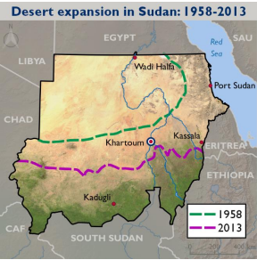
Figure 1: Desert expansion in Sudan: 1958-2013 (Climate Change Risk Profile, Sudan, USAID)

Covid-19
In Sudan, from 3 January 2020 to 12:27pm CEST, 3 June 2021, there have been 35.656 confirmed cases of COVID-19 with 2662 deaths, reported to WHO. As of 2 June 2021, a total of 402.114 vaccine doses have been administered. While Sudan may benefit from the geographic isolation of many rural communities, with a comparatively low population density, the country’s limited health services capacity presents a potentially high risk should the infection rate rise in the country.
The socio and economic impact of Covid-19 in Sudan features mainly a reduction in welfare by certain population segments which may have increased existing social inequalities, including substantial impact on food consumption. At a macro level, the following impact has happened in Sudan:
- Reduction in national review by 46%.
- Disruptions in the labor market of employment.
- Disruption in the export / import operation due to the lockdown.
- Negative impact on current A/C due to impact of lockdown on the financial system country wide and worldwide.
- Low productive capacity in the micro and small and medium enterprises.

The IEA estimates that across Africa, COVID-19 has pushed 30 million people back into energy poverty.

Energy Situation Overview
Although Sudan has one of the largest power systems in Sub-Saharan Africa, with 3,500MW of electricity generation capacity from hydro and thermal sources, power availability and reliability remains a challenge. Electricity demand doubles in summer (June and July) due to the need for air conditioning, which represents the largest energy consumption category of residential and commercial in Sudan. Additionally, due to the on-going fuel crisis, the country is experiencing power interruptions and load shedding have increased, as a result of fuel shortages.

Access to electricity is low (at 54%% in 2019), and there is a large discrepancy between the population with access to electricity in urban areas (70%) and those in rural areas (22%). The residential sector consumed 56.7% of all electricity in 2015. Also, where it is available, the reliability of electricity is not assured. To address the low electricity access, the Sudanese Electricity Distribution Company (SEDC) is undertaking “The Rural Area Electrification by Solar Energy Project”, which aims to serve over one million households by 2035 with solar home systems (SHS). In early2020, the rural electrification department at SEDC, the RE general directorate under the Sudanese Hydro Generation Company and the RE General directorate under the SEHC were merged to form the Renewable Energy General Directorate under the Sudan Electricity Holding Company.

Energy Policy Baseline and Institutional overview
The Electricity Act of 2001 still governs the electricity sector in Sudan. There is a new drafted 2019 Electricity Act that is yet to be passed by the government of Sudan. There is also a renewable energy act and renewable energy master plan in the making that will target a total renewable energy deployment of 1,600MW by 2031 (solar PV and wind). There is no specific off-grid legislation or regulations in Sudan.

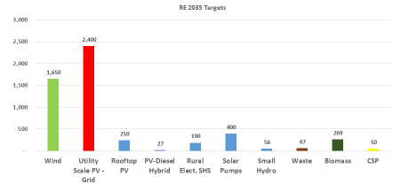
Figure 2: Renewable Energy Master Plan targets by technology for 2035, Sudan

Ministry of Energy and Petroleum (MoEP) holds the 4 electricity companies by sector (hydropower generation, thermal power generation, transmission, and distribution) under a holding company, Sudan Electricity Holding Company (SEHC) and also the Electricity Regulatory Authority (ERA). The below graph represents this institutional arrangement:
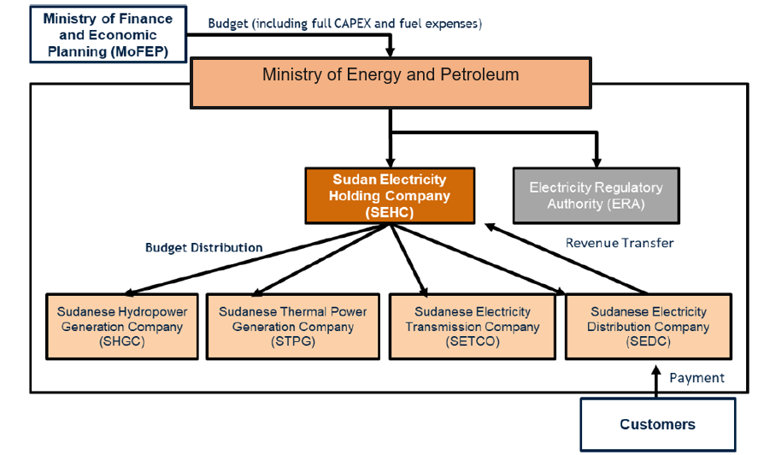
Figure 3: Institutional structure of Sudan's Energy Sector (adapted by PPG Team Leader from a World Bank repot)

Electricity Pricing

Electricity retailing prices have long been criticized by many as the key to the sector’s long-term sustainability in Sudan. In January 2021 the government of Sudan dramatically increase electricity prices in the local currency as per the following table:

Table 2: Electricity prices in Sudan (PPG Team Leader, 2021)
 | 2021 January |  | 2020 and before
 | Consumption range (in kWh) | Price in SDG/kWh | Consumption range | Price in SDG/kWh | 2021 increment
Residential | 0-100 | 0.8 | 0-200 | 0.15 | 433%
Residential | 100-200 | 1 | 0-200 | 0.15 | 567%
Residential | 201-300 | 1.2 | 200-400 | 0.26 | 362%
Residential | 301 – 400 | 1.4 | 200-400 | 0.26 | 438%
Residential | 401 – 500 | 1.6 | 400-600 | 0.32 | 400%
Residential | 501 – 600 | 1.8 | 400-600 | 0.32 | 463%
Residential | > 600 | 6.35 | > 800 | 0.85 | 647%
Commercial | NA | 10.2 | NA | 1.6 | 538%
Industrial | NA | 6.35 | NA | 1.6 | 297%
Government | NA | 10.2 | NA | 0.7 | 1357%
Agriculture | 0-200 | 0.8 | NA | 1.6 | -50%
Agriculture | 200-500 | 1 | NA | 1.6 | 63%
Agriculture | > 500 | 1.6 | NA | 1.6 | 100%
Agriculture | Foreign investment | 6.35 | NA | 1.6 | 397%

Although the average unit retailing prices still remains very low (0.01USD/kWh) the average increase of electricity retailing prices in comparison to the past tariffs is 429%. This increase is an important step by the government towards shifting from a heavy subsidy electricity price approach to a less subsidy-heavy, more cost-reflective model. The social acceptance of these new electricity retailing prices is yet to be seen. On the other hand, the cost of service is estimated to be around 0.20 USD/kWh, which makes the energy sector completely unsustainable and heavily subsidy dependent. Furthermore, electricity demand has grown by 11 percent since 2013.
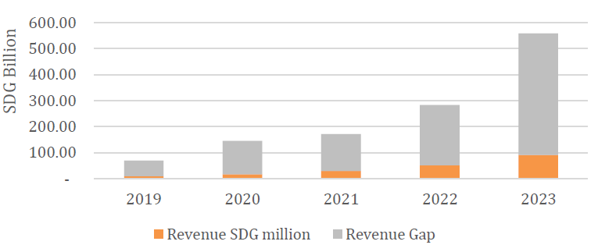
Figure 4: Projected Electricity Sector Revenue Gap and Subsidy Needs to 2023 (Source: World Bank)

Minigrid current status
Sustainable Development Goals (SDG7) seeks affordable and reliable energy for all, and this is critical for the development agenda in Sudan. Sectors such as education, health, agriculture need electricity as a key pillar to fully succeed and unfold. In this regard, Sudan has set a target of achieving 80% electricity access by 2030.

Although Sudan presents a high opportunity for renewable energy minigrids, the uptake of this technology solution for rural electrification has been overlooked in the past. The Sudanese Thermal Generation Company (STGC) operates around a handful of the so-called diesel off-grid stations, which are essentially diesel minigrids. The below table provides an overview of these brown-fields:
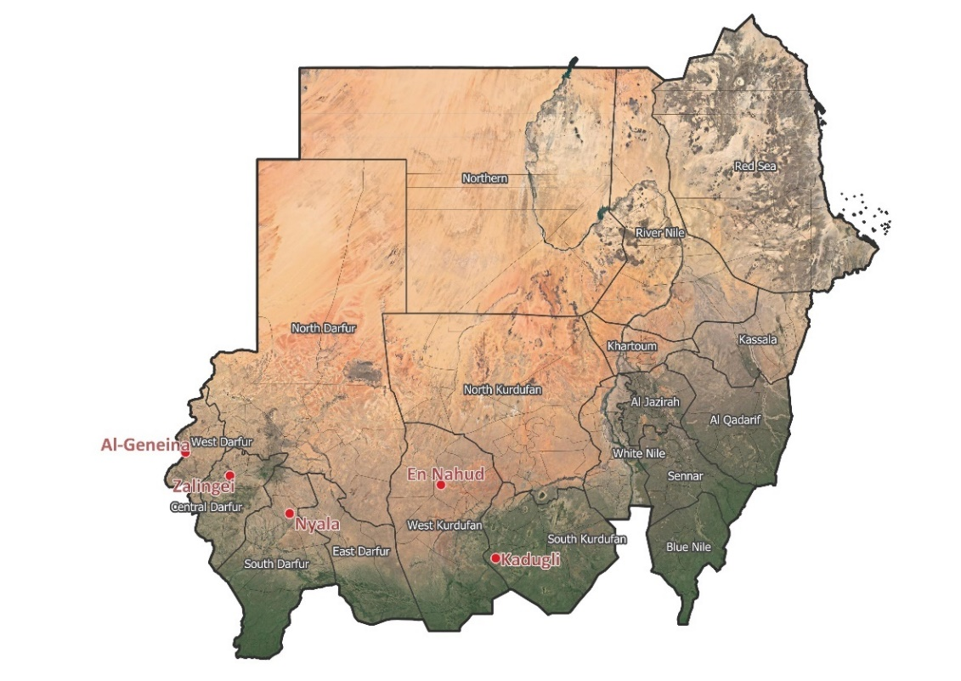
Figure 5: Five towns in Sudan where STGC is operating diesel-based minigrids (map by PPG Team Lead)
The operation of these diesel-based state-owned infrastructures are expensive, and the Sudanese Thermal Generation Company (STGC) direct owner and responsible, under the Ministry of Energy and Petroleum (MoEP) are looking into retrofitting the existing power generation infrastructure with solar PV power plants. Additionally, MoEP and other actors recognize that in smaller towns and communities there are several informal minigrids serving basic level of electricity to their neighbors with diesel generation. These informal electricity providers are not legally recognized, nor licensed, but are serving a market.

This Africa Minigrids Program national child project for Sudan will support the uptake of solar PV in minigrids, as a cornerstone to help Sudan’s renewable energy uptake, decrease their fuel dependency (in particular in off-grid settings), boost new electricity connections and piggyback on previous, existing efforts towards gender equality and gender opportunities too. In this regard, Sudan’s target of achieving 80% electrification rate by 2030 is supported by this Child project.

Strategy

In this section, the AMP Sudan opportunities to disrupt this market are presented, as well as some of the specific challenges to Sudan energy context – and how these challenges could be turned into opportunities. This section also touches on the linkages between AMP Sudan child project and its regional umbrella programme, and the design decisions proposed to ensure alignment between the implementing partner, stakeholders and the regional programme while promoting complementarity among all parties.

Minigrid market and opportunity

The minigrid market in Sudan is very limited and mostly led and operated by the public utility, the Sudanese Electricity Holding Company (SEHC, for the distribution part) and Sudanese Thermal Generation Company (STGC, for the generation part). There are few informal fuel-based minigrids operating in remote communities in the south and west part of the country, which are operating independently of the law without being registered. There are about 40 diesel off-grid stations (i.e. diesel minigrids) with an estimated total installed capacity of 63.8MW owned by MoEP and operated by the Sudanese Thermal Generation Company (STGC) in different parts of the country, including in Port Sudan.

The renewable energy sector lacks visibility to the international community and donors for many years, besides UNDP very few other international organizations are active in the renewable energy space in Sudan. There is an opportunity for renewable energy minigrids, through the AMP programme, to unlock the potential of renewable energy projects in Sudan, in particular by harvesting the low-hanging fruits that the existing diesel off-grid stations represent. Additionally, due to the lack of specific off-grid regulations, AMP has the right opportunity to help Sudan moving in a direction in alignment with Sudan’s vision while also stimulating the market through a bottom-up approach (more on the description of Activity 1.1.1.1). The following graphic illustrates a high-level assessment in Sudan’s electricity sector and identifies the opportunities for renewable energy minigrids (including the retrofitting of existing diesel based minigrids with renewable energy) to flourish under the AMP programme:

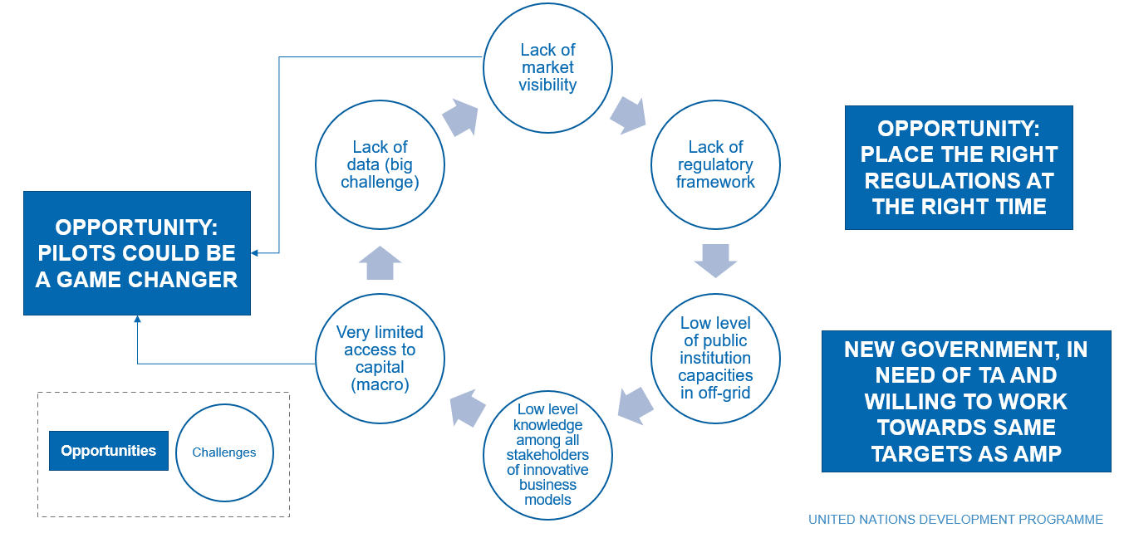
Figure 6: Minigrid opportunity assessment in Sudan (2020, by PPG Team Leader)

This project is a Child project under the PFD (Program Framework Document) Africa Mini-Grid Program. The whole program is aligned with Objective 1 of the Climate Change Focal Area to “Promote innovation and technology transfer for sustainable energy breakthroughs”, through CCM1-1 - Promote innovation and technology transfer for sustainable energy breakthroughs for de-centralized power with energy usage.
It also contributes to points 113, 118, and 119 of the GEF-7 Programming Directions to accelerate “the speed and scale of sustainable energy investment in developing countries”, to develop “innovative business models that go beyond business as usual” and to foster innovation. The overall contribution towards supporting “transformational shifts towards low emission and climate-resilient development pathways” is particularly important given access to affordable renewable energy is unavoidable for sustainable development, particularly in a context where countries are struggling to extend national grids to secure energy access to off-grid communities.
In addition to the program, the child project in Sudan is also aligned with the objective to focus “on the demonstration and early deployment of innovative technologies to deliver sustainable energy solutions that control, reduce or prevent GHG emissions” (117).

Minigrids lie at the nexus between rural electrification, community empowerment and education, climate resilience and sustainable development. As technology advances and downward cost trends have markedly improved the business case for RE minigrids, in many countries they are not yet competitive with fossil-fuel based alternatives.
The overall AMP Theory of Change (TOC) is premised on the understanding that the high costs of RE minigrids are partly attributed to a range of risks, each of which contributes a premium to the development costs of minigrid infrastructure.
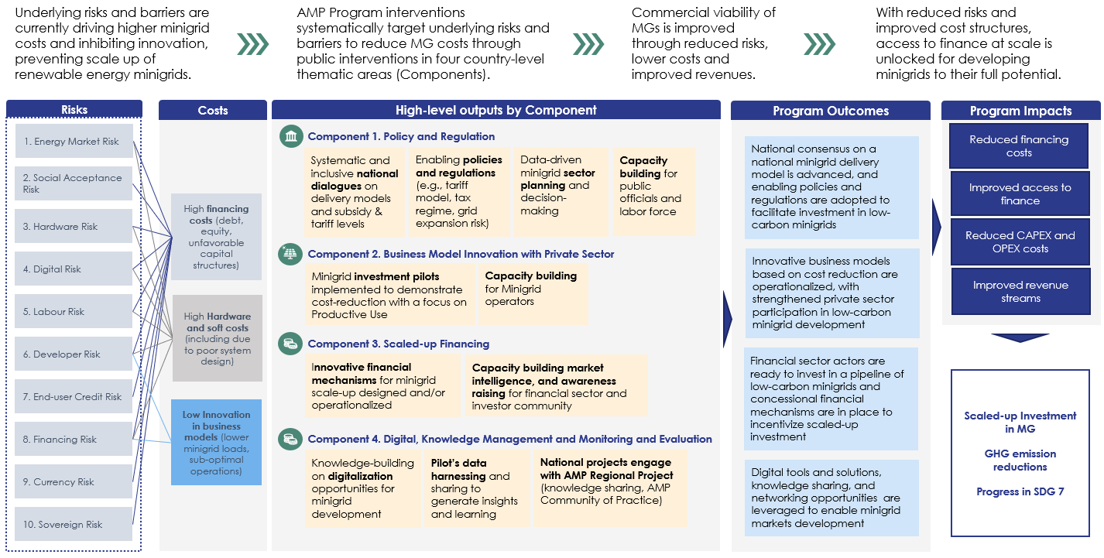

Figure 7: Theory of Change, AMP

Thus, as a result of the three key thematic interventions or components shown in the above figure, the programme will result into an increased impact at scale.

AMP Areas of opportunity in Sudan
Given the (A) overall low market penetration of renewable energy mini-grids in Sudan, (B) the practically non-existing legislation around mini-grids and (C) the unsustainable subsidy scheme in electricity, the AMP programme arrives in a key moment for Sudan energy transition, and represents a unique opportunity for Sudan to revolutionize its electricity landscape into a much broader set of possibilities, hungry of external investment into the sector. In particular the following schematic represents the three key areas of opportunity that align with the regional objective and core lines of the African Minigrid Programme:
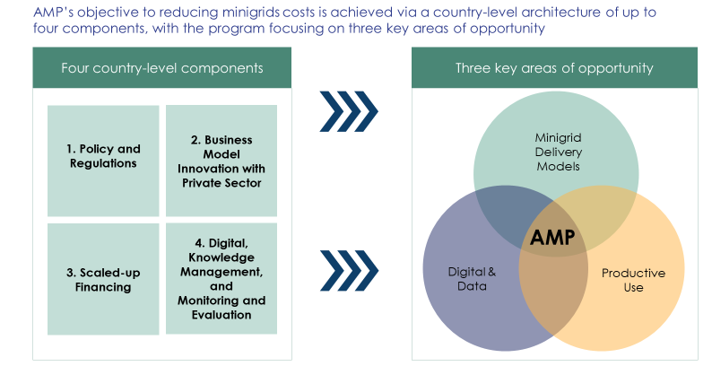
Figure 8: AMP's three key areas of opportunity

Mini-grid Delivery models
Box 1 The Concept of a Minigrid Delivery Model
The concept of a minigrid ‘delivery model’ is a key concept for AMP Sudan project. This text box seeks to set out a common understanding of the concept, its importance to the project, and the current status of the minigrid delivery model in Sudan.
Definition: A minigrid delivery model, determined by the national government, is the cornerstone of a country’s over-arching minigrid regulatory framework. It defines who finances, builds, owns and who operates and maintains the mini-grids. A minigrid delivery model is closely associated to other key components of a minigrid framework, including tariff structures or mechanisms and subsidy levels and mechanisms.
Identifying one or several delivery models will provide a framework for all sector stakeholders to plan for the longer term, particularly with regard to mobilizing private investment as one of the main objectives of the project. Figure 8: Conceptual outline of minigrid delivery models below describes the spectrum of design options for delivery models, across a number of different elements (ownership, policies, finance etc.)
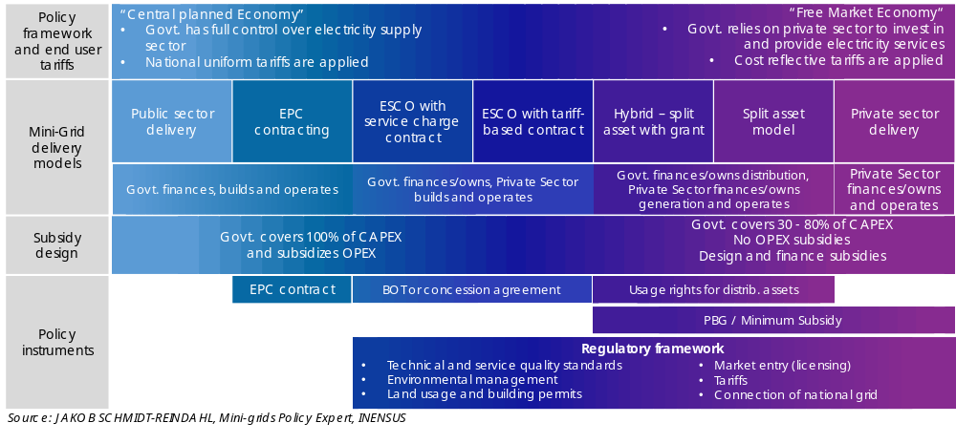
Figure 9: Conceptual outline of minigrid delivery models

This decision-making process around identifying a delivery model is complex and should ideally be done in the form of a national dialogue involving all relevant stakeholders to varying degrees (different ministries such as energy, finance, health and environment, local authorities, the public, the media, the beneficiary communities, utilities, the private sector, and other key stakeholders) in order to build a national consensus on the basis of which large-scale deployment of mini-grids can be accelerated and have a sustainable impact.
Pilot projects planned under this project will also seek to fit into this framework. The more clarity there is on the part of the government regarding the choice of delivery model, the easier it is to develop or plan business models which can reduce minigrid costs. A clearly identified delivery model minimizes the risk of investments being made based on assumptions that are not in line with government expectations and may lead to conflicts and economic losses down the line. It also helps the government to answer the important questions related to the rural electrification sector to provide clarity for private investors and operators and build confidence

Minigrid Delivery Model in Sudan: MoEP has expressed that Sudan wants to have a high degree of control over the planning and ownership of the mini-grid assets that will be deployed in the country over the next years during the several consultations conducted. This policy decision however does not reconcile well with the capacity, pace of implementation and current economic resources government of Sudan has to meet the rural electrification targets by 2030 and SDGs, and the current electrification rates. Although more detail is provided in further sections of this document, it will be important for the success of this project to keep several delivery models open for the implementation of green minigrids in Sudan, not only for the minigrids that this project will support as a pilot but other delivery models as part of the work around policy and regulation.

The following schematic summarizes the high-level roadmap designed and envisioned for Sudan AMP on delivery models, the recommended delivery models (BOOT to hybridize existing diesel minigrids, and bottom-up proposals with no registration, no tariff regulation on LV minigrids) and room for new upcoming delivery models that will come up through the national dialogues planned under Component 1:
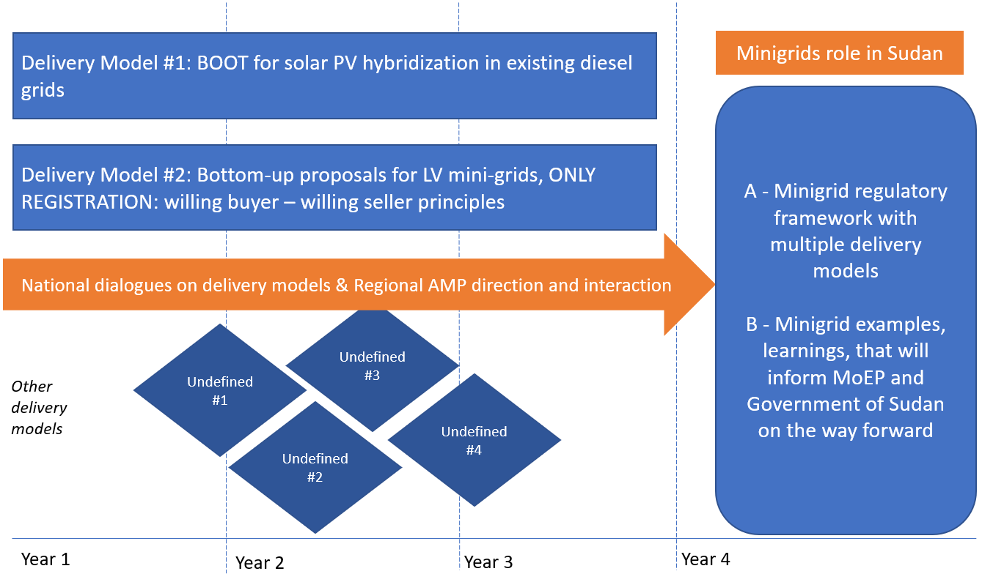
Figure 10: Delivery models roadmap for Sudan AMP (Alberto Rodriguez, 2021)

Digitalization
Box 2 Minigrid Digitalization
Digital technologies and solutions provide a set of solutions and advantages off-grid electrification. In fact, the emergence of minigrids as a viable and financial attractive solution to electrify remote and isolated communities relies strongly on certain digital technologies such as remote monitoring of minigrid operations and the use of digital money to collect customers’ payments. Figure 9: Digital and data opportunities for minigrids in the AMP below represents an initial categorization of the digital and data opportunities for minigrids under the AMP. The ability to remotely access data on power plant performance, customer electricity indicators (including payments) reduces cost associated to travels for O&M and enables different stakeholders to consult, and eventually take the necessary actions, from anywhere in the world as long as there is internet access.
Digital opportunity for minigrids. It’s increasingly clear that digital is a key entry point across minigrid market development. Figure below shows different categories of digital solutions in the minigrid sector: (i) digital planning, (ii) digital operations, (iii) digital aggregation platforms, and (iv) digital payments. In common to all these is the potential of digital technologies – whether used by policy makers, financiers or minigrid developers - to lower minigrid costs, reduce risks, and address barriers to scale.
Data use opportunity for minigrids. Many opportunities around digitalization are related to leveraging the large amount of data generated by minigrid projects to surface actionable insights, learning and optimization to consolidate business models and technical solutions for scaling-up minigrids. For instance, the use of operational performance information from existing systems to forecast demand and design future minigrid can help avoid a very common pitfall of many minigrid systems which are significantly oversized and hence not financially viable.
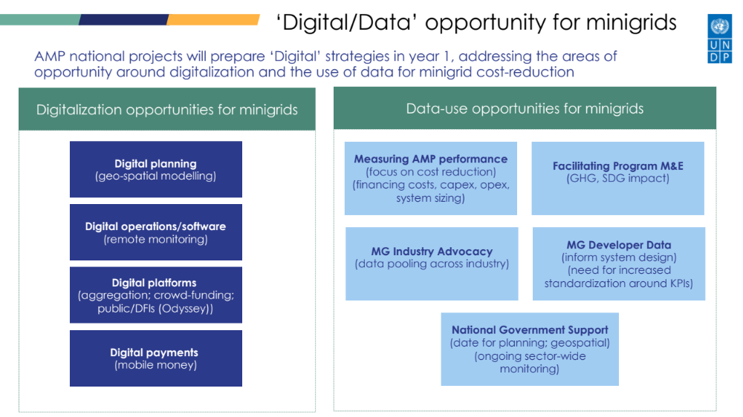
Figure 11: Digital and data opportunities for minigrids in the AMP

The potential for using data and digital tools and solutions to add value at various stages of the minigrids value chain remains largely untapped. With enhanced capacity, minigrid developers could streamline their operations though smart metering and remote control of their assets and potentially reduce operations and maintenance costs by about 15% to 30%(*) through reduced site visits, labor and component replacement costs. Government stakeholders could leverage digital solutions for energy sector planning, to streamline licensing, monitor quality of service and broadly improve sector oversight. However, data of sufficient quality is not always available for these purposes, and government stakeholders often lack the necessary technical capacity. And while data could be a tremendously valuable asset in the minigrid sector, this potential that remains largely underutilized due to the lack of standardization and common data reporting protocols and the fact that this sector is still very nascent and remains relatively fragmented.
Opportunities across the Program, and with the AMP regional project. The AMP provides a unique opportunity to develop a single set of metrics and guidelines for data collection, and use them to collect data from minigrid investment pilots across different national projects which the AMP Regional Project can then aggregate, derive insights from, and systematically disseminate knowledge with participating AMP countries and with the broader minigrids sector in Africa. At the same time, the link between the regional project and the total of eighteen (18) national child projects provides a unique ‘distribution channel’ opportunity across Africa for AMP to mainstream the use of digital tools and solutions for minigrids cost-reduction and scale-up.
(*) AMMP Technologies. “Reducing the cost of operations and maintenance for remote off-grid energy systems.” September 2018.

Digitalization is in general one of the areas in which Sudan needs to put a lot of efforts into, in a 2019 report GSMA ranked Sudan the 3rd last country within North Africa and Middle East in terms of Mobile Internet Connectivity and scores 38.2/100. Therefore, before a digital minigrid revolution can happen Sudan needs to invest in infrastructure to head in the direction that will allow minigrids to piggyback into the infrastructure possibilities to become “digital”.

Productive Use
Productive uses of electricity does not have a formal definition by the sector, but basically implies that the utilization of electricity (or energy) for activities that enhance income, productivity and welfare. A typical example are agricultural activities, processes and machines that result into a more automatize activity (i.e. less human power required) but some commercial activities can also be categorized as productive uses of electricity.

Productive uses of electricity (as opposed to non-productive uses such as lighting, cooking or entertainment) have a higher economic impact in the community, which also impacts in the economic performance of the minigrid economics and finance.

Although not concrete activities are designed under this project for productive uses, the following direction and decisions have been made that should help the IP during the implementation
- Pilot selection – the proposed pilot selection has taken into account the potential of agricultural activities
- Private sector participation – this project proposes that during the preparation and execution of the call for proposals to the private sector to implement the solar PV power plants that will hybridize the existing diesel minigrids, the call extends the scope of works to also call for innovative ideas from the same private sector entities to work with these communities in productive uses of electricity
- Third party appliances/machines providers – in order for this project to financially assist or finance activities related to productive uses of electricity the programme will be able to financially support only if the appliances or machines that enhance productive uses are owned by a third party (i.e. not the final user of the machine such as a farmer, a tailor or other)

Covid 19 opportunities
The multidimensional COVID-19 crisis creates opportunities for the project to mitigate country- and project-level impacts, to contribute toward green recovery and building back better, and also to leverage global responses to COVID-19 to deliver global environmental benefits and/or climate adaptation and resilience benefits. The following opportunities as relevant for AMP have been identified for inclusion in each projects as relevant:

- Leveraging economic recovery and stimulus plans. Governments across the continent have been structuring and implementing stimulus and economic recovery plans, social programs and even policy reforms during the crisis. These offer a good opportunity to accelerate the energy transition and step-up climate ambition. Putting people back to work will be an important part of stimulus plans and clean energy is an important source for new job creation and has great potential to spur local economic activity. This creates opportunities for AMP as increased funding availability and public support for renewable energy projects could be leveraged to augment AMP’s results. Also, increased support to energy consumers could address widening affordability gaps which pose risks for project implementation.

- Promoting the inclusion of electric cooking into minigrid operators service offer. With more attention paid to respiratory health issues as a result of the health crisis, an opportunity arises to address air pollution and make the case for accelerated decarbonization of the electricity matrix, clean transport, and clean cooking and heating technologies. AMP national child projects could provide a way to develop a broad array of energy services as part of a social protection program for the crisis response, particularly focused on provision of clean cooking e-technologies from minigrid operators, which are particularly important to reducing health-related vulnerabilities to COVID-19. Households switching to minigrid-powered electric cooking save money compared with traditional methods. Electric cooking also presents minigrid developers with a valuable opportunity to increase their load factor and boost their revenue.

- Minigrid site selection with COVID-19 considerations. AMP projects could also seek to help policymakers and regulators integrate elements from government strategies to respond and recover from the pandemic into energy sector planning. For instance, rural electrification strategies and plans could prioritize areas based on the presence of essential health facilities, key economic activities, particularly vulnerable populations, or other factors to concentrate efforts where COVID-19 impacts are highest. AMP national child projects can help enhance coordination between the energy and health sectors to ensure national electrification plans and minigrid sector planning consider the energy needs of the health sector.

- Health facilities as beneficiaries of specific minigrid investment pilots. AMP projects provide support to a number of specific minigrid investment pilots across AMP countries. Projects could use digital mapping tools to proactively identify minigrid sites that can benefit health facilities in addition to households, commercial, and productive users.

- Improved business case for minigrids providing energy for health facilities. With its focus on minigrid cost-reduction, AMP could potentially add value in reducing the cost and increasing the commercial viability of minigrids providing energy for healthcare facilities in several ways including supporting governments: (i) to improve data collection on energy access in the health sector and conducting comprehensive community energy needs assessments of health facilities that consider both electricity and thermal energy needs; and (ii) to utilize specialized digital tools to assist minigrid operators in targeting health care providers and designing appropriate minigrid systems for rural health clinics.

- Communities of Practice focused on COVID-19 impacts. If there was enough interest among several countries AMP could specifically create a specific Community of Practice (CoP) to focus on impacts, risks and opportunities around minigrids and the global pandemic. This would allow AMP countries to document and exchange experiences and knowledge on how off-grid lighting and electrification can alleviate some of the disadvantages and challenges experienced by households, productive users, health facilities and communities without access to electricity in facing the different stages of the COVID-19 pandemic and bolster recovery efforts.

Linkages with the AMP Regional Project
The project will align with the AMP Regional Project to foster knowledge sharing, learning, and synthesis of experiences in a multi-directional manner – i.e. flowing from the AMP Regional Project to the Sudan project, and vice versa, and between the Sudan project and other national projects within the Program. The AMP Regional Project will connect countries to knowledge, resources and networks of best practice and will support the rapid deployment of expertise, solutions and tools to support on-the-ground implementation. The main role of the AMP Regional Project is to make best practices in regulations and policies, innovative and inclusive business models, digitalization and financing available to all AMP beneficiary countries.

Cost reduction is one of the key themes guiding the strategy of the AMP in Sudan as will be seen in leaning towards hybridization, increasing the funds dedicated to technical capacity building of public electric companies to reduce operational losses, and focusing on enhancing tariff collection systems to reduce commercial losses.

In addition, components under the AMP in Sudan are in line with the harmonized results framework developed by the AMP Regional Project to provide guidance to participating national projects and streamline program implementation on the regional level. Furthermore, and in line with the protocol established in the AMP Program PFD, 10% of the consequential/indirect GHG impacts calculated for this project are allocated to the regional child project core results indicator, in line with the apportioning of the overall program budget. This reflects the benefits of this and all other national child projects accessing the regional child project’s support.

Specifically, Sudan’s child project will have the unique opportunity to contribute with the overall programme impact in the following ways:
- Deploy MW-scale off-grid projects unlike in many other child projects and markets, thus having a greater impact on emissions and economics on project basis.
- Become a pioneer in a stagnant market that is need of improving its energy landscape and move away from fossil fuel in off-grid settings through funding the pilots, programme dissemination and consultation with stakeholders, policy and regulation work and working with financiers
- Data sharing through continuous remote monitoring. Sudan lacks data in the energy space, through the interventions proposed in Sudan’s child project and in particular through the implementation of remote monitoring, a large amount of useful data will be gathered. This data will not only be useful for Sudan, but for the regional project to examine in detail technical patterns and issues on MW-scale solar PV diesel hybrid mini-grids
- Regulation and policy; unlike other African nations where mini-grid regulations have been developed over the past years, in Sudan no off-grid regulations or laws have been stablished or drafted. This represents a unique opportunity for the regional programme to put its best efforts, state-of-the-art regulations and policy practices, lessons learned and best practices to ensure Sudan embraces a set of adequate regulations for its context and unique challenges

Summary of changes from the Concept Note to the CEO Endorsement Request (CEO ER)
The proposed strategy in this Project Document builds upon the strategy presented in the Concept Note for this project. It continues to be aligned with the GEF focal area on Climate Change Mitigation (CCM-1-1) targeting the promotion of innovation and technology transfer for sustainable energy breakthroughs for de-centralized renewable power with energy usage. The project is also aligned with the UN’s Sustainable Development Goals (SDGs) and contributes to achieving SDG-7 which identifies electricity as an essential ingredient for lifting people out of poverty, improving health, boosting educational levels, reducing gender inequities, and enabling sustainable economic development. The project also contributes to achieving SDG-13 by contributing to integrating climate change measures into national policies, strategies, and planning, and SDG-5 by utilizing all project activities as opportunities to promote diversity and gender-balance to help achieve gender equality and empower women and girls.
The project’s title has not been changed during PPG development. The objective, components, and outcomes have been updated by the AMP Regional Project team for all countries participating in the AMP. Perhaps the most substantial change from Concept Note to PPG stage is about pilots; while the concept note proposed the development of 10 green minigrids (newly developed minigrids) this project document proposes to hybridize with solar PV power plants existing diesel minigrids (off grid stations), a low-hanging fruit that presents great potential to displace CO2 emission with renewable energy electricity generation. This shift in the proposed pilots has been identified as a key opportunity during the several bilateral consultations between the PPG Team Lead and the Implementing Partner.
Furthermore, some of the proposed outputs have been rephrased to enhance their clarity and specificity, while new outputs have been introduced to address specific challenges identified during PPG development. The following table presents a summary of the changes proposed to the project outputs from the Concept Note to the CEO ER.

Table 3: Summary of changes
Change | Justification for change or explanation
Budget. The total project budget has not changed, but the distribution of each component. More weight has been given for Component 1 and Component 2.
  Component | Project Document | Concept Note
  Component 1 | 19.05% | 17.03%
  Component 2 | 54.14% | 51.54%
  Component 3 | 11.03% | 13.43%
  Component 4 | 9.75% | 13.15%
Activity 1.1.1.5 – Institutional set-up support has been deleted from the Concept Note phase | During the consultations with Ministry of Energy and Petroleum, their stated this is not desired
1.4. Institutional capacity of Sudan Standards and Meterology Organisation (SSMO) strengthened to publicize and enforce domesticated standards has been deleted from the Concep Note phase | There is significant work to be done with MoEP, ERA and the electricity companies in capacity building and the budget is limited
Communities of Practice. Originally one activity within Component 4 was the establishment of communities of practice for mini-grids and knowledge Networks. This is no longer the case | There is an existing working group / community of practice called “The National Sustainable Energy Network” that this project proposes to piggyback for the purpose of the communities of practice
Pilot projects. During the concept note stage it was planned that the project will support the development of mini-grids, “Greenfields”. The pilot project no longer recommends to support the development of new Greenfields but the hybridization of existing brownfields with solar PV assets. | For the IP, MoEP, the hybridization of existing off-grid stations is of utmost importance and urgency due to the current fuel crisis the country has been experiencing recently. Reducing OPEX costs on fuel is key for MoEP and also to move away from fossil fuels.
Co-financing | The total co-financing committed to this project is now USD 5,550,000.

Results and Partnerships

The main objective of the project is to help develop solar PV minigrids as a major avenue for rural electrification in Sudan’s rural energy landscape, which is currently an underdeveloped market in which private sector involvement and appetite has been very limited in the past. Solar PV minigrid infrastructure could be key to Sudan’s target to achieve 80% electrification rate by 2030, yet the current experience is almost non-existing.
This child project proposes to piggyback on existing rural brown infrastructure (i.e. diesel based minigrids) to deploy solar PV power plants in order to “green” these sites as one of the first intervention, reducing diesel expense and avoid CO2 emissions, while also boosting new connections (as a result of reducing OPEX) within the existing operating infrastructure.
In regards to policy and regulation, Component 1, the proposed activities aim to stimulate the right discussions among Ministry of Energy and Petroleum and stakeholders, to come up with different delivery models than the current context (i.e. utility driven), use the DREI tools to inform some of these decisions, and provide extensive capacity building to Sudan energy’s actors, with a strong focus on MoEP and ERA.
Innovation in business models and finance, together with digitalization, Component 3 and 4 respectively, will also play an important role under the proposed project and various activities have been designed to help Sudan in its energy transition and pursue of 80% electrification rate by 2030. The procurement of a digital platform to manage minigrid tenders and perform M&E activities will play a pivotal role in this project at various aspects; training and capacity building, collect data that will inform future decision, and collect data for dissemination in the future.
The project will have access to (if requested) a variety of dedicated technical and operational support from the AMP regional project, as described in Box 3:

Box 3 Linkages to the AMP Regional Project –Access to technical and operational support
As part of the AMP network, the project will have access to (if requested) a variety of dedicated technical and operational support from the AMP regional project as follows:
- Access to specialized expert international consultants in selected areas (DREI, data, GIS modeling, mini-grid business models, etc.) hired, retained, contracted and paid for by the AMP regional project and made available to all participating national project staff and selected beneficiaries on as needed basis. The areas of support, listing of available firms/individual consultants under contract by the regional project and protocol for how the project can request and/or access such expertise (if needed/requested) will be elaborated in the first year of regional project implementation and disseminated to this project and the staff of all other participating AMP national projects. This support may range from virtual assistance to in-country missions. All requests for such assistance must be approved by the project manager of the AMP regional project management unit.
- Provision of a database of qualified international consultants and firms disaggregated by their expertise in the four main components of this national project and other key operational areas (procurement, M&E, communications, etc.). These individuals will not be retained or contracted under the regional project but rather provided to the project for informational purposes only in an effort to assist in identifying high-quality experts and firms who may be available for contracting by national governments under their own procurement rules and modalities.
- Provision of generic terms of reference (ToR) for various standard activities (mentioned above) under the four main components of the national project.
- Advisory support by the AMP regional project management unit to staff of the project on trouble shooting (operational support, ToR reviews and problem solving) on an ad-hoc and as-needed basis. These services will be paid for the regional project and available on a first-come/first-serve bases under a protocol to be established by the regional project.
- Specialized advisory support for implementing UNDP’s minigrid DREI analyses. During project implementation, the UNDP DREI Core team, working with the regional project, will make available to national teams and consultants the resources and tools to conduct full quantitative DREI applications, and will provide ongoing support and quality assurance.
A full detailed elaboration of these offerings and the protocols attached to each service will be communicated to the project at the inception workshop of the regional project and at the inception workshop of each national project.

One of the primary ways national ‘child’ project staff will interface with the regional project is via the ‘Communities of Practice’ (CoPs) and associated activities/platforms. While it is expected that many of the activities under Component #3 will be undertaken virtually (via internet-based platforms, webinars, or digital platforms) it is also expected that the CoPs will include actual in-person workshops, meetings or training events.

Policy and Regulation
This component will work on having the necessary policy dialogues and producing adequate regulations at the right time as the minigrid market evolves over the 48 months of the project duration. As the minigrid market in Sudan is in its infancy, continuous dialogue through working groups and capacity building is essential under this component, as an attractive, enabling environment for minigrids is yet to be developed in Sudan in comparison with other countries.
Sudan electricity market is still governed by the 2001 Electricity Act, although a new, 2019, Electricity Act has been drafted, is in the approval final stages. There is an existing energy working group established in Sudan, “The National Sustainable Energy Network”, that could be used as the basis to set-up the deliver model working group proposed in the following activities.
  - Stakeholder ownership in a national minigrid delivery model is advanced, and appropriate policies and regulations are adopted to facilitate investment in low-carbon minigrids
    - Mini-grid delivery model(s) identified from national dialogues on minigrid delivery models
      - Set-Up Delivery Model Working Group and host a series of workshops. It will be important for the programme to host on-going conversations for the initial phase of the project on delivery models for minigrids different than utility-led, utility-operated that fit within the government vision and objectives for 2030-2031. Such consultations will carefully include the voice and interest of vulnerable groups such as women and youth. Some of these workshops could be supported or hosted by the regional project component 3 implemented by RMI.
      - Participation in regional or continental workshops and/or webinars organized by other African countries in order to hear experiences, lessons learned and recommendations from other African regulators and Ministries of Energy
      - Preparation and execution of a 2-month placement of 1 senior staff from ERA in the offices of another African country regulator. During the proposed 2-month placement the selected senior staff from ERA will be exposed to new ideas, different ways of dealing with energy regulations, processes and protocols and projects from a different energy regulator. This activity will be prepared and executed in close coordination with AMP Regional programme, and a range of options will be prepared by AMP Regional programme to AMP Sudan child project
      - Provide input to the discussion and Delivery Working Group in the form of gap analysis, best practices reports and recommendations for delivery models in alignment with decisions already taken
    - Registration process for Low Voltage minigrids in place and disseminated among stakeholders
      - Provide input to MoEP and ERA, best practices from other African countries on lessons learned and what works well in a light-handed approach registration process to encourage the bottom-up minigrid proposals by private sector, NGOs and states
      - Develop a simple, adequate, straight forward registration process for Low Voltage minigrids (independently of their installed generation capacity). This activity is conceived to be a fast-track avenue for green minigrids in Sudan
      - Dissemination of the registration process at national and international level. As much as the registration process for LV minigrids is important, the dissemination will be key to reach potential interested parties. AMP Sudan can piggyback on the regional AMP project for the outreach and other platforms such as the African Minigrid Developers Association (AMDA)
      - Feedback session on the registration process for LV minigrids 6 months after its publication with stakeholders (including private sector, NGOs and other relevant actors)
    - A full minigrid regulatory framework is in place and adopted by MoEP and ERA through a series of inclusive national dialogues, with a streamlined licensing process and clear rules and requirements defined.
      - Drafting of minigrid regulation in close coordination with ERA. This activity has to be closely and heavily informed on the outcomes of Outputs 1.1.1 and 1.1.2, in particular this activity has to have some initial delivery models selected or narrowed down from earlier activities. This draft minigrid regulation should encompass a tariff regulation methodology, a licensing procedure (including licensing exemptions if applicable), technical regulations (power and service quality requirements), customer service aspects and arbitration mechanisms
      - Development of a tariff calculation tool that is appropriate for Sudan’s specific context and requirements. This activity will be a joint effort from ERA and MoEP
      - Support to ERA in the preparation and conduction of public consultations. Consequently adjustments and feedback from this consultations into Activity 1.1.3.1 and Activity 1.1.3.2
      - Development and implementation of a license application management online platform
      - Consolidation of full regulatory framework for solar PV minigrids
    - Minigrid DREI techno-economic analyses carried out to propose most cost-effective basket of policy and financial de-risking instruments and contribute to AMP Flagship Report on Cost Reduction
      - Initial, full quantitative national DREI analysis (Year 1). A full quantitative DREI application will be conducted in the first year of project implementation. The PMU will assemble a task team to perform the national DREI analysis including consultants (international, national), government stakeholders, and members of PMU. Deliverables will include interviews, completed financial models, and national reports/knowledge products. The AMP Regional Project can in turn provide various support on DREI to the national project: including finalizing TORs for the country-level, recommendations (in the form of a vetted roster of consultants) on international consultants that are trained on DREI already, as well as resources and tools (Excel models etc.) to conduct the DREI analysis. Results from the full quantitative national DREI analysis will be shared with the regional project to feed into a regional flagship AMP knowledge product, across all AMP countries, on DREI and lowering mini-grid costs. This regional AMP knowledge product will be funded by the regional project.
      - Dissemination of DREI analyses and adaptive management (Year 2). In the first half of Year 2, the project will disseminate the national DREI analysis and, in the second half of Year 2, the flagship DREI regional knowledge product (south-south learning) through dissemination activities at the national level. Together, these dissemination activities will encompass 3 or 4 round-table workshops with government, private sector and other key stakeholders, over a 12-month period. Along-side these dissemination activities, the PMU will utilize the findings of the national DREI analysis to inform any adaptive management of the national project’s outputs/activities, to address identified needs for public measures arising from the national DREI analysis. These activities will be funded by the national project.
      - Coordination with regional project on national DREI analysis update (Year 4). In the final year, or year 4, of the national project’s implementation period , whichever happens first, the original national-level DREI analyses will be refreshed to track evolutions in financing costs as well as in hardware and soft costs. For administrative efficiency, the regional project will fund and execute this update (a ‘light quantitative DREI analysis’), on behalf of the national project. The deliverable will be a brief note of 2-5 pages on the DREI national update. The data from the national refreshed DREI analysis will be fed into an update note to the year 2 flagship regional DREI knowledge product, which will provide an end-of-program overview of the evolution in minigrid costs across AMP countries. The national project’s contribution to this activity will be: facilitating the DREI national update (to be executed by the regional project); disseminating the findings of the national DREI update note, and the update to the regional flagship DREI product.
    - Pre-feasibility studies for minigrid sites to enhance sector planning and decision-making on a delivery model for minigrid development, including geospatial studies
      - Conduct geospatial, techno-economic modeling of least-cost off-grid renewable electricity technologies (minigrids, grid extension, stand-alone renewable energy plants). This activity will have to co-exist with existing efforts by the World Bank. The World Bank has just concluded a GIS high-level analysis focusing on macro issues such as population or access to electricity nationwide. Through the Sudan Energy Transition Access Project (SETAP), World Bank plans to carry out more detail GIS analysis in 2021 in particular a least-cost study for grid extension, minigrid and stand-alone RE technologies
      - Research and data collection of (i) socio-economic data for a sample of pre-identified suitable sites for minigrid development. The socio-economic data will touch on ability and willingness to pay, and presence of public institutions and potential productive uses of electricity including anchor loads. This research and data collection will also include (ii) detailed demand assessment, (iii) site specific development costs estimates (transport, labor cost, etc.)
    - Capacitate public institutions, in particular MoEP and ERA on technical, managerial, and regulatory issues including design procurement and tender processes that incorporate cost-reduction levers and innovative business models
      - Institutional capacity building provided to MEM, ERA, SPGC and SEDC on technical, managerial, and regulatory issues. An important topic for this activity will be digitization of technical and commercial information of the customer database SEDC, along with remote monitoring and local monitoring best practices and benchmarks
      - Embedding a minigrid expert at Ministry of Energy and Petroleum for continuous support
      - Capacity building provided to public officials in MoEM and ERA specifically to design procurement/tender processes that incorporate cost-reduction levers and innovative business models

Box 4 Current Status of Minigrid Delivery Models in Sudan
As the market in Sudan is underdeveloped and receives practically no international attention, key aspects of the minigrid delivery models are still undefined and should be evaluated from scratch. Table 4: Current Status of minigrid delivery models in Sudan provides a summary of the current status of key aspects of minigrid delivery models in Sudan. It is important to note that Sudan, as opposed to other African nations such as Kenya, Nigeria, Ethiopia among others, has not had significant discussions around this due to their recent political history and development.
Table 4: Current Status of minigrid delivery models in Sudan
Aspect | Current Status
Ownership and Operation | Formal minigrids: fully public. So far the government of Sudan through Ministry of Energy and Petroleum has financed, constructed and operated the off-grid stations. It is also important to stress the role that State governments play in developing and co-financing distribution network assets  Informal mini-grids: private. Through the interviews carried out to different actors (MoEP, Practical Action) reference was made to the existence of informal, fuel-based, minigrids in villages that charge monthly fees to the customers on the bases of “willing buyer-willing seller”. These minigrids are operated by private groups or individuals. Although these minigrids operate out of the law and are not licensed by ERA, they are serving a market that the government of Sudan is not capable of
Tariff mechanisms | Tariffs are highly subsidized as described in Table 2: Electricity prices in Sudan (PPG Team Leader, 2021) of the Strategy section
Subsidy mechanisms | Subsidy mechanisms in the national electricity sector have been heavily subsidized and are highly unsustainable  State government role, in Sudan each state is financially responsible for the construction of MV network. The cost of LV lines and last-mile connections is borne by electricity users. In Sudan’s decentralized model of electrification, the national government (including SEDC) functions as a technical advisor on project design and the operator of built assets.  Potential subsidy mechanisms in the off-grid space: a potential subsidy for financing solar PV mini-grids (Greenfields and brownfields) are high CAPEX subsidies to operators and enter into concession agreements through a BOOT or similar. CAPEX subsidies will have different percentages depending on whether is a greenfield or brownfield.
Regulations | The government recognizes the need to start working in off-grid regulations and introduce regulatory pieces that contribute to the uptake of RE mini-grids in Sudan. In particular, during the validation workshop held on 19th of April 2021, ERA recognized this need and made a call for this programme to help them in developing this.
Bottom-up mini-grid market | There is no accurate information or knowledge of how many customers are being served by informal mini-grids, but it could be in the order of tens of thousands, unfortunately these informal mini-grids rely on diesel to generate electricity. There is a market opportunity that if properly addressed by MoEP supported by ERA, could tap into this – this is why Activity 1.1.1.1 is proposed.

The possible options for each aspect need to be thoroughly understood by stakeholders and substantiated with real examples. The decisions for and against certain options must be openly discussed and weighed up in terms of the interplay between the aspects and the resulting consequences for the sector. These decisions are often influenced by the historical and cultural background on the one hand, and by the current political and economic situation of a country on the other.

To this end, one of the first activities envisaged in the project to is to get all relevant stakeholders on board and initiate a process of national dialogue to weigh up all aspects of mini-grid delivery models (Activity 1.1.1.2) with the aim of defining one or several sector-wide delivery models

Business Model Innovation with Private Sector
This component will target deploying solar PV power minigrid plant pilots in existing off-grid minigrid infrastructure in Sudan. The pilots will aim at developing, implementing, operate and maintain, and monitor at least 2 projects piloting the hybridization (or retrofitting) of existing diesel based minigrids (or off-grid stations as per the term used by MoEP and STGC) in order to reduce the O&M costs of operating these power plants with fuel only. Subject to further exploration during implementation, it is recommended that the implementation of these solar PV power plants and its associated infrastructure will be done by the private sector, through a Build, Own, Operate and Transfer (BOOT) model (concession). The pilot implementation will be done in a “phased-approach” aiming at fast-tracking the deployment of these solutions and to reduce the risk and lower the initial CAPEX investment required:
Phase 1: Low-penetration solar PV-diesel minigrids pilots. In the first phase of the project pilots, existing diesel-based minigrids will be retrofitted with a low solar share energy penetration (less than 20% of the total energy) as the integration into the existing assets will be easier and the CAPEX will be lower, therefore pace of implementation will be faster.
Phase 2: Medium or High solar PV-diesel minigrids pilots. After 1 year of O&M and M&E of the phase 1, the project pilots will be ready to move into phase 2 in which a second retrofitting intervention could be made. By expanding the solar PV power plant and introducing batteries, the minigrids will move from low penetration to medium to high solar share penetration (20% to 50% energy penetration for medium penetration and more than 50% for high penetration). This will require a more sophisticated control and the inclusion of batteries.
For the tender phase and private sector selection for pilots the IP will use a digital platform as a one-stop-shop of all documents, questions and evaluations performed as part of the procurement and call for proposals exercise. By using digital platforms for pilots, capacity of key stakeholders will be developed, which can then set the foundation for later using digital platforms for sector-wide large scale tenders.
The main objectives of this component are:
1 – Increase the private sector participation in the off-grid market of Sudan
2 – Reduce existing fuel consumption in off-grid sites
3 – Use digital platforms for the procurement, implementation and monitoring of this component intervention
4 – Women’s inclusion in the pilot intervention and beyond

Pilot minigrids funded by GEF INV are required to comply with all the relevant national standards of the country as well as UNDP standards on social and environmental safeguards, gender equity and stakeholder consultation. In support of this, an Environmental Safeguards Management Framework (ESMF), developed for the program, a gender action plan and stakeholder engagement plan accompany this ProDoc. The ESMF is structured as a program-wide framework that provides guidance that is both generically applicable to all AMP country projects as well as country specific. This guidance will have to be incorporated and considered in developing the environmental and social impact assessments and management plans for pilot minigrids.
A critical consideration under this ESMF is the need to ensure environmentally sound management of replaced equipment, including batteries, inverters and solar panels, after their usage. The responsible handling of waste with recycling of batteries and other recyclable equipment, should be clearly documented, budgeted and monitored in compliance with national and UNDP safeguards requirements.
Box 5 Pilots and the Project’s Environmental Safeguards Management Framework (ESMF)

  - Innovative business models based on cost reduction are operationalized, with strengthened private sector participation in solar PV-battery or low-carbon minigrid development
    - Pilots for an indicative two to four (2-4) existing diesel minigrids have been hybridized with solar PV and a small electrical storage. This infrastructure is successfully implemented, operational, and maintained by the private sector, involving women’s vocational training and participation, leading to cost-reduction in minigrids
      - A detailed feasibility study is prepared in at least 2 possible sites of existing diesel minigrids. Economic and financial cost and benefit analysis performed. An in-depth feasibility study, including the economic and financial benefits of retrofitting the selected sites with PV power plants will be conducted. These sites should be ranked based on the following multicriteria analysis: (i) agricultural and agro-processing potential, (ii), potential to boost new connections within the existing network, (iii) potential to expand distribution network to neighboring areas where the network has not reached, (iv) CO2 displacement potential per inhabitant and other indicators. These feasibility studies will then be used for developing the Minigrid Pilot Plan set out in Activity 1.2.1.2
      - Develop a detailed project plan (the project’s ‘Minigrid Pilot Plan’) for advancing the project’s minigrid pilot(s).The PMU will lead and develop, in close collaboration with other stakeholders and support from the AMP Regional Project, a detailed project plan (the project’s ‘Minigrid Pilot Plan’) for advancing the pilot(s). Once prepared, the project’s Minigrid Pilot Plan will first be reviewed for clearance by UNDP (CO and BPPS NCE), and then shared with the Board. This activity will build upon the feasibility studies in Activity 1.2.1.1. The Minigrid Pilot Plan should be completed by the end of year 1.

The project’s Minigrid Plan Pilot Plan will determine, among other aspects, the following:
• Clear objective for the pilot(s)
• The minigrid delivery model(s) which will be demonstrated in the pilot(s). As stated above, BOOT, appears to be promising. The deliver model will ensure full financial sustainability, including O&M, of the minigrid over its asset lifetime.
• The proposed type of pilot(s), here likely to include hybridization of existing minigrids, with the possibility of productive use overlays
• The estimated target number of pilot(s), based on ex-ante estimates of available GEF INV
• Inputs, as necessary, on site selection, including based on geo-spatial mapping, for the pilot(s)
• Site-specific assessments and other requirements (e.g., demand sizing, social and environmental safeguards (SES) (see Box [5]) , gender assessments, e-waste disposal), including those in activity 1.2.1.1. Some assessments may be needed to be performed by the project ex-ante, to inform follow-up competitive tenders,
• The use of the digital platform for
- Competitive tendering, as necessary.
- Ongoing data collection from mini-grid pilot(s), including data-sharing requirements from mini-grid pilot(s), as well as digital hardware requirements
• The project’s approach to ensure minimal concessionality for the level of GEF INV support to the pilot(s) (when there are private sector beneficiaries)
• Review of the IP’s modalities for transfer of GEF INV support to the pilot(s), ensuring they are aligned with UNDP’s policies and financial rules.
• If a pilot includes GEF INV support for productive use, ensuring the pilot takes a third-party ownership model to productive use equipment
• Coordination, and rationale, on any associated technical assistance activities by the project for the minigrid pilot(s)
• Brief summary updates, at the time of drafting the plan, on the status in Sudan of
- Any other solar-battery minigrid pilots (specifications, any results/findings to date), and
- Examples of minigrid productive use applications (specifications, any results/findings to date)

      - Set-up a data management platform for digital tendering and pilot monitoring. A data management platform will be procured under Component 4 (see information on Component 4 and activities below) with functionalities that will enable the PMU to run and manage digital tenders, collect data from pilot projects, and use these data for learning purposes.
      - Meter modernization – part of pilot. Within this output, as an activity this project proposes that a fraction of the meters employed by SEDC in the selected pilots will be modernized with smart meters that allow remote monitoring. As the number of connections that the proposed solar PV power plants and battery banks (phase 2) will be “greening” is in the order of tens of thousands, modernizing all the connections and metering will imply millions of dollars. Therefore Ministry of Energy and Petroleum, with the assistance of SEDC will select a percentage of customers in each selected site where the meters will be replaced by modern smart meters that allow remote monitoring. The sample will have to be significant and will have to include few customers under each category as per the latest electricity price schedule (presented in the development challenge of this project document). Each customer category will have a minimum (tbd) of customers where customers will be modernized (residential, commercial, public institutions and industrial)
      - Design, launch and completion of call for proposals (CfP) for the minigrid pilot tender. STGC and MoEP issue a call for proposals to the private sector to hybridize at least 2 existing brownfields under a BOOT delivery model or similar. This CfP will be through a 2 stages procurement, first an expression of interest by the wide private sector and second a call for proposals for the shortlisted candidates that comply with the requirements stipulated at the EoI stage
      - Execute contracts or agreements with selected bidders and commission the pilot projects. Having entered into contracts/agreements with minigrid developers for the implementation of minigrid pilots, the PMU will administer these contracts and make payments to the selected bidders in a timely manner as per a predefined schedule of payments associated to milestones, including the key milestone of commissioning the solar PV power plants and battery bank (for phase 2). The PMU will use the data management platform to, among other things, validate the power plant delivery of the private sector entity
      - Monitor pilots, collect and aggregate data shared by pilots. The data to be collected will be on the generation power plant and also on the smart meters that will be modernized under Activity 2.1.1.4. The information will help MoEP and stakeholders for (1) obtain lessons learned and data to inform the design of phase 2 of the pilot projects and (2) to evaluate cost reductions, lessons learned, consumption levels and other data for the potential scale-up of solar PV retrofitting projects in Sudan. This activity will also help promoting energy efficiency an energy conservation within the existing off-grid stations

    - Capacity of potential tender bidders (private sector developers) strengthened to consider innovative business models and cost-reduction levers. This output will also benefit from Activity 3.1.2.1 (hands-on coaching on minigrid developers)
      - Capacity assessment. Local and regional developers will be assessed for their capacities, current exposure, and commitment to develop, engineer and deploy minigrids in Sudan. Specific technical assistance interventions (such as the ones proposed in Component 3, hands-on coaching for minigrid developers) will be organized, including workshops and webinars
      - Support in site selection exercise for minigrids. The PMU, with the close assistance and dedication of the senior embedded minigrid expert, will provide support and recommendations for site selection. This will include GIS tools to identify and rank suitable communities and locations for green minigrid development. Important country-specific factors will also be touched on such as mobile coverage, consumption patterns depending on region (agricultural patterns, pastoralism among others), remoteness and O&M costs associated to it (important for Sudan as it’s a vast country)

    - A “solar sister” (brand name) programme is in place, that supports and capacitates Sudanese women on technical, managerial, and economic aspects of solar hybrid minigrids
      - Supporting the capacities of vocational training institutions to provide courses on the design and O&M of solar / hybrid minigrids. Including a detailed course in design and O&M of low solar fraction solar PV-hybrids and medium to high solar fraction solar PV-hybrids. Within this activity the following sub-activities are envisioned:
            - Analyze existing vocational training programs and perform a gap analysis. Introduce the gap analysis findings to the vocational training institutes and to the authorities in charge of providing the budget to these institutes
            - Support the development of partnerships between local institutions, women’s groups or cooperatives, and international partners for the integration of courses on solar PV and solar PV hybrid minigrid design and O&M into existing engineering curricula and vocational training programmes. An example here would be to support the integration of an international partner like Barefoot college (India) into Sudan, making sure it connects and develops relationships with all relevant parties
            - Organized Training of Trainers (ToT) workshops to train course providers from the selected institutions on delivering newly integrated courses, using course material from partner institutions.

PILOT PROJECT ZOOM IN
Concept and Categorization
The proposed pilot intervention of AMP Sudan particularly aims at reducing operating expenses (OPEX) to STGC (and more in general to the Sudanese electricity holding company and the government of Sudan) and reducing diesel consumption in the off-grid stations with MW-scale solar PV power plants. The category of pilot project is therefore hybridization of an existing diesel minigrid (with new solar-battery equipment).
Deploying MW-scale PV power plants in off-grid settings will not only help Sudan reduce the diesel consumption across these sites, but will also increase the off-grid market visibility and potential appetite by local and international investors to invest in this market.
Objectives:
These country-specific objectives fit within the three overall objectives of AMP regional programme in the following manner:
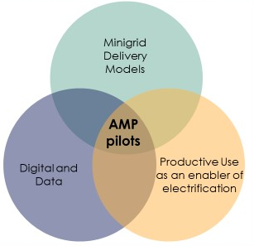
Figure 12: Thee "Key Areas of Opportunity" for AMP to drive minigrid cost-reduction

Table 5: Key areas of opportunity for Sudan AMP Pilot project
Key area of opportunity | Sudan Child Project | Alternatives or Challenges
Minigrid Delivery Model | BOOT implementation | Different alternatives have been evaluated and could be reassessed during the project implementation through national dialogues (as part of the various activities in Component 1). See Table 5: Delivery models for pilot projects: PPG team lead evaluation
Productive Use | The locations have been chosen in areas where there is large agricultural area  Third-party ownership model | Private sector to conduct and assessment in the selected sites for pilots as part of the RfP scope of works
Digital & Data | - Training  - Procurement of a digital platform  - GIS tools | Sudan currently performs poorly at providing digital data in any market and obtaining data in general about Sudan is a challenge. AMP through the project pilot digital & data area of opportunity has a unique opportunity to gather and analyze data that could inform future mid-term decisions on the public and private interventions
A. Where? Pilot Final Site Selection
The pilot final selection for the hybridization of existing diesel-based minigrids with solar PV could be done based on the potential of agricultural activity and agro processing opportunities nearby and within the infrastructure that will be deployed within the AMP timeline. The following image shows a GIS layer on agricultural activity from 2019 in the five locations proposed by MoEP for the pilot (each pixel represents an equivalent area of 100x100 meters):
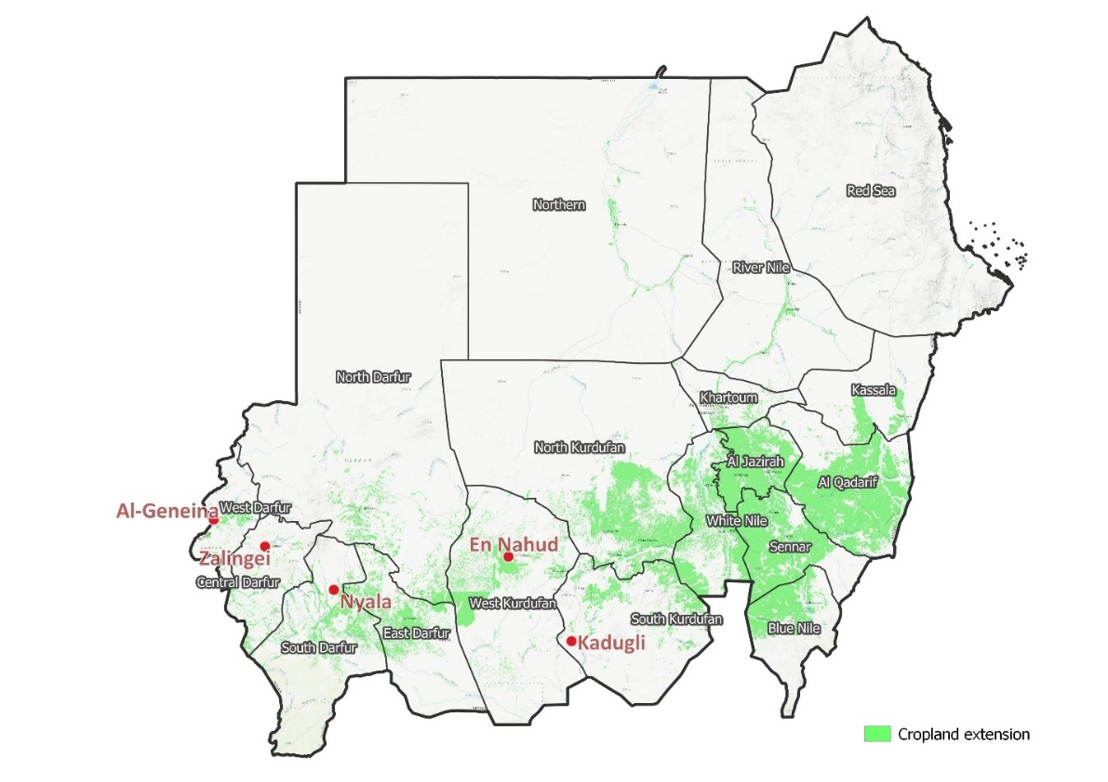
Figure 13; GIS cropland layer of Sudan (2019, Copernicus Global Land Cover Layers: CGLS-LC100 collection 3) superposed with the 5 proposed locations (from left to right: Al-Geneina, Zalingei, Nyala, En Nahud, Kadugli)

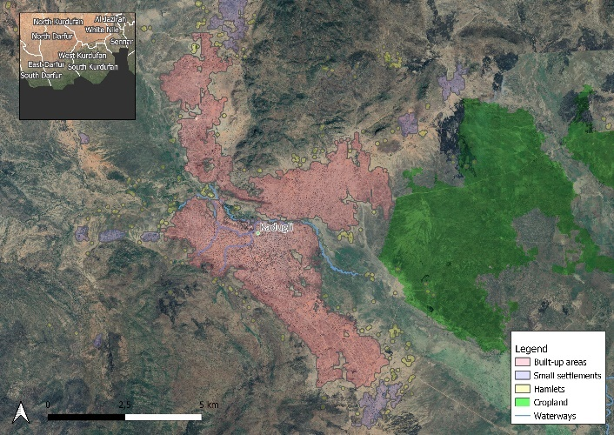 | 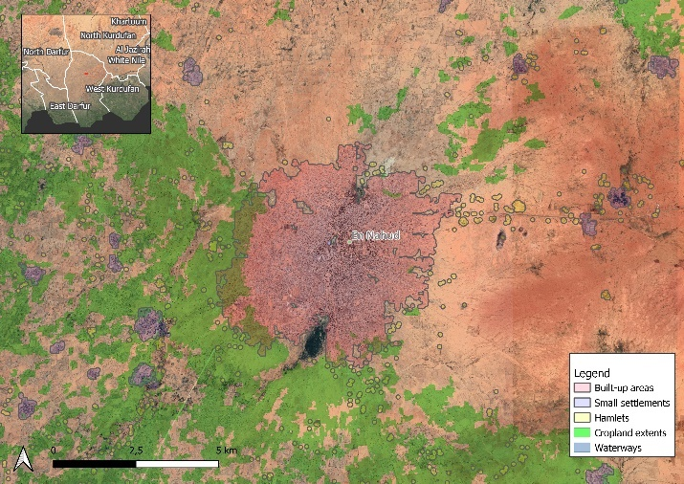
Kadugli | El Nahud
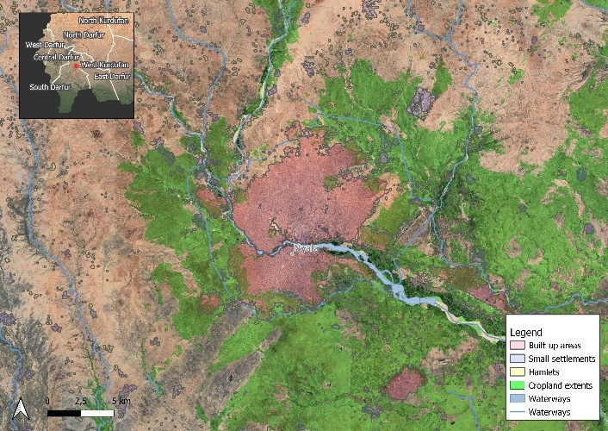 | 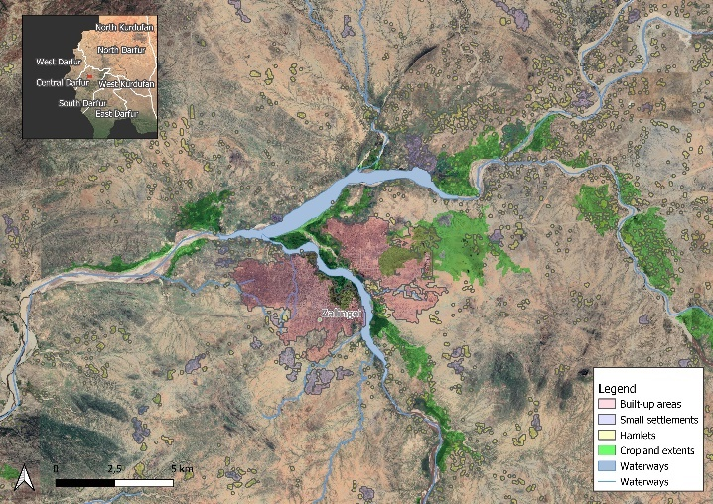
Nyala | Zalingei
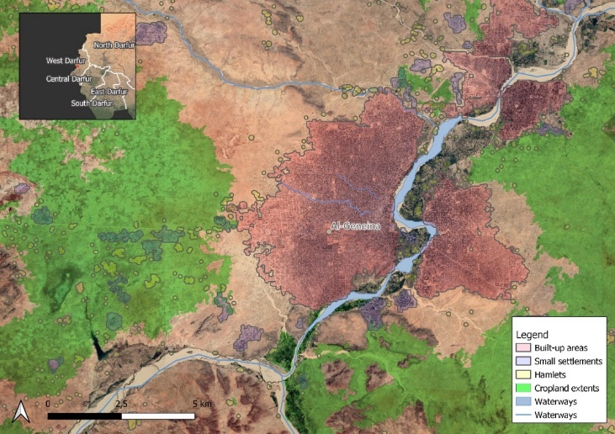
Al-Geneina

The following table presents basic data on current power infrastructure supply, dates since commissioning, number of clients and distribution network length per site:

Table 6: Basic information on 5 proposed pilots
Site info |  | Current Power Infrastructure Supply |  | Dates |  | Distribution Network |  | Customers
 | Name | Installed Capacity (MW) | Peak consumption (MW) | Operating since | Diesel genset year of installation | MV approx. length (km) | LV approx. length (km) | Number of clients as of 2020
1 | Al-Geneina | 8.8 | 10.5 | 1987 | 2018 | 63.6 | Unknown | 10,595
2 | Kadugli | 6.6 | 5.5 | 2004 | 2018 | 34.2 | Unknown | 14,137
3 | Nyala | 31.2 | 27 | 1970 | 2017 | 156.3 | Unknown | 33,193
4 | Zalingei | 1.3 | 3 | 2009 | 2010 | 14.7 | Unknown | 4,103
5 | Al Nuhud | 5.7 | 5.5 | 1984 | 2018 | 25.3 | Unknown | 12,779
 | TOTAL | 53.6 |  |  |  | 294 |  | 74,807

B. Process: Pilot “phased” approach description
The opportunity to hybridize existing diesel-based minigrids owned by the Government of Sudan and operated by STGC is a “low-hanging fruit”. When hybridizing an existing diesel based minigrids (or brownfields) with solar PV plants, the control and battery required is different depending on the PV penetration category. The following table provides a quick overview on the four (4) main penetration categories that can be distinguished:

Table 7: Solar PV hybrid penetration categories (Alberto Rodríguez, TTA)
Category | PV Energy penetration | PV installed capacity / load | Attributes
Low | < 20% | < 50% | - Genset(s) always on during duty cycle  - PV allows small reduction in fuel consumption  - No supervisory controller or batteries needed  - Low capital costs and high internal rate of return (IRR)  - Low environmental benefits
Medium | 20 – 50% | >50% | - Genset(s) always on during duty cycle  - Simple controller or small storage for frequency/voltage regulation  - Account for spinning reserve  - Medium environmental benefit
High | >50% | >150% | - Genset(s) not always on  - Requires sophisticated controller for grid regulation and control of electronic components  - Requires batteries for PV energy time shifting  - High CAPEX, low OPEX  - High environmental benefits
Autonomous | >80% | >200% | - Genset as backup/emergency  - Requires sophisticated controller for grid regulation and control of electronic components  - Requires batteries for PV energy time shifting  - High CAPEX, low OPEX  - High environmental benefits

The recommendation for the pilot project is to implement them in a “phased” approach as following:

- Phase 1: Low-penetration solar PV-diesel minigrids. In the first phase, the existing diesel-based minigrids will be retrofitted with a low solar share energy penetration (less than 20% of the total energy). As opposed to a higher penetration of solar energy (medium, high or autonomous), low penetration solar PV-diesel minigrids do not require a sophisticated control system and require no or small battery bank capacity for their operation, which results in a lower CAPEX investment and a faster project implementation.
- Phase 2: Medium or High solar PV-diesel minigrids. After 1 year of O&M and M&E of the phase 1, in which the project would produce some lessons learned and have gathered data, the project will be ready to move into phase 2 in which a second retrofitting intervention could be made. By expanding the solar PV power plant and introducing batteries for energy storage, this infrastructure will move from low penetration to medium to high solar share penetration (20% to 50% energy penetration for medium penetration and more than 50% for high penetration). This will require a more sophisticated control and the inclusion of batteries, in comparison with low-penetration solar PV-diesel minigrids, however as the private sector would already have been working for 1 year in these sites, the data and confidence to “upgrade” with the BOOT concession terms would be in place

C. How? BOOT concession for the power generation
A Build, Own, Operate and Transfer (BOOT) concession agreement with the private sector is recommended as the most appropriate implementation model aiming at (1) attract private sector capital of the overall CAPEX investment required and (2) have a model in which private sector and public sector work together. Through this model the private sector will be in charge of the final engineering, constructing the power plants, operating and owning them for a period of at least 10 years, after having paid back the investment and the obtained a desirable, reasonable return on investment, then transfer the assets to the government.
Given the current tariff subsidy level in Sudan and the final end-user tariffs, it is anticipated that the private sector will enter into a “take or pay” agreement with STGC for the power generation sales of the solar PV power plants installed in the selected locations, so that even if there is not enough demand from the consumption side, STGC will be required to pay the equivalent of a minimum figure on monthly basis.
D. Gender dimensions to be considered in the development of pilots
The development of 2-4 pilot minigrids will be preceded by context specific gender analysis and action planning process focusing on minigrid development project cycle which will have dimensions of inclusion of women and disadvantaged groups in consultation and planning, leveraging women’s role in the agricultural value chain, supporting women owned business to invest and/or engage in operation and management of hybridized minigrids.
E. Digital requirements on the pilots
F. Productive Uses
Box 6 Digital data sharing for mini-grids

Pilot beneficiaries (e.g. minigrid operators) receiving support from the project will be required to share minigrid performance data with the national project

Specific terms and conditions for data-sharing and how best to operationalize the commitment and its adoption by the beneficiaries will be defined and agreed upon with minigrid operators during project implementation, including details of what data can and cannot be used, based on consultations with industry stakeholders and with support from the AMP Regional Project.

The specifications around the data generation by the demonstration pilots supported by the project will consult and follow guidance/standards provided by the AMP Regional Project. A standardized Quality Assurance and Monitoring Framework (QAMF) for application in all minigrid pilots supported under the project will be developed in year 1 of the regional project and disseminated to all national projects.

A data platform will be procured by the project (under Component 4, Output 4.2) to serve different purposes including: (1) running digital tenders by which minigrid developers will be selected as beneficiaries to receive support under the project and (2) managing all technical and financial data related to minigrid sites.

Through the implementation of this data management platform, minigrid developers selected to implement minigrid pilots with support from the project will have access to a set of best-in-industry tools for analyzing minigrids (e.g. demand forecasting, system optimization, distribution network design, detailed financial modeling at the site and portfolio level). Similarly, as part of the roll-out of the data platform, minigrid developers (as well as key government and other stakeholders) will receive capacity-building and in-depth training to use analytical tools and data management technologies.
Productive uses of electricity within minigrids is key to improve a virtuous cycle of higher loads resulting into lowering Levelized Cost of Electricity. Although specific productive uses of electricity have not been identified in any of the 5 proposed sites for the pilots, some work will have to be done during the feasibility study (Activity 1.2.1.1) in order to identify both, existing productive uses of electricity already connected to the diesel minigrids and, potential productive uses of electricity that can be incorporated into the minigrid with some additional efforts.
Within the existing budget for pilots (GEF INV) the implementation partner could use some financial resources to finance activities related to productive uses, this however will be in the form of Third Party Ownership Models. Third party ownership models involve the minigrid asset owner purchasing the productive use equipment, and then effectively leasing it back to the end-user, as part of an energy as a service offer. This third-party ownership model is necessary to justify the use of climate finance, as the funding can be presented holistically as part of the overall system design required for an economic minigrid.
If deemed necessary, after the findings from the feasibility study perform on the selected sites (Activity 1.2.1.1) in the call for proposals for the private sector bids, a call or third party ownership models as part of their technical proposals could be part of the evaluation criteria, giving more points for those bidders that propose productive uses activities through a Third Party Ownership Model.
Climate Change and Adaptation: Productive uses for Water Pumping and Irrigation
Sudan presents a hot desert climate (area in red in the image below) and hot semi-arid climate for almost all its land coverage according to the Köppen-Geiger climate classification system. Several environmental changes have occurred in the Sudan in the past; several are ongoing; and others are projected to happen in the future. The Sudan has witnessed increases in temperature, floods, rainfall variability, and concurrent droughts. In a country where agriculture, which is mainly rainfed, is a major contributor to gross domestic product, foreign exchange earnings, and livelihoods, these changes are especially important, requiring measurement and analysis of their impact.
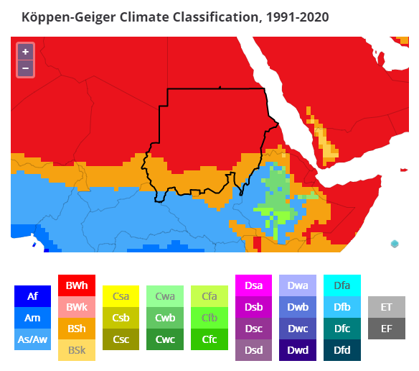
Figure 14: Sudan's Köppen-Geiger Climate Classification

In the Sudan, the agriculture sector accounts for more than a third of GDP. Being mainly rainfed, agriculture in the Sudan is vulnerable to variations in rainfall amounts and timing. The proposed pilot projects have the opportunity to increase, through water pumping and irrigation, the agricultural needs of these lands, as climate change action.

Innovative Financing for Minigrids
As this child project aims at helping Sudan in transitioning from almost no experience in private sector participation into a more inclusive, multilateral rural electrification approach for other actors (private sector, states and potentially cooperatives or non for profit), innovative and adequate financing mechanisms need to be formulated and availed to support the financing needs of eventual projects. Similarly, it will be essential for this child project to identify and help other actors in developing a list of sites that are best served by minigrid technologies, in order to bring these sites into funding stages and support pipeline development activities.
The Bank of Sudan, after the complete islamization of the banking system in 1992, eliminated treasury bills and government bonds that carried interest rates. In their place, the bank issues financial certificates conforming to the Islamic system.
  - Innovative financing mechanisms explored at local and regional level, and final design options with recommendations on financing needs and opportunities for the uptake of both (i) solar PV greenfield minigrids, and (ii) solar PV hybridization in brownfield minigrids
    - Design support for minigrid innovative financing mechanisms
      - Support identification and design of innovative minigrid financing solutions to support investments in PV minigrids. There are multiple ways of executing this activity, one of them will be through a pre-vetted drawdown funds for upfront CAPEX needs for mini-grids, that could be called Minigrid Funding Facility (MFF) or similar. This fund could be implemented by different local and regional lenders contributing to a pool where various developers with a positive track record can lend the money and repay it as per the conditions defined
      - Workshop, facilitated by an international expert, on non-standard finance sources such as Peace Renewable Energy Certificates (P-RECS) or crowd or blockchain enable financed. Various stakeholders should attend this workshop, including the private sector, state departments officials in charge of energy planning, civil society representatives and the NGO sector
    - Financing needs to support the uptake of minigrids are assessed and identified
      - Market assessment of existing financing mechanisms and capacity assessment of local financial institutions. Already some banks and financing mechanisms appear to become available for the market, following the Islamic banking principles
      - Local and international private sector players will be engaged to determine what key financial barriers are there in Sudan market. AMDA, Practical Action and other organizations with local relevant presence and knowledge will be interviewed towards the same end
      - Domestic financial sector capacity-building on business and financing models for minigrids
    - Feasibility study support provided to minigrid developers, creating a pipeline of investible assets in unelectrified communities in Sudan
      - Feasibility study and capacity building support provided to minigrid developers. A hands-on coaching in how to conduct feasibility studies for minigrids to the local private sector and non-for profit organizations like cooperatives. Rather than a consulting company conducting minigrid feasibility studies for the government of Sudan, the idea would be that a consulting team or a group of experts support different minigrid developers (for profit companies and non-for profit) in developing a feasibility study for a site or a group of sites (portfolio). Important areas for this hands-on coaching will be: i) energy demand assessment and load profile characterization, ii) willingness to pay and ability to pay studies, iii) minigrid design, both generation and distribution, iv) economic and financial analysis, vi) O&M plans, vii) project planning, viii) tariff setting in alignment with regulation
      - Training provided to local developers on mobilizing financing
      - General market intelligence study on minigrids (strongly based on the results of Activity 1.1.1.1 among other activities) prepared and disseminated amongst public officials and finance community

Digital, Knowledge Management, and Monitoring and Evaluation
This component aims to ensure that the AMP in Sudan is well aligned and piggybacks on the activities of Knowledge Management under the AMP Regional Project level, while also complying with UNDP/GEF M&E requirements. In terms of KM, the results of Component 4 activities will feed data and lessons learned to the AMP Regional Project for onward sharing with other participating countries and the mini-grids ecosystem as a whole. There will also be opportunities for these results to be shared directly with other countries through corresponding KM activities built into each national project looking to promote interaction between other AMP national child projects. Hence, the AMP in Sudan will participate in AMP Communities of Practice (CoPs) which will be set-up and managed by the AMP Regional Project. Participation on the part of national child projects will include attending actual in-person workshops, meetings, or training events. In addition, Component 4 explicitly includes the activities required to comply with M&E requirements from both UNDP and GEF.

  - Digitalization and data mainstreamed, across stakeholders, in particular into the existing public minigrid infrastructure where digital data is currently non existing. Increased knowledge, awareness and network opportunities in the minigrid market among stakeholders, including benefiting from linkages to international good practices
    - A Project Digital Strategy is developed and implemented, including linkages to a following guidance from the regional project
      - Set-up a dedicated workflow within MoEP (IP) well staffed to work on a digital strategy for mini-grids (and off-grid in general) in Sudan, closely working with the AMP Regional Project for their advice, guidance and feedback
      - Integrate the digital strategy aspect into the existing community of practice ““national sustainable energy network”
      - Develop and implement a Digital Strategy for the project in year 1 which will be implemented thereafter. The Project Digital Strategy will updated on an annual basis to reflect learnings from project implementation, guidance received from the AMP Regional Project on digital tools and solutions, and insights gained from minigrid pilot(s) data.
      - Upon implementation of the Project Digital Strategy, and based on lessons learned around opportunities to leverage digital tools and solutions for minigrid sector development, the project will develop a set of evidence-based recommendations for rolling out digital solutions for minigrids at the national level. These recommendations will be shared with key national stakeholders and provide the basis for developing a digital strategy for minigrid development post-project.
    - Minigrids digital platform implemented to run tenders and manage data from pilots, and to support minigrids scale-up and cost-reduction
        - Evaluation and assessment of requirements that the minigrid digital platform needs to offer for Sudan’s AMP. Key capabilities will be strongly dependent on the pilot projects
      - Solar PV hybridization of existing diesel gensets) but should also have the necessary features for future, upcoming green minigrids (i.e. Greenfields)
      - A 2-day in-person training workshop to MoEP and other relevant stakeholders (SEDG, STGC, ERA) on the benefits, features and cost-reduction opportunities of digital platforms, including the necessary upgrades and changes in infrastructure hardware, legislation and other areas to fully understand and utilize the potential of a minigrid digital platform
      - Develop Terms of Reference (TORs) for procuring a the minigrids digital platform using standardized TOR provided by the AMP Regional Project and tailoring them to the specific country/project needs based on the previous two activities. Box 6 further below provides indicative specifications for the Digital Platform which the AMP regional project will develop further into standardized TOR and the project PMU will tailor to the specific country/project needs.
      - Procure the digital platform and set it up to enable (i) convening and capacity building for key stakeholders (public/private), (ii) collecting and managing technical and financial data related to minigrid pilot(s) based on the project’s Quality Assurance and Monitoring Framework (QAMF), including linking to the AMP Regional Project, and (iii) acting as the mechanism for running digital tenders for minigrid developers/sites.
    - A Quality Assurance and Monitoring Framework (QAMF) for measuring, reporting and verification of the sustainable development impacts of all minigrids pilots supported, including GHG emission reductions, is adopted an operationalized based on standardized guidance from the regional project
      - Provide inputs and feedback to the AMP Regional Project on the development of a standardized Quality Assurance and Monitoring Framework (QAF).
      - Adopt and utilize the standardized QAF and the associated data reporting protocols. This is a mandatory requirement for all mini-grid pilots supported under AMP (e.g. applicable to all national projects) and each mini-grid operator/sponsor who is the beneficiary of investment subsidies and technical support by the project will be required to formally commit to using the QAF as a condition of assistance. The adoption of the QAF by all mini-grid operators/sponsors supported under AMP national projects will ensure that the AMP Regional Project can aggregate common data metrics and track a standardized set of key performance indicators across all mini-grid pilots supported by AMP across all partner countries and report this data to the donor on a programmatic level
      - Lessons learned captured and disseminated at all levels
      - Replication plant (including investment plan) for scaling up minigrids in Sudan

    - M&E and Reporting, including (i) Conducting inception workshop and preparing report, (ii) Ongoing M&E, (iii) Mid-term Review (MTR), and (iv) Terminal Evaluation (TE)
      - Conducting inception workshop and preparing report. A project inception workshop held to officially launch the project and, among other aims, familiarize key stakeholders with the detailed project strategy, roles and responsibilities of the project team. The national inception workshop will be carried at the beginning of project implementation (within 60 days of CEO endorsement of this project). The workshop will be organized by the PMU with support from the project’s IP. An Inception workshop report will be prepared by the PMU and submitted to UNDP within 90 days of CEO endorsement of this project.
      - Ongoing project monitoring. Data on Results Framework Indicators systematically collected and analyzed to provide decision-makers, managers, and Stakeholders with information on progress in the achievement of agreed objectives and the use of allocated resources, as set out in the Monitoring and Evaluation Plan.
Monitoring provides management and the main stakeholders of an ongoing intervention with indications of the extent of progress and achievement of objectives and progress in the use of allocated funds. It provides regular feedback on performance of projects and programs taking into account the external environment. Information from systematic monitoring serves as a critical input to ongoing management decisions (adaptive management), evaluation, and learning. The GEF Core indicators included in the UNDP Project Document (Annex 15) will be used to monitor global environmental benefits and will be updated for reporting to the GEF prior to MTR and TE. Also, the indicators found in the Results Framework will be monitored as per the Monitoring Plan in Annex 5 and the M&E Plan and Budget in Section VI of this project document.
The UNDP-GEF project is accompanied by various plans including Stakeholder Engagement Plan, mitigation plan for project risks, and Gender Action Plan. These plans will be reviewed according to the monitoring and evaluation requirements. According to the project’s social and environmental risk rating, there is a need to carry out continuous monitoring of the social and environmental safeguards as proposed in the Environmental Social Management Framework (ESMF) and other SES frameworks/plans. The ESMP that will emanate from the ESMF will also be monitored under this activity.
Data collected by monitoring GEF Core indicators, Results Framework indicators, project plans and social and environmental safeguards will be used to prepare the PIR to report to the GEF.
      - Mid-term Review (MTR). An independent mid-term review (MTR) will take place at the half-way mark of project implementation and will be conducted according to guidance, rules and procedures for such evaluations established by UNDP and GEF as reflected in the UNDP Evaluation Guidance for GEF Financed Projects. The MTR will be made widely available to all project stakeholders in the relevant language.
      - Terminal Evaluation (TE). An independent terminal evaluation (TE) will take place upon completion of all major project outputs and activities. The project’s terminal GEF PIR along with the TE report and corresponding management response will serve as the final project report package. The final project report package shall be discussed with the Project Board during an end-of-project review meeting to discuss lessons learned and opportunities for scaling up
    - Engage with the AMP Regional Project, including, but not limited to, via (i) Participating in Communities of Practice (CoPs), and (ii) Capturing and sharing lessons learnt
      - Participate in AMP ‘Communities of Practice’ (CoP). One of the primary ways national ‘child’ project staff will interface with the regional project is via the ‘Communities of Practice’ (CoPs) and associated activities/platforms. While it is expected that many of the activities under the Regional Project Component #3 will be undertaken virtually (via internet-based platforms, webinars or digital platforms) it is also expected that the CoPs will include actual in-person workshops, meetings or training events.
      - Sharing of research and lessons learned with the regional child project. Research and lessons learned will be systematically shared with the regional project based on guidelines that will be defined by the regional project and shared at the project’s Inception Workshop. Capacity building will be provided to the Project Management Unit to compile lessons learned and share knowledge effectively.
      - Collaborate with the regional project on an ‘Insight Brief’. Every national ‘child’ project is expected (in the course of the four years’ implementation cycle) to collaborate with regional project staff on the development of at last 1 ‘insight brief’ capturing (in an accessible format) selected key highlights from a successful national project activity. The ‘insight brief’ can cover any activity of the project and take the form of a written brief or video brief. The regional project has budgeted resources for the production of ‘insight briefs’ under Component #1 Knowledge Tools, but the success of regional staff in producing insight briefs highlighting national project activities will be dependent on content and data provided by the national project team and stakeholders. In order to facilitate such collaboration each national project is required to hire a consultant or local firm to gather data and audio-visual content (video footage, photos, etc.) on the subject for the ‘insight brief’. The information and data collected at the national level will be provided to the regional project staff who will utilize this content and produce an ‘insight brief’ according to a standardized communications format for all AMP knowledge products for external audiences. The ‘insight brief’ will be produced in both the local/national language of the relevant national project as well as English for dissemination by the regional project to regional stakeholders and publishing on the AMP website.

To aid and direct Ministry of Energy and Petroleum activities within Component 4 around the digital platform, the following initial specifications to the platform are provided in the Box below. The IP should also rely on advice as much as possible to the AMP Regional program and team, that will be best placed to guide the IP in the final description of the platform specifications and what applies and does not apply to Sudan’s specific context and needs.
Box 7 Initial Specifications for the Project’s Digital Platform
Offering | Details
National digital convening platform for key stakeholders | - Set up a web-based platform to manage all technical and financial data related to minigrid sites specific to Sudan’s minigrid needs and characteristics  - Single site register of minigrid sites, with geospatial views (optional: and technical/financial benchmarks for site assessment)  - Capacity-building and in-depth training of key government and other stakeholders to use analytical tools and data management technologies  - Data ingestion, management, and analysis of all feasibility study data collected  - All data in each national platform can be rolled up into views at the regional level
National monitoring and evaluation platform (remote monitoring & analytics) | - Direct integration with smart meters and remote monitoring systems for live data feeds and monitoring  - For systems without cloud-based inverter or remote monitoring platform, option to install low-cost controller that can be integrated into data platform. This should be carefully examined for Sudan’s pilot projects  - Big data analytics to calculate standardized metrics for system performance, customer consumption, and financials  - Customized reporting module for manual reporting by relevant organizations. This could be very important for Sudan’s minigrid programme  - Full-time data science team managing data quality, consistency, and alerting of issues  - Interactive tools to analyze data, filter, and view at varying levels of granularity  - All data can be rolled up into regional view or country-specific
Financing platform for running tenders to select minigrid pilot beneficiaries | - Complete end-to-end management of electronic tenders for mini-grids customized to specific project/pilot needs (e.g. customized technology solutions, customized workflow, customized KPIs for pilot monitoring)  - Data-driven tendering process, compatible with DFI e-tendering requirements  - Automated proposal analysis for quantitative proposal components  - Complete data management for results-based financing schemes, including customized technology solutions for claims submissions and independent verification (including customized data validations to ensure quality claims submissions processes)  - Remote verification of connections through smart meter integrations  - Automated M&E analytics for all RBF program indicators (connections deployed, amounts paid, gender/environmental impact metrics, etc.)

Linkages to AMP Regional Project

Further to what precedes, the Sudan project will also establish linkages with the Regional Project which, for this specific component, will be as described in the following text box

Box 8 Linkages to the AMP Regional Project – Component 4 – Digital, KM and M&E
The project will receive support and guidance from, as well as participate in activities led by the AMP Regional Project in the following key areas of interface between the AMP regional project and the AMP national projects:

- Digital.
  - Knowledge building/sharing. The regional project will build and share knowledge with the project on the potential for use of digital tools and solutions, including leveraging minigrid projects’ data to improve the commercial viability of renewable energy minigrids.
  - Data aggregation platform. The AMP Regional Project will make a data management platform available to aggregate data from all national project pilots based on a common M&E framework to track Results Framework indicators as well as program objectives, SDG impacts and GHG emission reductions for all child projects.
- Knowledge Management.
  - Information sharing. The AMP regional project will support and facilitate knowledge management and information sharing between the regional child project and national child projects, among national child projects, and between the program and the larger minigrid community.
  - Insight Briefs. National projects will gather data and audio-visual content (video footage, photos, etc.) highlighting national project activities which will be the subject of an ‘insight brief’ to be developed by the AMP Regional Project. The ‘insight brief’ will be disseminated by the regional project to regional stakeholders and published on the AMP website.
  - Communities of Practice. One of the primary ways national project staff will interface with the regional project is via the ‘Communities of Practice’ (CoPs) and associated activities/platforms. While it is expected that many of the activities will be undertaken virtually (via internet-based platforms, webinars or digital platforms) it is also expected that the CoPs will include actual in-person workshops, meetings or training events that project staff will participate on.
- Monitoring and Evaluation (M&E).
  - Common M&E Framework/QAMF. The AMP Regional Project will develop, with inputs from national projects, a common M&E framework with SMART indicators to ensure that the program is able to track progress toward its overarching objective. This common M&E framework will include both the Results Framework indicators as well as additional Key Performance Indicators (KPIs) which will be adopted by the national projects to track progress toward project and program objectives (i.e. minigrid cost-reduction). The project will thereafter provide on an annual basis (and to the extent feasible if requested on an ad-hoc basis) the following M&E information to the AMP regional project staff: (a) Standard reporting on all indicators in the results framework; and (b) Reporting on all additional Key Performance Indicators (KPIs) adopted by the project under the common M&E framework.
Operational support for national project M&E activities. The AMP Regional Project will provide support to the project, through its PMU staff or by hiring or recommending subject matter experts, for the project to execute M&E activities such as the inception workshop, ongoing monitoring, and project evaluations. Further details provided in Section VI. MONITORING AND EVALUATION (M&E) PLAN.
- Digital.
  - Knowledge building/sharing. The regional project will build and share knowledge with the project on the potential for use of digital tools and solutions, including leveraging minigrid projects’ data to improve the commercial viability of renewable energy minigrids.
  - Data aggregation platform. The AMP Regional Project will make a data management platform available to aggregate data from all national project pilots based on a common M&E framework to track Results Framework indicators as well as program objectives, SDG impacts and GHG emission reductions for all child projects.
- Knowledge Management.
  - Information sharing. The AMP regional project will support and facilitate knowledge management and information sharing between the regional child project and national child projects, among national child projects, and between the program and the larger minigrid community.
  - Insight Briefs. National projects will gather data and audio-visual content (video footage, photos, etc.) highlighting national project activities which will be the subject of an ‘insight brief’ to be developed by the AMP Regional Project. The ‘insight brief’ will be disseminated by the regional project to regional stakeholders and published on the AMP website.
  - Communities of Practice. One of the primary ways national project staff will interface with the regional project is via the ‘Communities of Practice’ (CoPs) and associated activities/platforms. While it is expected that many of the activities will be undertaken virtually (via internet-based platforms, webinars or digital platforms) it is also expected that the CoPs will include actual in-person workshops, meetings or training events that project staff will participate on.
- Monitoring and Evaluation (M&E).
  - Common M&E Framework/QAMF. The AMP Regional Project will develop, with inputs from national projects, a common M&E framework with SMART indicators to ensure that the program is able to track progress toward its overarching objective. This common M&E framework will include both the Results Framework indicators as well as additional Key Performance Indicators (KPIs) which will be adopted by the national projects to track progress toward project and program objectives (i.e. minigrid cost-reduction). The project will thereafter provide on an annual basis (and to the extent feasible if requested on an ad-hoc basis) the following M&E information to the AMP regional project staff: (a) Standard reporting on all indicators in the results framework; and (b) Reporting on all additional Key Performance Indicators (KPIs) adopted by the project under the common M&E framework/QAMF.
  - Operational support for national project M&E activities. The AMP Regional Project will provide support to the project, through its PMU staff or by hiring or recommending subject matter experts, for the project to execute M&E activities such as the inception workshop, ongoing monitoring, and project evaluations. Further details provided in Section VI. MONITORING AND EVALUATION (M&E) PLAN.

Co-financing contributing directly to results

It is important to note that some of the abovementioned project results will be realized by co-financing activities with resources that do not flow through UNDP accounts. In particular, the mini-grid pilots to be built in the projects (Output 1.2.1) will be funded through a CAPEX (partial) subsidy from the project budget (GEF funds and UNDP TRAC), and the remaining of the CAPEX will be funded by third parties (who will likely be private sector developers or IPPs, but those are not precisely defined yet). While the funds from third parties will not flow through UNDP accounts, they will directly contribute to the same mini-grid pilots the GEF and UNDP funds are contributing to and will be essential to realizing the project objectives. For this AMP child project, these are “co-financing activities included as project results”. The precise sources and amounts of these co-financing activities will only be known at implementation stage. UNDP is accountable to monitor all project results, including results to be delivered by these co-financing activities, to ensure consistency with UNDP and GEF policies and procedures, including social and environmental safeguards policies and requirements (SES). This is further detailed in the ESMF (Annex 9).
For these co-financed activities included as project results with resources that do not flow through UNDP accounts, the following procedures will need to be applied before co-financing activities start:

- The co-financing partner’s capacities will need to be assessed through the Partner Capacity Assessment Tool (PCAT) and the co-financing partner will need to develop a risk management strategy if gaps are identified, for UNDP’s approval and subsequent oversight/assurance.
- The co-financing partner will need to sign a legal agreement with UNDP or the Implementing Partner to confirm accountabilities, mentioning in particular the following sentence: “The co-financed activities will be undertaken in full compliance with [co-financing partner’s] policies and procedures. However, because the activities are included in the results of the project the [co-financing partner] commits to monitor these activities consistent with the UNDP Project Document. The Project Board and UNDP will also assume an oversight and assurance role to further ensure the project, including the co-financed activities covered by this letter, remains consistent with UNDP policies and procedures. These arrangements will be confirmed through [signature of Project Document OR signature of Responsible Party Agreement with reference to the Project Document].”.
- Risks stemming from and/or to co-financed activities – as with risks from/to all other project activities – will be included in the project risk register and monitored accordingly. The risk description will clarify relation to the specific co-financing.
- Social and environmental risks associated with the co-financed activities will be identified during project design and included in the SESP and relevant safeguard management plans. Relevant safeguards instruments prepared by the co-financing partner will be reviewed by UNDP for consistency with UNDP’s SES, during project development and implementation; any gaps will be resolved in discussion with the co-financier.

Once the co-financing activities will have started, risks will need to be monitored (as per item 3 above) and results achieved through co-financed activities will be monitored and reported in the annual GEF PIR, the independent mid-term review and the independent terminal evaluation.

Table 8: List of co-financed activities included as project results

Co-financing source | Co-financing type | Co-financing amount (USD) | Included in project results? | If yes, list the relevant outputs
Private sector developers (To be confirmed at implementation stage) | Grant, Loan and/or Equity investment | To be confirmed at implementation stage | Yes | Output 2.1
TOTAL |  | To be confirmed

Partnerships and co-financing (not contributing directly to project results)

Partnerships

AMP Child project in Sudan, through its implementing partner, Ministry of Energy and Petroleum will create working groups and communities of practice to ensure alignment of all relevant parties and voices, while strongly taking into consideration the local context, challenges, and opportunities. Ministry of Energy and Petroleum (MoEP) will take a leading role in implementing all project activities, with the support of the Energy Regulatory Authority (ERA), and other governmental entities under MoEP. From the existing energy working group “national sustainable energy network” the delivery model working group and other appropriate working groups will derive.

In particular, two partnerships will be key for the project success:

- Private sector partnership. Ministry of Energy and Petroleum will have to lead a partnership with the private sector for the implementation under a BOOT arrangement (or similar) for the hybridization of existing diesel-based minigrids. A concession agreement is envisioned to be the most appropriate legal arrangement to provide the necessary trust and environment for a private company to co-invest in the designed, proposed pilot project. The following analysis has been performed to select a BOOT through a concession for the PPP delivery model:

Table 9: Delivery models for pilot projects: PPG team lead evaluation
Dimension | EPC | BOOT (concession) | Off-grid IPP
CAPEX subsidy | High | Medium | Low or none
OPEX subsidy | Low or none | Medium or low | Medium
Private sector strengthening | Medium | High | Medium
Job creation | Short-term | High | High
Replication potential | High | High | High
Private sector capital | NA | Yes | Yes
Risks / Comments | Lack of government capacity to operate after EPC  Not enough private sector participation (AMP) | A concession may be a good trade-off in between both models | Lack of international players responding, technically sound proposals

- Gender focus programme partnership. A partnership with the Sudanese Knowledge Society (SKS) and Practical Action to piggyback on their previous efforts in gender and understanding of gender issues in Sudan. This programme will target to provide training in the design and O&M of solar PV minigrids to women who live in rural communities, to empower women who live in the targeted communities and beyond, in technical and engineering issues around solar PV minigrids. The programme could be called “solar sister” or similar.

Co-financing (not contributing directly to project results)

A number of the abovementioned partners have provided letters of co-financing for this project, as attached in Annex 16 to this project document. As further described in the Table below, most of these co-financed activities correspond to funds not flowing through UNDP accounts and whose results are not included in the project results framework. In this case, UNDP is accountable to monitor the risk to realization of co-financing amounts and realization amounts annually in the GEF PIR, at mid-term and at terminal evaluation. Specifically, potential risks associated with co-financing that may affect the Project, including safeguards related risks that fall within the project context or area of influence, will be considered in safeguards due diligence and the project risk register and monitored accordingly. Risk management measures identified will be only those within the control of the UNDP project (e.g. managing reputational risk). See the ESMF (Annex 10) for more details on the management of risks related to the different types of co-financed activities in this project.

Table 10: List of co-financed activities not included as project results
Co-financing source | Co-financing type | Co-financing amount (USD) | Included in project results? | If yes, list the relevant outputs
National Energy Research Centre | In-kind | 3,000,000 | No | N/A
Electricity Regulatory Authority | In-kind | 1,000,000 | No | N/A
Sudan Electricity Holding Company | In-kind | 500,000 | No | N/A
Renewable Energy General Directorate, Ministry of Energy and Petroleum | In-kind | 500,000 | No | N/A
Higher Council for Environment and Natural Rescues | In-kind | 250,000 | No | N/A
TOTAL |  | 5,250,000

Other Stakeholders and Initiatives

World Bank is assisting the Government of Sudan with a new programme, the Sudanese Electricity Transition Access Programme (SETAP) with four components:

- Component 1 – Strengthening grid resilience and energy efficiency
- Component 2 – Rural Electrification
- Component 3 - Utility scale, RE generation. Technical Assistance
- Component 4 - Project Management, Communication, Energy Reforms

Practical Action is an NGO that is very active in the energy space in Sudan and their interest in RE mini-grids is rapidly growing.

Risks:

# | Description | Risk Category | Impact &  Probability | Risk Treatment / Management Measures | Risk Owner
1 | IP Capacity to effectively lead the AMP Sudan child project | Operational  Organizational | P = 3  I = 5 | Embedded Senior Minigrid Expert at MoEP  HACT and PCAT assessments done by UNDP already | MoEP
2 | Lack of appropriate private sector involvement | Political  Regulatory  Market Dynamics | P = 3  I = 4 | - Pilots as soon as possible  - Light-handed regulations for minigrids under a certain generation capacity (bottom-up proposals)  - Minigrid digital platform | Project Board
3 | Currency fluctuations | Financial | P = 4  I = 4 | - A hard currency payment guarantee  - Establishment of a financing mechanism with the electricity distribution company | MoEP
4 | The security situation in Sudan may pose some risks or perceived risks. Such perception may hinder investment by main parties. | Political | May slow investment  P = 3  I = 3 | - Data transparency  - Pipeline of projects  - Minigrid digital platform | Project Board
5 | Inability to meet digitalization objectives and activities within component 4. Lack of adequate and reliable market data to facilitate the monitoring of project impacts and planning of further policy measures | Operational and infrastructural | P = 2  I = 3 | - Extensive support from AMP Regional Programme  - Establishment of baseline data through a baseline survey and the results of GIS mapping exercise  - Robust MRV arrangements will be put in place | MoEP
6 | Persistence of COVID-19 throughout the project implementation | Health | P = 4  I = 3 | The implementation of the project during a pandemic can potentially lead to (i) change in national priorities and context, (ii) procurement delays due to restrictions on imports, and (iii) exposure risks for the project team, consultants, partners, and communities during implementation  Mitigation actions;  - Supporting the government with energy access goals readily supports COVID-19 responses by facilitating the stay-home conditions for people, and ensures more reliable energy access for health facilities.  - Supporting digital transformation and promoting remote performance monitoring and consumption tracking serves to increase system efficiency while minimize in-person contact to ensure sustainability during pandemic emergencies without putting the different target groups at exposure risks. | MoEP
7 | Climate risk | Environmental  Climate Change | P =3  I=3 | If anything this project and the project’s proposed pilot intervention will make the targeted communities more resilience against climate change as it will diversify the energy generation and will decrease the diesel consumption (and therefore the CO2 emissions).  This is an external risk to the project that will be mitigated in the context of a variety of other third-party activities from the Government. | MoEP  Project Board
8 | Ethnic conflict and violence, civil unrest | Security, political | P = 2  I = 5 | The ESMF will capture this risk, to be further assessed and managed through the ESIA/ESMP. | MoEP  Project Board
9 | Battery and Hazardous Waste Disposal | environmental, health | P = 3  I = 5 | ESMF | MoEP and Project Board
10 | Land acquisition and resettlements | Environmental, political | P = 2  I = 4 | ESMF  The priority will be to avoid any potential resettlement by emphasizing the use of government owned land for the construction of minigrids.  Stakeholder Engagement Plan captures this  Grievance Redress Mechanism (GRM)
11 | Agriculture and biodiversity | Environmental | P = 2  I = 2 | ESIA  Any critical habitats will be identified and avoided | MoEP and Project Board
12 | Community Health and Safety Issues | Environmental, health | P = 3  I = 2 | ESMF captures prevention for child labor, gender-based violence, sexual harassment and sexual exploitation and risk reduction for communicable disease | MoEP and Project Board
13 | Social exclusion of some potential beneficiaries in project target areas due to social status and/or inter-community relations | Political, security | P = 3  I = 3 | The project will incorporate approaches to avoid or mitigate discrimination and ensure equitable access to project benefits, with risks captured in the ESMF and subsequent ESIA/ESMP providing preventative measures and monitoring. | MoEP and Project Board
14 | Localized pollution | Environmental | I = 2  P = 2 | The ESMF will capture this risk; the ESIA will assess the impact of constructing the minigrids and solar PV power plants, discuss the potential with communities and local stakeholders | MoEP and Project Board
15 | Project might have unintentional impacts that will affect women in terms of access to resources, decision-making, and socio-economic benefits of the project. | Gender | P = 1  I = 3 | The project incorporate gender several gender considerations, including the output “solar sister” programme to promote the inclusion of women in the design, O&M of solar PV mini-grids | MoEP and Project Board
16 | Unidentifiable risks from as yet defined activities and changing economic, health and travel circumstances, for example related to changes in conflict situations and COVID-19. | Political, climate change, security | P = 2  I = 2 | Quarterly reports, annual project implementation reports (PIRs), and the mid-term review (MTR) will screen for additional risks that develop during project implementation.  Any additional risks identified will be added to monitoring, and mitigation measures designed by the Project Management Unit (PMU) and consultants as required, in discussion with the Project Steering Committee and UNDP Country Office. | MoEP and Project Board

Stakeholder engagement and south-south cooperation: Refer to the detailed stakeholder engagement plan included in Annex. Summarize the main engagement strategies that will be necessary to ensure stakeholder engagement throughout the project duration. If Free, Prior and Informed Consent (FPIC) is required, then ensure this is clearly stipulated, with reference to the specific project activities for which it is required.

The project aims to involve stakeholders that represent the government, private sector and civil society, including: government standards and test agencies; customs; standardization institutes; certification and accreditation bodies; private sector solar energy providers and distributors; manufacturers; consumer organizations; NGOs and CBOs; and targeted women's groups or cooperatives.
The main stakeholders involved in carrying out the activities of this project are:
- Ministry of Energy and Petroleum (MoEP)
- Electricity Regulatory Authority (ERA), under MWRIE;
- Sudanese Thermal Generation Company (STGC)
- Sudanese Electricity Distribution Company (SEDC);
Other target groups and potentially affected groups by the project include:
- Solar Energy companies and associated manufacturers and distributors;
- End-users of Solar PV minigrids.
- Institutions in charge of gender issues at national level such as: Ministries with gender components in their mandates, the gender focal point for the Ministry of Energy, civil society organizations working in the fields of gender and climate change as well as research institutions and development partners working on gender issues.

Furthermore, the proposed strategy for the AMP in Sudan should capitalize as much as possible on the project being part of the AMP Regional Project and use all possible opportunities for South-South and Triangular Cooperation. Hence, the AMP in Sudan will have access to (if requested) a variety of dedicated technical and operational support from the AMP Regional Project as follows:
- Access to specialized expert international consultants in selected areas (DREI, data, GIS modelling, mini-grid business models, etc.) hired, retained, contracted, and paid for by the AMP regional project and made available to all participating national ‘child’ project staff and selected beneficiaries on as needed basis. The areas of support, listing of available firms/ICs under contract by the regional project and protocol for how the project can request and/or access such expertise (if needed/requested) will be elaborated in the first year of regional project implementation and disseminated to this project and the staff of all other participating AMP national ‘child’ projects. This support may range from virtual assistance to in-country missions. All requests for such assistance must be approved by the project manager of the AMP regional project management unit.
- Provision of a database of qualified international consultants and firms disaggregated by their expertise in the four main components of the national project and other key operational areas (procurement, M&E, communications, etc.). These individuals will not be retained or contracted under the regional project but rather provided to the project for informational purposes only in an effort to assist in identifying high-quality experts and firms who may be available for contracting by national governments under their own procurement rules and modalities.
- Provision of generic ToRs for various standard activities (mentioned above) under the four main components of the national project.
- Advisory support by the AMP regional project management unit to staff of the project on trouble shooting (operational support, ToR reviews and problem solving) on an ad-hoc and as-needed basis. These services will be paid for the regional project and available on a first-come/first-serve bases under a protocol to be established by the regional project.

A full detailed elaboration of these offerings and the protocols attached to each service will be communicated to the project at the inception workshop of the AMP Regional Project and at the inception workshop of each national child project.

Gender equality and Women’s Empowerment:

The gender analysis identified the following key gaps in terms of the status of men, women, boys and girls in their access to clean energy and their roles and contributions in the production and distribution of electricity in Sudan:

- With over 70% of population living in rural areas and very limited access to electricity, everyday women and girls in Sudan travel long distances to collect firewood, grind flour using traditional methods, collect biomass residue and cook in an open fire to satisfy household energy needs. Girls’ study less time due to absence of lighting during nighttime faced with vulnerabilities to gender-based violence. As compared to men, access to clean energy is transformative addressing the above-mentioned challenges uniquely experienced by women and girls.
- Sudan is in the state of revising of its constitution, policies and strategies and draft documents show favorable constitutional and policy back-up to address gender inequality issues in different sectors including energy sector. However they look shallow for example a review of the Draft Electricity Act 2019 does not consider the realities of men and women generally address them as “person” and in reference to liability and legal issues the act address every one as “He”. Besides there is no explicit mention of the inclusion of vulnerable groups in the governing board representing customers’ voice.
- In terms of practical steps, a lot of gaps exist mainly due to gender relations are governed by customary laws, strong social norms, and traditions accompanied by limited institutional capacities to systematically identify and address gender gaps.
- Promising practices observed by non-government organization to engage rural women in inclusion in planning of energy related interventions, training to become solar technicians, facilitation of access to loan from community-based financing systems.
- Evidences and up-to-date data are limited about the gender dimension of energy particularly in the minigrid context

As per the findings the following are some of the proposed gender transformative actions aligned with the four components of AMP:

- Intentional integration of gender dimensions in policy dialogues around delivery model choices, studies such as willingness to pay, to be conducted under this project
- Organize capacity building training for Ministry of Energy and Petroleum staff on gender mainstreaming especially during project development process formulate action plan for AMP and participate fully in site
selection and help in community engagement process
- Establish female-cohort of minigrid technicians from rural areas through vocational training opportunities (Scale-up) existing promising practices in this area
- Provide targeted finance/incentivize to women owned enterprises, purchase of electrical appliances to start-up or improve business
- Prepare minimum standards on the engagement of women in various capacity building trainings, consultation meetings on tariff, digitalization process, business opportunities to be created by this project
- Partner with organizations that have already identified promising practices and tested different approaches to engage women in the energy value chain
- Document success stories, set gender and clean energy as an agenda in the community of practice to be established by this project

Innovativeness, Sustainability and Potential for Scaling Up:

Given the existing low electrification rates in Sudan, low involvement of the private sector and large distances to cover in the south and western regions of the country, mini-grids (and off-grid technologies in general) and innovation associated around minigrids will be key for Sudan achieving its own rural electrification targets and SDGs. PPPs will play a major role in the sustainability of minigrids in Sudan (and more broadly the energy sector in Sudan) as the government alone cannot

The potential for scaling up minigrids in Sudan is enormous, with 20 million people not having access to modern, reliable electricity, many minigrids of different sizes, technologies and ownership models could be implemented in the next decade shall the government of Sudan embrace this solution. The scale up opportunities will also depend on the successful uptake of digital technologies as explained in earlier sections of this document.

More broadly, increasing the commercial viability of solar PV mini-grids will have long-term positive environmental and economic impacts. Promoting low-carbon development is also in line with the recommended global response to the COVID-19 crisis and helps to reduce the risk of emerging infectious diseases in the future, while increasing the resilience of the ecologic and socio-economy systems to emergencies.

Equipment replacement: through the Build, Own, Operate and Transfer (BOOT) implementation model (via a concession agreement or similar arrangement) the private sector will have both, (i) the financial capabilities and the time horizon to plan and replace batteries, converters, other hardware as well as to perform any preventive and corrective O&M activities as required, and (ii) the incentives (i.e. obligations) to do it as per the agreement. Through the revenues the private sector will be receiving from the Sudanese Electricity companies (the off-takers), the private sector will be capable of carrying out any O&M activity, including the purchase and replacement of major hardware. Failure to comply with equipment replacement or O&M activities within the concession terms will result in penalties (or lack of payment as per the final details of agreement) or contract termination, details will and should be developed in the concession agreement in this regard. The revenues will allow the private sector to obtain reasonable returns on their investment while also sparing some funds for equipment replacement and O&M. Additionally, due to the proposed nature of the project, a phased-approach, initially the diesel mini-grids will only be retrofitted with a solar PV component in a first phase, and then in a second phase will be retrofitted with additional solar PV and batteries – this is described in the section Component 2. Business Model Innovation with Private Sector Participation of the CEO ER. This means the battery replacement will be necessary only after the phase 2 of the project is completed.

Environmentally sound management; during the PPG phase and through the various consultations and document revisions, no national applicable waste management law, requirements or guidelines has been identified. However, the project will piggyback on another GEF funded project: “PIMS 5674 - UNDP-GEF ProDoc for Leapfrogging EE”, in particular to its” Component 5 – Enhancing environmentally sound management of lighting products and air conditioners” and to the “Outcome 5.1: Reduction/minimization of leakage of hazardous materials to the environment by reducing the input”. Awareness campaigns among stakeholders and involvement of recycling companies are activities planned in this project that the IP will benefit from and will use to tackle the dimension of a sustainable waste management plan.

Project Results Framework
This project will contribute to the following Sustainable Development Goal (s): SDG5, SDG7 and SDG 13
SDG 7: Ensure access to affordable, reliable, sustainable and modern energy for all (SDG 7.1 By 2030, ensure universal access to affordable, reliable and modern energy services; SDG 7.2 By 2030, increase substantially the share of renewable energy in the global energy mix)
SDG 13: Take urgent action to combat climate change and its impacts.
SDG 5: Achieve gender equality and empower all woman and girls
This project will contribute to the following country outcome (UNDAF/CPD, RPD, GPD):
UNDAF Outcomes 6 – Good governance: National and local institutions and actors ensure the effective, efficient, and transparent management of public resources for inclusive and equitable development.
UNDAF Outcome 7 – Community resilience: Livelihoods of poor rural and peri-urban communities are improved to enhance their resilience to climate risks, shocks and food insecurity.
UNDAF Outcome 8 – Equitable development of the regions: The living conditions of the poorest populations are improved for better management and protection of natural resources and ecosystems strengthening resilience and promoting equitable regional development.
 | Objective and Outcome Indicators  (no more than a total of 20 indicators) | Baseline | Mid-term Target | End of Project Target
Project Objective:  Supporting access to clean energy by increasing the financial viability and promoting scaled-up commercial investment in minigrids in Sudan | Mandatory GEF Core Indicators:  Indicator 1: Greenhouse gas emissions mitigated (metric tons of carbon dioxide equivalent)  (Units of measure: metric tons of CO2e) | Zero, since the project has not yet started | Zero, since the project pilot(s) have not yet been commissioned. | 61,932 (direct)  1,944,000 (indirect)
 | Mandatory GEF Core Indicators:  Indicator 2: Number of direct beneficiaries disaggregated by gender (and customer segment) as co-benefit of GEF investment | Zero, since the project has not yet started | Zero, since the project pilot(s) have not yet been commissioned. | 144,002 people (of which 50% women)  -------  136,521  people (residential)  1,298  people (social)  6,183  people (commercial/PUE)  144,002  people (total)  ---  22,754  connections (residential)  433  connections (social)  1,546  connections (commercial/PUE)  24,732  connections (total)
 | Indicator 3: Sub-indicator 6.4: Increase in installed solar PV capacity (MW) and battery storage (MWh) | Zero, since the project has not yet started | 2,500kW | Solar PV: 2.5 MWBattery storage: 6.93 MWh
 | Indicator 4: Jobs directly created by the programme disaggregated by gender. Local residents employed by the relevant local MG operator disaggregated by gender (including full time and part-time) | Zero, since the project has not yet started | Female:6  Male: 6  Total: 12 | Female: 20  Male: 20  Total: 40
Project component 1 | Policy and Regulations
Project Outcome 1  Stakeholder ownership in a national minigrid delivery model is advanced, and appropriate policies and regulations are adopted to facilitate investment in low-carbon minigrids | Indicator 5: Number of policy derisking instruments for minigrid investments - - whose development has been supported by the project -- endorsed by the national government (Units of measure: Absolute number of policy derisking instruments)  Note: The list of qualifying types of policy derisking instruments would have to be defined for this indicator in the M&E Plan and should be based on UNDP’s DREI framework. | Zero, since the project has not yet started | 2 policy derisking instrument(s) | 4 policy derisking instrument(s)
 | Indicator 6: A mini-grid delivery model and roadmap to enable minigrid development is endorse/adopted by the national government through a consultative process involving key stakeholders (MoEP, ERA, private sector, gender representatives, community representatives, PA, WB, etc.)  (Units of measure: binary (1/0)) | Zero, since the project has not yet started | Multi-stakeholder, national dialogue platform on minigrid delivery models established and active (1) | At least one minigrid delivery model is identified and endorsed by the government through the work of the multi-stakeholder platform and dialogue. (1)
 | Indicator 7: Number of bottom-up minigrid proposals put forward to Ministry of Energy and Petroleum and ERA (Units of measure: number of proposals)_ | Zero, since the project has not yet started | 5 | 30
 | Indicator 8: Minigrid DREI applications and geospatial modeling least-cost off-grid electrification options (Units of measure: binary (1/0)) | Zero, since the project has not yet started | A full quantitative DREI application is conducted. | DREI analyses refreshed to track evolutions in financing costs as well as in hardware and soft costs and presented for government endorsement.
Outputs to achieve Outcome 1 | - National dialogues on minigrid delivery models  - A full minigrid regulatory framework is in place and adopted by MoEP and ERA through a series of inclusive national dialogues, with a streamlined licensing process and clear rules and requirements defined.  - Pre-feasibility studies for mini-grid sites to enhance sector planning and decision-making on a delivery model  - Capacitate public institutions, in particular MEM and ERA on technical, managerial, and regulatory issues
Project component 2 | Business Model Innovation with Private Sector
Outcome 2  Innovative business models based on cost reduction are operationalized, with strengthened private sector participation in solar PV-battery or low-carbon minigrid development | Indicator 9: minigrid pilots with private sector engagement implemented that demonstrate a delivery model, cost-reduction measure(s) and/or productive use of electricity  (Units of measure: binary (1/0)) | Zero, since the project has not yet started | The project’s detailed design plan (the ‘Minigrid Pilot Plan’) for advancing the minigrid pilots is developed, and cleared by UNDP and the Project Board. (1)  Any project tendering process, as applicable, for minigrid pilots is launched. (1) | 100% of the planned minigrid pilots, as identified in the project’s Minigrid Pilot Plan, are commissioned. (1)
 | Indicator 10: Number of women trained in design, O&M and other aspects of solar PV minigrids  (Units of measure: number of women) | Zero, since the project has not yet started | 40 | 100
 | Indicator 11: Capacity of minigrid developers and operators is enhanced to implement innovative business models and incorporate cost-reduction levers in minigrid projects  (Units of measure: binary (1/0)) | Zero, since the project has not yet started | Planned capacity building activities for year 1 and 2 are implemented. (1)  + The capacity of targeted recipients is assessed by survey towards the end of year 2. On a scale of 1 to 5, an average score of at least 2 is achieved.  - 1 represents a low level of capacity  - 5 represents a strong capacity to understand relevant issues and apply knowledge and skills to find effective solutions. (1) | Planned capacity building activities for year 3 and 4 are implemented. (1)  + The capacity of targeted recipients is assessed by survey towards the end of the project. On a scale of 1 to 5, an average score of at least 4 is achieved.  - 1 represents a low level of capacity  - 5 represents a strong capacity to understand relevant issues and apply knowledge and skills to find effective solutions. (1)
Outputs to achieve Outcome 2 | 1.2.1 Two to four solar PV diesel hybrids successfully implemented, operational, and maintained by the private sector, involving women’s vocational training and participation  1.2.2 A “solar sister” (brand name) programme is in place, that supports and capacitates Sudanese women on technical, managerial, and economic aspects of solar hybrid minigrids
Project component 3 | Innovative Financing for mini-grids
Outcome 3  An innovative financing mechanism and accompanying financial instruments in place to incentivize investments in the development of solar PV-battery minigrids | Indicator 12: Capacity of financial institutions is enhanced through training, knowledge sharing, and/or awareness raising events aimed at increasing the financial sector’s capacity to evaluate investment in MG  (Units of measure: binary (1/0)) | Zero, since the project has not yet started | Planned capacity building activities for year 1 and 2 are implemented. (1)  + The capacity of targeted recipients is assessed by survey towards the end of year 2. On a scale of 1 to 5, an average score of at least 2 is achieved.  - 1 represents a low level of capacity  - 5 represents a strong capacity to understand relevant issues and apply knowledge and skills to find effective solutions. (1) | Planned capacity building activities for year 3 and 4 are implemented. (1)  + The capacity of targeted recipients is assessed by survey towards the end of the project. On a scale of 1 to 5, an average score of at least 4 is achieved.  - 1 represents a low level of capacity  - 5 represents a strong capacity to understand relevant issues and apply knowledge and skills to find effective solutions. (1)
 | Indicator 13: Capacity of mini-grid developers is enhanced to access finance to meet their capital requirements, contributing to a pipeline of minigrid investment opportunities  (Units of measure: binary (1/0)) | Zero, since the project has not yet started | Zero, since the activities for this indicator won’t be reached yet | The capacity of targeted recipients is assessed by survey towards the end of the project. On a scale of 1 to 5, an average score of at least 4 is achieved.  - 1 represents a low level of capacity  - 5 represents a strong capacity to understand relevant issues and apply knowledge and skills to find effective solutions. (1)
 | Indicator 14: Number of market intelligence reports completed (disaggregated by geographical location)  (Units of measure: number of reports) | Zero, since the project has not yet started | 1 | 3
Outputs to achieve Outcome 3 | 1.3.1 Financing needs to support the uptake of minigrids are identified  1.3.2 A pipeline of investible assets in unelectrified communities in Sudan
Project component | Digital, Knowledge management and M&E
Outcome 4  Digitalization and data mainstreamed, across stakeholders, in particular into the existing public minigrid infrastructure where digital data is non existing. Increased knowledge, awareness and network opportunities in the minigrid market among stakeholders, including benefiting from linkages to international good practices | Indicator 15: A digital strategy for the project is prepared and implemented by the relevant PMU to contribute to project implementation and local minigrid market development  (Units of measure: binary (1/0)) | Zero, since the project has not yet started | Digital strategy is prepared, in consultation with public and private parties, and close collaboration with the AMP Regional Project (1). | The strategy is implemented and staff members in public authorities, including women, are capacitated to utilize the associating tools and reporting procedure (1)  Recommendations for rolling out digital solutions for minigrids at national level have been shared with key national stakeholders. (1)
 | Indicator 16: Number of replication plans, including detailed budgets, for scaling up the deployment of sustainable minigrids in Sudan (based on annual lessons learned and geospatial modelling of least-cost technology options for off-grid electrification)  (Units of measure: number of plans) | Zero, since the project has not yet started | 1 | 2
 | Indicator 17: Number of minigrid pilots sharing data on minigrid performance with the regional project and other stakeholders following best practices and guidance provided by the AMP regional project  (Units of measure: binary (1/0)) | Zero, since the project has not yet started | The project’s ‘Minigrids Digital and Data Management Platform’ is procured and operational, ready for data collection from the project’s mini-grid pilot(s), and for data sharing with the AMP regional project’s digital platform. (1) | 100% of the planned minigrid pilots, as identified in the project’s Minigrid Pilot Plan, are collecting and sharing data with the AMP Regional Project [at least on a quarterly basis] using the project’s ‘digital & data management platform’ (1)
Outputs to achieve Outcome 4 | 1.4.1 A Digital Strategy is developed and implemented, including linkages to an following guidance from the regional project  1.4.2 Minigrids digital platform implemented to run tenders and manage data from pilots, and to support minigrids scale-up and cost-reduction  1.4.3 A Quality Assurance and Monitoring Framework (QAMF) for measuring, reporting and verification of the sustainable development impacts of all minigrids pilots supported, including GHG emission reductions, is adopted an operationalized based on standardized guidance from the regional project  - M&E and Reporting, including (i) Conducting inception workshop and preparing report, (ii) Ongoing M&E, (iii) Mid-term Review (MTR), and (iv) Terminal Evaluation (TE)  1.4.5 Engage with the AMP Regional Project, including, but not limited to, via (i) Participating in Communities of Practice (CoPs), and (ii) Capturing and sharing lessons learnt

Monitoring and Evaluation (M&E) Plan

The project results, corresponding indicators and mid-term and end-of-project targets in the project results framework will be monitored annually and evaluated periodically during project implementation. If baseline data for some of the results indicators is not yet available, it will be collected during the first year of project implementation. The Monitoring Plan included in Annex details the roles, responsibilities, and frequency of monitoring project results.

The project will provide (on a bi-annual/annual basis and to the extent feasible if requested on an ad-hoc basis) the following M&E information to the AMP regional project staff:
- Standard reporting on all indicators in the results framework for aggregation and reporting to GEFSEC (by the regional project) on the impacts of all participating national ‘child’ projects for the program as a whole
- Reporting on all additional Key Performance Indicators (KPIs) adopted by the project

Project-level monitoring and evaluation will be undertaken in compliance with UNDP requirements as outlined in the UNDP POPP and UNDP Evaluation Policy. The UNDP Country Office is responsible for ensuring full compliance with all UNDP project monitoring, quality assurance, risk management, and evaluation requirements.

Additional mandatory GEF-specific M&E requirements will be undertaken in accordance with the GEF Monitoring Policy and the GEF Evaluation Policy and other relevant GEF policies. The costed M&E plan included below, and the Monitoring plan in Annex, will guide the GEF-specific M&E activities to be undertaken by this project.

In addition to these mandatory UNDP and GEF M&E requirements, other M&E activities deemed necessary to support project-level adaptive management will be agreed during the Project Inception Workshop and will be detailed in the Inception Report.

Additional GEF monitoring and reporting requirements:

Inception Workshop and Report: A project inception workshop will be held within 60 days of project CEO endorsement, with the aim to:
- Familiarize key stakeholders with the detailed project strategy and discuss any changes that may have taken place in the overall context since the project idea was initially conceptualized that may influence its strategy and implementation.
- Discuss the roles and responsibilities of the project team, including reporting lines, stakeholder engagement strategies and conflict resolution mechanisms.
- Review the results framework and monitoring plan.
- Discuss reporting, monitoring and evaluation roles and responsibilities and finalize the M&E budget; identify national/regional institutes to be involved in project-level M&E; discuss the role of the GEF OFP and other stakeholders in project-level M&E.
- Update and review responsibilities for monitoring project strategies, including the risk log; SESP report, Social and Environmental Management Framework and other safeguard requirements; project grievance mechanisms; gender strategy; knowledge management strategy, and other relevant management strategies.
- Review financial reporting procedures and budget monitoring and other mandatory requirements and agree on the arrangements for the annual audit.
- Plan and schedule Project Board meetings and finalize the first-year annual work plan.
- Formally launch the Project.

GEF Project Implementation Report (PIR):
The annual GEF PIR covering the reporting period July (previous year) to June (current year) will be completed for each year of project implementation. Any environmental and social risks and related management plans will be monitored regularly, and progress will be reported in the PIR. The PIR submitted to the GEF will be shared with the Project Board. The quality rating of the previous year’s PIR will be used to inform the preparation of the subsequent PIR.

GEF Core Indicators:
The GEF Core indicators included as Annex will be used to monitor global environmental benefits and will be updated for reporting to the GEF prior to MTR and TE. Note that the project team is responsible for updating the indicator status. The updated monitoring data should be shared with MTR/TE consultants prior to required evaluation missions, so these can be used for subsequent ground truthing. The methodologies to be used in data collection have been defined by the GEF and are available on the GEF website.

Independent Mid-term Review (MTR):
The terms of reference, the review process and the final MTR report will follow the standard templates and guidance for GEF-financed projects available on the UNDP Evaluation Resource Center (ERC).

The evaluation will be ‘independent, impartial and rigorous’. The evaluators that will be hired to undertake the assignment will be independent from organizations that were involved in designing, executing or advising on the project to be evaluated. Equally, the evaluators should not be in a position where there may be the possibility of future contracts regarding the project under review.

The GEF Operational Focal Point and other stakeholders will be actively involved and consulted during the evaluation process. Additional quality assurance support is available from the BPPS/GEF Directorate.

The final MTR report and MTR TOR will be publicly available in English and will be posted on the UNDP ERC by 04/05/2024. A management response to MTR recommendations will be posted in the ERC within six weeks of the MTR report’s completion.

Terminal Evaluation (TE):
An independent terminal evaluation (TE) will take place upon completion of all major project outputs and activities. The terms of reference, the evaluation process and the final TE report will follow the standard templates and guidance for GEF-financed projects available on the UNDP Evaluation Resource Center.

The evaluation will be ‘independent, impartial and rigorous’. The evaluators that will be hired to undertake the assignment will be independent from organizations that were involved in designing, executing or advising on the project to be evaluated. Equally, the evaluators should not be in a position where there may be the possibility of future contracts regarding the project being evaluated.

The GEF Operational Focal Point and other stakeholders will be actively involved and consulted during the terminal evaluation process. Additional quality assurance support is available from the BPPS/GEF Directorate.

The final TE report and TE TOR will be publicly available in English and posted on the UNDP ERC by 4/02/2026. A management response to the TE recommendations will be posted to the ERC within six weeks of the TE report’s completion.

Final Report:
The project’s terminal GEF PIR along with the terminal evaluation (TE) report and corresponding management response will serve as the final project report package. The final project report package shall be discussed with the Project Board during an end-of-project review meeting to discuss lesson learned and opportunities for scaling up.

Agreement on intellectual property rights and use of logo on the project’s deliverables and disclosure of information: To accord proper acknowledgement to the GEF for providing grant funding, the GEF logo will appear together with the UNDP logo on all promotional materials, other written materials like publications developed by the project, and project hardware. Any citation on publications regarding projects funded by the GEF will also accord proper acknowledgement to the GEF. Information will be disclosed in accordance with relevant policies notably the UNDP Disclosure Policy and the GEF policy on public involvement.

Regional Project Linkages

Box 8: Linkages to the AMP Regional Project – M&E
The project will share M&E information with the AMP Regional Project as follows:
- The project will provide on an annual basis (and to the extent feasible if requested on an ad-hoc basis) the following M&E information to the AMP regional project staff: (a) Standard reporting on all indicators in the results framework for aggregation and reporting to GEF (by the regional project) on the impacts of all participating national projects for the program as a whole; and (b) Reporting on any and all additional Key Performance Indicators (KPIs) adopted by the project under the common M&E framework.

The project will receive support and guidance from the AMP Regional Project for conducting M&E activities as follows:
- Inception workshop. The AMP Regional Project PMU will:
  - Provide support to the project PMU to develop content and materials to facilitate project planning activities to be completed during and after the Inception Workshop. This includes but is not limited to support for the PMU to prepare and/or update ‘key project planning instruments’ such as the Total Budget and Work Plan, multi-year work plan, Annual Work Plan (AWP), Monitoring Plan, and Procurement Plan, among others.
  - Participate either remotely or in-person in the Inception Workshop.
  - Review and provide inputs to the Inception Workshop Report prior to submitting to UNDP.
- Ongoing project monitoring. The AMP Regional Project PMU will:
  - Develop a ‘common monitoring and evaluation (M&E) framework’ against which GHG emission reductions and broader SDG impacts and program objectives can be measured, and work closely with national child projects to ensure operationalization and harmonization.
  - Provide support to the project PMU for updating ‘key project planning instruments’ at least on an annual basis as required to comply with UNDP project monitoring, quality assurance, and risk management requirements, and ensure adequate project planning and adaptive management. This may entail developing common templates for ‘key project planning instruments’.
  - Review and provide feedback on reports submitted by the project PMU seeking to continuously improve the quality and ease of reporting by national projects.
  - Aggregate M&E data from all national projects, including Results Framework and all additional Key Performance Indicators (KPIs) adopted by the project under the common M&E framework, and report back to GEF at the program level.
- Evaluations (MTR and TE). The AMP Regional Project PMU will:
  - Make available to national projects standardized terms of reference for MTR and TE as well as a roster of vetted evaluation consultants.
  - Review and provide feedback on terms of reference and draft evaluation reports shared by the project PMU to ensure project-level evaluation will be undertaken in compliance with UNDP requirements.
  - Make themselves available for interviews and consultation in the context of national project mid-term and terminal evaluations.

Monitoring and Evaluation Plan and Budget:
This M&E plan and budget provides a breakdown of costs for M&E activities to be led by the Project Management Unit during project implementation. These costs are included in Component 4 of the Results Framework and TBWP. For ease of reporting M&E costs, please include all costs reported in the M&E plan under the one technical component. The oversight and participation of the UNDP Country Office/Regional technical advisors/HQ Units are not included as these are covered by the GEF Fee.
GEF M&E requirements | Indicative costs (US$) | Time frame
Inception Workshop | 5,000 | Within 60 days of CEO endorsement of this project.
Inception Report | None | Within 90 days of CEO endorsement of this project.
M&E of GEF core indicators and project results framework | Zero, as M&E of GEF core indicators is part of PIR or MTR and TE | Annually and at mid-point and closure.
GEF Project Implementation Report (PIR) | Zero, as GEF PIRs are prepared by the M&E specialist and Project Manager as part of their TORs | Annually typically between June-August
Monitoring of environmental and social risks, gender action plan, fuel displaced by project pilots and corresponding management plans as relevant | 22,417 | On-going.
Supervision missions | None | Annually
Independent Mid-term Review (MTR) | 30,000 | 04/05/2024
Independent Terminal Evaluation (TE) | 30,000 | 04/02/2026
TOTAL indicative COST | 87,417.00

Governance and Management Arrangements

Roles and responsibilities of the project’s governance mechanism:

In this section, the terminology used are in line with UNDP POPP (Programme and Operations Policies and Procedures). We understand that other organizations might have different terminology. This box is provided to avoid any clarification.
UNDP Terminology | GEF Terminology
Implementing Partner | Executing Agency
Development Partner | Implementing Agency

Implementing Partner: The Implementing Partner for this project is (insert name). Ministry of Energy and Petroleum.

The Implementing Partner is the entity to which the UNDP Administrator has entrusted the implementation of UNDP assistance specified in this signed project document along with the assumption of full responsibility and accountability for the effective use of UNDP resources and the delivery of outputs, as set forth in this document.

The Implementing Partner is responsible for executing this project. Specific tasks include:
- Project planning, coordination, management, monitoring, evaluation and reporting. This includes providing all required information and data necessary for timely, comprehensive and evidence-based project reporting, including results and financial data, as necessary. The Implementing Partner will strive to ensure project-level M&E is undertaken by national institutes and is aligned with national systems so that the data used and generated by the project supports national systems.
- Risk management as outlined in this Project Document;
- Procurement of goods and services, including human resources;
- Financial management, including overseeing financial expenditures against project budgets;
- Approving and signing the multiyear workplan;
- Approving and signing the combined delivery report at the end of the year; and,
- Signing the financial report or the funding authorization and certificate of expenditures.

Project stakeholders and target groups

Table 11: Project stakeholders and their roles and responsibilities
Stakeholder | Roles and Responsibilities
Sudanese Thermal Generation Company (STGC) | Smooth cooperation throughout the project, in particular related to the pilot project component  Support MoEP in anything as required  Facilitate knowledge, personnel, and infrastructure (vehicles, etc.) for the studies pilot implementation  Engagement and assistance in the trainings, workshops and capacity building activities
Sudanese Electricity Distribution Company (SEDC) | Smooth cooperation throughout the project, in particular related to the pilot project component  Support MoEP in anything as required  Facilitate knowledge, personnel, and infrastructure (vehicles, etc.) for the studies pilot implementation  Engagement and assistance in the trainings, workshops and capacity building activities
Electricity Regulatory Authority | Lead all activities, in conjunction with MoEP related to Component 1  Engage with AMP Regional activities related to digitalization, licensing minigrids, tariff regulation as established in component 1,2,3 and 4 of the results and partnership  Review bottom-up proposals coming out of Activity 1.1.1.1 in a timely and efficient manner  Assist and represent ERA in all stakeholder consultations and workshops as part of 1.1.1.2
Private Sector | Attendance in all stakeholder consultations and workshops as part of 1.1.1.2  Proposal submission during the request for proposals for the pilot project implementation
Sudanese Knowledge Society | Engagement and leadership in the gender-based activities related to the project, “solar sister”  Smooth cooperation throughout the project, in particular related to the pilot project component
Practical Action | Engagement and leadership in the gender-based activities related to the project, “solar sister”  Smooth cooperation throughout the project, in particular related to the pilot project component
State governments and state departments | Smooth cooperation throughout the project, in particular related to the pilot project component  Support MoEP in anything as required  Facilitate knowledge, personnel, and infrastructure (vehicles, etc.) for the studies pilot implementation
Sudan Standards and Metrology Organization | Smooth cooperation throughout the project, in particular related to the pilot project component  Engagement, input and feedback in relevant activities
National Energy Research Center | Smooth cooperation throughout the project, in particular related to the pilot project component  Engagement, input and feedback in relevant activities
World Bank and other development partners | Smooth cooperation throughout the project  Appropriate coordination with IP on other initiatives to avoid potential overlapping, conflict related to lack of coordination  Complementarity
Higher Council of Environment and Natural Resources | Smooth cooperation throughout the project, in particular related to the pilot project component  Input, leadership and feedback in all activities related to environmental and natural resources in particular the ESMF

UNDP: UNDP is accountable to the GEF for the implementation of this project. This includes oversight of project execution to ensure that the project is being carried out in accordance with agreed standards and provisions. UNDP is responsible for delivering GEF project cycle management services comprising project approval and start-up, project supervision and oversight, and project completion and evaluation. UNDP is also responsible for the Project Assurance role of the Project Board/Steering Committee.
Implementing Partner: Ministry of Energy and Petroleum
Project Board/Steering Committee
Development Partner
UNDP
Project Executive
Implementing Partner
MoEP

Beneficiary Representatives
STGC, SEDC, ERA, Private sector, women’s group representative, PA, and other stakeholders
UNDP Three Tier Project Assurance
(HQ/Regional/CO)

Project Support:
- PMU (PM, M&E officer, financial officer)
- Minigrid Embedded Expert
- Consultants task-forced
Project Organization Structure
Project organisation structure:

The Project Board (also called Project Steering Committee) is responsible for taking corrective action as needed to ensure the project achieves the desired results. In order to ensure UNDP’s ultimate accountability, Project Board decisions should be made in accordance with standards that shall ensure management for development results, best value money, fairness, integrity, transparency and effective international competition.

In case consensus cannot be reached within the Board, the UNDP Resident Representative (or their designate) will mediate to find consensus and, if this cannot be found, will take the final decision to ensure project implementation is not unduly delayed.

Specific responsibilities of the Project Board include:
- Provide overall guidance and direction to the project, ensuring it remains within any specified constraints;
- Address project issues as raised by the project manager;
- Provide guidance on new project risks, and agree on possible mitigation and management actions to address specific risks;
- Agree on project manager’s tolerances as required, within the parameters set by UNDP-GEF, and provide direction and advice for exceptional situations when the project manager’s tolerances are exceeded;
- Advise on major and minor amendments to the project within the parameters set by UNDP-GEF;
- Ensure coordination between various donor and government-funded projects and programmes;
- Ensure coordination with various government agencies and their participation in project activities;
- Track and monitor co-financing for this project;
- Review the project progress, assess performance, and appraise the Annual Work Plan for the following year;
- Appraise the annual project implementation report, including the quality assessment rating report;
- Ensure commitment of human resources to support project implementation, arbitrating any issues within the project;
- Review combined delivery reports prior to certification by the implementing partner;
- Provide direction and recommendations to ensure that the agreed deliverables are produced satisfactorily according to plans;
- Address project-level grievances;
- Approve the project Inception Report, Mid-term Review and Terminal Evaluation reports and corresponding management responses;
- Review the final project report package during an end-of-project review meeting to discuss lesson learned and opportunities for scaling up.
- Ensure highest levels of transparency and take all measures to avoid any real or perceived conflicts of interest.
- Designate the ‘beneficiary representative’ of the project on the AMP Regional Project’s Steering Committee/Project Board

A representative of the project will sit on the project board/steering committee of the AMP Regional Project in a role as ‘beneficiary representative.’ It is expected that all AMP Regional Project board meetings will be held virtually (i.e. not in-person) and that beneficiary representatives will participate in project board meetings via video-conference. The representative of the project on the AMP Regional Project board will be from MoEP. It is expected that the AMP regional project board will meet a maximum of twice per year.

The composition of the Project Board must include the following roles:

- Project Executive: Is an individual who represents ownership of the project and chairs the Project Board. The Executive is normally the national counterpart for nationally implemented projects. The Project Executive is: Mr. Yasir Abdalla Saied, Director General, Directorate of Renewable Energy, Ministry of Energy and Petroleum.

- Beneficiary Representative(s): Individuals or groups representing the interests of those who will ultimately benefit from the project. Their primary function within the board is to ensure the realization of project results from the perspective of project beneficiaries. Often civil society representative(s) can fulfil this role. The Beneficiary representative (s) is/are: El Khitma El Awad Mohammed Acting secretary General, Higher Council for Environment and Natural Resources.

- Development Partner(s): Individuals or groups representing the interests of the parties concerned that provide funding and/or technical expertise to the project. The Development Partner(s) is/are: Yuri Afanasiev, UNDP RR.

- Project Assurance: UNDP performs the quality assurance and supports the Project Board and Project Management Unit by carrying out objective and independent project oversight and monitoring functions. This role ensures appropriate project management milestones are managed and completed, and conflict of interest issues are monitored and addressed. The Project Board cannot delegate any of its quality assurance responsibilities to the Project Manager. UNDP provides a three – tier oversight services involving the UNDP Country Offices and UNDP at regional and headquarters levels. Project assurance is totally independent of project execution.

Project extensions: The UNDP Resident Representative and the UNDP-GEF Executive Coordinator must approve all project extension requests. Note that all extensions incur costs and the GEF project budget cannot be increased. A single extension may be granted on an exceptional basis and only if the following conditions are met: one extension only for a project for a maximum of six months; the project management costs during the extension period must remain within the originally approved amount, and any increase in PMC costs will be covered by non-GEF resources; the UNDP Country Office oversight costs in excess of the CO’s Agency fee specified in the DOA during the extension period must be covered by non-GEF resources.

Financial Planning and Management

The total cost of the project is USD 8,187,247. This is financed through a GEF grant of USD 2,615,173 administered by UNDP, USD 300,000 in cash co-financing to be administered by UNDP and additional support of USD 5,250,000 (include GEF grant administered by other GEF Agencies as relevant). UNDP, as the GEF Implementing Agency, is responsible for the oversight of the GEF resources and the cash co-financing transferred to UNDP bank account only.
Confirmed Co-financing: The actual realization of project co-financing will be monitored during the mid-term review and terminal evaluation process and will be reported to the GEF. Note that all project activities included in the project results framework that will be delivered by co-financing partners (even if the funds do not pass through UNDP accounts) must comply with UNDP’s social and environmental standards. Co-financing will be used for the following project activities/outputs:

Co-financing source | Co-financing type | Co-financing amount | Planned Co-financing  Activities/Outputs | Risks | Risk Mitigation Measures
Energy Research Centre | Equity Investment | 3,000,000 | Co-financing of the pilots | There is a risk (low) that the partners engagement in the project will not be as significant as expected, due to competing priorities. | A Co-financing monitoring framework will be developed at the project inception phase ad implemented to coordinate effectively the level of progress on the implementation of the committed the government co-financing  Also, if the need be, the Risk will be escalated to the Projet Board on a biannual basis for discussions and way forward actions  Letter of commitments for all co-financing are available
Ministry of Energy and Petroleum | In-kind | 500,000 | Project management, project assistance, M&E, office space and other related infrastructure support.
Higher Council for Environment and Natural Resources | In-kind | 250,000 | Various activities within Components of the project, including hiring local and international consultants
Sudan Electricity Holding Company | In-kind | 500,000 | Various activities within Components of the project, including hiring local and international consultants
Electricity Regulatory Authority | In-Kind | 1,000,000 | Various activities within the 4 Components, but in particular in Component 1. Including hiring consultants and companies for the various activities on policy and regulation.
UNDP | Grant | 300,000 |  | Low | Letter of commitment is available

Budget Revision and Tolerance: As per UNDP requirements outlined in the UNDP POPP, the project board will agree on a budget tolerance level for each plan under the overall annual work plan allowing the project manager to expend up to the tolerance level beyond the approved project budget amount for the year without requiring a revision from the Project Board.

Should the following deviations occur, the Project Manager/CTA and UNDP Country Office will seek the approval of the BPPS/GEF team to ensure accurate reporting to the GEF:

a) Budget re-allocations among components in the project budget with amounts involving 10% of the total project grant or more;
b) Introduction of new budget items that exceed 5% of original GEF allocation.

Any over expenditure incurred beyond the available GEF grant amount will be absorbed by non-GEF resources (e.g. UNDP TRAC or cash co-financing).

Audit: The project will be audited as per UNDP Financial Regulations and Rules and applicable audit policies. Audit cycle and process must be discussed during the Inception workshop.

Project Closure: Project closure will be conducted as per UNDP requirements outlined in the UNDP POPP. All costs incurred to close the project must be included in the project closure budget and reported as final project commitments presented to the Project Board during the final project review. The only costs a project may incur following the final project review are those included in the project closure budget.

Operational completion: The project will be operationally completed when the last UNDP-financed inputs have been provided and the related activities have been completed. This includes the final clearance of the Terminal Evaluation Report (that will be available in English) and the corresponding management response, and the end-of-project review Project Board meeting. Operational closure must happen with 3 months after posting the TE report to the UNDP ERC. The Implementing Partner through a Project Board decision will notify the UNDP Country Office when operational closure has been completed. At this time, the relevant parties will have already agreed and confirmed in writing on the arrangements for the disposal of any equipment that is still the property of UNDP.

Transfer or disposal of assets: In consultation with the Implementing Partner and other parties of the project, UNDP is responsible for deciding on the transfer or other disposal of assets. Transfer or disposal of assets is recommended to be reviewed and endorsed by the project board following UNDP rules and regulations. Assets may be transferred to the government for project activities managed by a national institution at any time during the life of a project. In all cases of transfer, a transfer document must be prepared and kept on file. The transfer should be done before Project Management Unit complete their assignments.

Financial completion (closure): The project will be financially closed when the following conditions have been met: a) the project is operationally completed or has been cancelled; b) the Implementing Partner has reported all financial transactions to UNDP; c) UNDP has closed the accounts for the project; d) UNDP and the Implementing Partner have certified a final Combined Delivery Report (which serves as final budget revision).

The project will be financially completed within 6 months of operational closure or after the date of cancellation. Between operational and financial closure, the implementing partner will identify and settle all financial obligations and prepare a final expenditure report. The UNDP Country Office will send the final signed closure documents including confirmation of final cumulative expenditure and unspent balance to the BPPS/GEF Unit for confirmation before the project will be financially closed in Atlas by the UNDP Country Office.

Refund to GEF: Should a refund of unspent funds to the GEF be necessary, this will be managed directly by the BPPS/GEF Directorate in New York. No action is required by the UNDP Country Office on the actual refund from UNDP project to the GEF Trustee.

Total Budget and Work Plan

TOTAL BUDGET AND WORK PLAN
Atlas[1] Proposal or Award ID: | 135331 | Atlas Primary Output Project ID: | 126615
Atlas Proposal or Award Title as in Atlas: | Sudan National Child Project under the GEF AMP Mini Grid
Atlas Business Unit | SDN10
Atlas Primary Output Project Title as in Atlas: | Sudan, National Child Project
UNDP-GEF PIMS No. | 6321
Implementing Partner | Ministry of Energy and Petroleum (MoEP)

Atlas Activity (GEF Component) | Atlas Implementing Agent (Responsible Party[2] , IP or UNDP) | Atlas Fund ID | Donor Name | Atlas Budgetary Account Code[3] | ATLAS Budget Account Description[3] | Amount Y1 | Amount Y2 | Amount Y3 | Amount Y4 | Total (USD) | See Budget Note:
 |  |  |  |  |  | (USD) | (USD) | (USD) | (USD) | Total (USD) | See Budget Note:
COMPONENT 1: Policy and Regulation | MoEP | 62000 | GEF | 71200 | International Consultants | 40,000 | - | - | - | 40,000 | 0
 |  |  |  | 71300 | Local Consultants | 20,991 | 10,991 | 10,991 | 10,992 | 53,965 | 1
 |  |  |  | 72100 | Contractual Services-Companies | 76,936 | 94,521 | 48,360 | 32,973 | 252,790 | 2
 |  |  |  | 72800 | Information Technology Equipment | 10,991 | 8,793 | 2,198 | - | 21,982 | 3
 |  |  |  | 71600 | Travel | 16,000 | 12,000 | 6,000 | - | 34,000 | 4
 |  |  |  | 75700 | Training, Workshops and Conferences | 21,982 | 17,585 | 4,396 | - | 43,963 | 5
 |  |  |  | sub-total GEF |  | 186,900 | 143,890 | 71,945 | 43,965 | 446,700
COMPONENT 1: Policy and Regulation | MoEP | 4000 | UNDP | 71200 | International Consultants | 44,300 | 21,600 | 21,600 | 21,600 | 109,100 | 6
 |  |  |  | sub-total UNDP |  | 44,300 | 21,600 | 21,600 | 21,600 | 109,100
COMPONENT 1: Policy and Regulation | MoEP | Total Outcome 1 |  |  |  | 231,200 | 165,490 | 93,545 | 65,565 | 555,800
Component 2: Business Model Innovation with Private Sector Engagement | MoEP | 62000 | GEF | 71200 | International Consultants | 63,498 | 31,749 | 31,749 | - | 126,996 | 7
 |  |  |  | 71300 | Local Consultants | 15,875 | 31,749 | 31,749 | - | 79,373 | 8
 |  |  |  | 72100 | Contractual Services-Companies |  | 501,538 | 467,584 | 391,814 | 1,360,936 | 9
 |  |  |  | 72200 | Equipment and Furniture | - | 20,000 | - | - | 20,000 | 10
 |  |  |  | 71600 | Travel | 5,000 | 2,000 | 5,000 | 200 | 12,200 | 11
 |  |  |  | 75700 | Training, Workshops and Conferences | 5,000 | - | 2,500 | - | 7,500 | 12
 |  |  |  | sub-total GEF |  | 89,373 | 587,036 | 538,582 | 392,014 | 1,607,005
 | MoEP | 4000 | UNDP | 71200 | International Consultants | 34,502 | 66,251 | 66,250 |  | 167,003 | 13
 |  | 4000 | UNDP | sub-total UNDP |  | 34,502 | 66,251 | 66,250 | 0 | 167,003
 |  | Total Outcome 2 |  |  |  | 123,875 | 653,287 | 604,832 | 392,014 | 1,774,008
Component 3: Innovative Financing for Mini-grids- |  |  |  | 71300 | Local Consultants | 15,366 | 15,366 | 7,683 | - | 38,415 | 14
 |  |  |  | 72100 | Contractual Services-Companies | 51,219 | 51,219 | 32,012 | - | 134,450 | 15
 |  |  |  | 75700 | Training, Workshops and Confer | 22,277 | 22,277 | 6,402 | - | 50,956 | 16
 |  |  |  | sub-total GEF |  | 88,862 | 88,862 | 46,097 | 0 | 223,821
Component 3: Innovative Financing for Mini-grids- |  | 4000 | UNDP | 71200 | International Consultants |  |  | 23,897 |  | 23,897 | 17
 |  |  |  | sub-total UNDP |  | 0 | 0 | 23,897 | 0 | 23,897
Component 3: Innovative Financing for Mini-grids- |  | Total Outcome 3 |  |  |  | 88,862 | 88,862 | 69,994 | 0 | 247,718
Component 4: Digital, Knowledge Management and Monitoring and Evaluation | MoEP | 62000 | GEF | 71200 | International Consultants | - | 27,324 | 27,324 | 22,657 | 77,305 | 18
 |  |  |  | 71600 | Travel | 5,000 |  | 5,000 | 5,000 | 15,000 | 19
 |  |  |  | 74200 | Audio Visual&Print Prod Costs | - | 15,000 | 10,000 | 15,000 | 40,000 | 20
 |  |  |  | 75700 | Training, Workshops and Conferences |  | 5,000 | 5,000 | 5,000 | 15,000 | 21
 |  |  |  | sub-total GEF - Digital KM |  | 5,000 | 47,324 | 47,324 | 47,657 | 147,305
 |  |  |  | 71300 | Local Consultants | - | 30,000 | - | 30,000 | 60,000 | 22
 |  |  |  | 72100 | Contractual Services - Companies | 7,417 | 5,000 | 5,000 | 5,000 | 22,417 | 23
 |  |  |  | 75700 | Training, Workshops and Conferences | 5,000 | 0 | 0 | 0 | 5,000 | 24
 |  |  |  | sub-total GEF - M&E |  | 12,417 | 35,000 | 5,000 | 35,000 | 87,417
 |  |  |  | Total Outcome 4 |  | 17,417 | 82,324 | 52,324 | 82,657 | 234,722
Project Management Cost (PMC) | MoEP | 62000 | GEF | 74100 | Professional Services | 2,000 | 2,000 | 2,000 | 2,000 | 8,000 | 25
 |  |  |  | 71800 | Contractual Services - Individ | 29,000 | 29,000 | 29,000 | 29,000 | 116,000 | 26
 |  |  |  | 74500 | Supplies | 250 | 250 | 250 | 248 | 998 | 27
 |  |  |  | sub-total GEF |  | 31,250 | 31,250 | 31,250 | 31,248 | 124,998
Project Management Cost (PMC) | MoEP | Total Project Management |  |  |  | 31,250 | 31,250 | 31,250 | 31,248 | 124,998
 |  |  |  | SUB-TOTAL GEF |  | 413,802 | 933,362 | 740,198 | 549,884 | 2,637,246
 |  |  |  | UNDP |  | 78,802 | 87,851 | 111,747 | 21,600 | 300,000
 |  |  |  | PROJECT TOTAL |  | 492,604 | 1,021,213 | 851,945 | 571,484 | 2,937,246

Summary of funds:
 |  | Y1, USD | Y2, USD | Y3, USD | Y4, USD | Total (USD)
GEF |  | 413,802 | 933,362 | 740,198 | 549,884 | 2,637,246
UNDP |  | 78,802 | 87,851 | 111,747 | 21,600 | 300,000
Sudan Electricity Holding Company |  | 97,136 | 178,186 | 50,964 | 173,714 | 500,000
National Energy Research Centre |  | 722,136 | 828,668 | 737,339 | 711,857 | 3,000,000
Higher Council for Environment and Natural Resources |  | 137,661 | 68,911 | 43,428 |  | 250,000
Electricity Regulatory Authority |  | 250,000 | 250,000 | 250,000 | 250,000 | 1,000,000
Ministry of Energy and Petroleum, Renewable Energy General Directorate |  | 125,000 | 125,000 | 125,000 | 125,000 | 500,000
TOTAL |  | 1,824,537 | 2,471,978 | 2,058,676 | 1,832,055 | 8,187,246

Budget note number | Comments:
0 | International consultant working on DREI analysis for a total of 40,000 USD
1 | Local consultants for the following:  A/ Local consultant supporting DREI analysis = 3,965 USD  B/ Local consultants full time working with MoEP and ERA to support on the work of light-handed regulations and a other pieces for a full regulatory framework = 50,000 for the four years.  Total = 53,965
2 | An international company hired to produce 1) a light-handed regulations and 2) a full regulatory framework for a total of USD 252,790
3 | IT equipment for MoEP, ERA, STGC, SEDC such as required computers and computer accessories. 20 computers @ 800 USD (including accessories). Another provision for 5,982 USD for other IT equipment as needed. The total for this budget line is therefore USD 21,982
4 | Travel budget broken down into the following:  A/ Travel for MoEP and ERA officials to attend regional workshops for mini-grid regulations = 12,000 USD  B/ ERA official travel to other African regulator offices to be exposed to other regulatory practices and past experiences = 10,000 USD  C/ T international consultant to travel as part of the DREI analysis =12,000  Total = 34,000 USD
5 | Venues to conduct workshops Total = 43,963
6 | This budget line is for ESIA and ESMF preparation and ESMF implementation:  A/ Year 1: ESIA and ESMF preparation 61,100  B/ All Years: Social and Environment Safeguards Officer/M&E officer at 12,000 USD per year = USD 48,000  Total = 109,100 USD
7 | Senior Energy Mini-grid Expert embedded at MoEP for the project duration, full time. During the first 3 years of the project. 42332 USD per year  Total = 126,996 USD
8 | National consultants and technical temporary staff (i.e. electrical engineers) to be hired by MoEP, STGC and SEDC for assisting during the pilot implementation for a total of USD 79,373
9 | Company in charge of the construction and equipment of CAPEX grant subsidy to be disbursed for the private companies to construct the solar PV power plants of the selected pilots  = 1,189,878 USD  An international engineering company that assists the IP as an independent engineer during construction  = 171,058 USD  Total= 1,360,936
10 | Provision for MoEP to buy electrical equipment necessary during construction and commissioning of the PV pilots (power analyzers, multimeters, infrared cameras) and electrical safety equipment: (a) 2 power analyzer for 5,000USD = 10,000 USD (b) 4 x 1,000 for multimeters and clamp meters = 4,000 USD (c) an infrared camera for 6,000 USD  Total = 20,000 USD
11 | Various travels to the pilots during project preparation and implementation  Total = 12,200 USD
12 | Workshops with selected bidders during CfP and after, workshop to present results on phase 1 of the pilots. Total = 7,500 US
13 | Local consultant that engages with local institutions in a series of consultations and assessments.  Total = 167,003 USD
14 | Consultant to conduct a series of trainings aimed a increasing the financial sector's capacity to evaluate investments in minigrids Total = 38,415 USD
15 | Company to conduct a market assessment on existing financing mechanisms and capacity assessment of local financing institutions.  Total = 134,450
16 | International company developing and conducting a trainings to local developers on mobilizing financing  Total = 50,956 USD
17 | International consultant working on a market intelligence report  Total = 23,897 USD
18 | An international consultant to support MoEP create the monitoring framework for the 2 pilot projects and minigrids in general  Total = 77,305
19 | Travel expenses for missions conducted by international consultants contracted to perform activities under Component 4.
20 | Contracting visual editing to a company for various materials for 10,000 USD per year for the last 3 years; Y1 = 0 USD, Y2 = 10,000 USD, Y3 = 10,000 USD, Y4 = 10,000 USD  Total = 30,000
21 | Expenditures for organizing consultation meetings, stakeholders’ engagement conferences, capacity building workshops, and round table discussions, to support the implementation of activities under Component 4.  Translation for MTR, TE and other documents/reports from M&E and coordination @ $6,000 in Y2 and $5,000 in Y4.
22 | 30,000 USD for the mid-term review in year 2 by an national consultant, including the cost of translating into English  30,000 USD for the end-term reviewTerminal Evaluation in year 4 by a national consultant, including the cost of translating into English  Total = 60,000
23 | Monitoring of environmental and social risks, gender action plan, fuel displaced by project pilots and corresponding management plans as relevant
24 | Inception workshop $5,000 in Y1.
25 | Audit every year at 2,000 USD per year  Total = 8,000 USD
26 | Management Unit; which will composed of  A) a project manager with an annual salary of 18,000 USD  B) A financial and admin associate with an annual salary of 11,000.  As this project is considered a full NIM all the services should be implemented by the IP with no UNDP execution support provided.  Total = 116,000 USD
27 | Office Supplies

Legal Context
Option a. Where the country has signed the Standard Basic Assistance Agreement (SBAA)
This project document shall be the instrument referred to as such in Article 1 of the Standard Basic Assistance Agreement between the Government of (country) and UNDP, signed on September 30, 1981. All references in the SBAA to “Executing Agency” shall be deemed to refer to “Implementing Partner.”

This project will be implemented by [name of entity] (“Implementing Partner”) in accordance with its financial regulations, rules, practices and procedures only to the extent that they do not contravene the principles of the Financial Regulations and Rules of UNDP. Where the financial governance of an Implementing Partner does not provide the required guidance to ensure best value for money, fairness, integrity, transparency, and effective international competition, the financial governance of UNDP shall apply.

The designations employed and the presentation of material on this map do not imply the expression of any opinion whatsoever on the part of the Secretariat of the United Nations or UNDP concerning the legal status of any country, territory, city or area or its authorities, or concerning the delimitation of its frontiers or boundaries.

Risk Management

Option a. Implementing Partner is a Government Entity (NIM)
- Consistent with the Article III of the SBAA [or the Supplemental Provisions to the Project Document], the responsibility for the safety and security of the Implementing Partner and its personnel and property, and of UNDP’s property in the Implementing Partner’s custody, rests with the Implementing Partner. To this end, the Implementing Partner shall:
- put in place an appropriate security plan and maintain the security plan, taking into account the security situation in the country where the project is being carried;
- assume all risks and liabilities related to the Implementing Partner’s security, and the full implementation of the security plan.

- UNDP reserves the right to verify whether such a plan is in place, and to suggest modifications to the plan when necessary. Failure to maintain and implement an appropriate security plan as required hereunder shall be deemed a breach of the Implementing Partner’s obligations under this Project Document.

- The Implementing Partner agrees to undertake all reasonable efforts to ensure that no UNDP funds received pursuant to the Project Document are used to provide support to individuals or entities associated with terrorism and that the recipients of any amounts provided by UNDP hereunder do not appear on the list maintained by the Security Council Committee established pursuant to resolution 1267 (1999). The list can be accessed via http://www.un.org/sc/committees/1267/aq_sanctions_list.shtml.

- The Implementing Partner acknowledges and agrees that UNDP will not tolerate sexual harassment and sexual exploitation and abuse of anyone by the Implementing Partner, and each of its responsible parties, their respective sub-recipients and other entities involved in Project implementation, either as contractors or subcontractors and their personnel, and any individuals performing services for them under the Project Document.
(a) In the implementation of the activities under this Project Document, the Implementing Partner, and each of its sub-parties referred to above, shall comply with the standards of conduct set forth in the Secretary General’s Bulletin ST/SGB/2003/13 of 9 October 2003, concerning “Special measures for protection from sexual exploitation and sexual abuse” (“SEA”).
(b) Moreover, and without limitation to the application of other regulations, rules, policies and procedures bearing upon the performance of the activities under this Project Document, in the implementation of activities, the Implementing Partner, and each of its sub-parties referred to above, shall not engage in any form of sexual harassment (“SH”). SH is defined as any unwelcome conduct of a sexual nature that might reasonably be expected or be perceived to cause offense or humiliation, when such conduct interferes with work, is made a condition of employment or creates an intimidating, hostile or offensive work environment.
- a) In the performance of the activities under this Project Document, the Implementing Partner shall (with respect to its own activities), and shall require from its sub-parties referred to in paragraph 4 (with respect to their activities) that they, have minimum standards and procedures in place, or a plan to develop and/or improve such standards and procedures in order to be able to take effective preventive and investigative action. These should include: policies on sexual harassment and sexual exploitation and abuse; policies on whistleblowing/protection against retaliation; and complaints, disciplinary and investigative mechanisms. In line with this, the Implementing Partner will and will require that such sub-parties will take all appropriate measures to:
  - Prevent its employees, agents or any other persons engaged to perform any services under this Project Document, from engaging in SH or SEA;
  - Offer employees and associated personnel training on prevention and response to SH and SEA, where the Implementing Partner and its sub-parties referred to in paragraph 4 have not put in place its own training regarding the prevention of SH and SEA, the Implementing Partner and its sub-parties may use the training material available at UNDP;
  - Report and monitor allegations of SH and SEA of which the Implementing Partner and its sub-parties referred to in paragraph 4 have been informed or have otherwise become aware, and status thereof;
  - Refer victims/survivors of SH and SEA to safe and confidential victim assistance; and
  - Promptly and confidentially record and investigate any allegations credible enough to warrant an investigation of SH or SEA. The Implementing Partner shall advise UNDP of any such allegations received and investigations being conducted by itself or any of its sub-parties referred to in paragraph 4 with respect to their activities under the Project Document, and shall keep UNDP informed during the investigation by it or any of such sub-parties, to the extent that such notification (i) does not jeopardize the conduct of the investigation, including but not limited to the safety or security of persons, and/or (ii) is not in contravention of any laws applicable to it. Following the investigation, the Implementing Partner shall advise UNDP of any actions taken by it or any of the other entities further to the investigation.
- The Implementing Partner shall establish that it has complied with the foregoing, to the satisfaction of UNDP, when requested by UNDP or any party acting on its behalf to provide such confirmation. Failure of the Implementing Partner, and each of its sub-parties referred to in paragraph 4, to comply of the foregoing, as determined by UNDP, shall be considered grounds for suspension or termination of the Project.
- Social and environmental sustainability will be enhanced through application of the UNDP Social and Environmental Standards (http://www.undp.org/ses) and related Accountability Mechanism (http://www.undp.org/secu-srm).
- The Implementing Partner shall: (a) conduct project and programme-related activities in a manner consistent with the UNDP Social and Environmental Standards, (b) implement any management or mitigation plan prepared for the project or programme to comply with such standards, and (c) engage in a constructive and timely manner to address any concerns and complaints raised through the Accountability Mechanism. UNDP will seek to ensure that communities and other project stakeholders are informed of and have access to the Accountability Mechanism.
- All signatories to the Project Document shall cooperate in good faith with any exercise to evaluate any programme or project-related commitments or compliance with the UNDP Social and Environmental Standards. This includes providing access to project sites, relevant personnel, information, and documentation.
- The Implementing Partner will take appropriate steps to prevent misuse of funds, fraud or corruption, by its officials, consultants, responsible parties, subcontractors and sub-recipients in implementing the project or using UNDP funds. The Implementing Partner will ensure that its financial management, anti-corruption and anti-fraud policies are in place and enforced for all funding received from or through UNDP.

- The requirements of the following documents, then in force at the time of signature of the Project Document, apply to the Implementing Partner: (a) UNDP Policy on Fraud and other Corrupt Practices and (b) UNDP Office of Audit and Investigations Investigation Guidelines. The Implementing Partner agrees to the requirements of the above documents, which are an integral part of this Project Document and are available online at www.undp.org.

- In the event that an investigation is required, UNDP has the obligation to conduct investigations relating to any aspect of UNDP projects and programmes in accordance with UNDP’s regulations, rules, policies and procedures. The Implementing Partner shall provide its full cooperation, including making available personnel, relevant documentation, and granting access to the Implementing Partner’s (and its consultants’, responsible parties’, subcontractors’ and sub-recipients’) premises, for such purposes at reasonable times and on reasonable conditions as may be required for the purpose of an investigation. Should there be a limitation in meeting this obligation, UNDP shall consult with the Implementing Partner to find a solution.

- The signatories to this Project Document will promptly inform one another in case of any incidence of inappropriate use of funds, or credible allegation of fraud or corruption with due confidentiality.

Where the Implementing Partner becomes aware that a UNDP project or activity, in whole or in part, is the focus of investigation for alleged fraud/corruption, the Implementing Partner will inform the UNDP Resident Representative/Head of Office, who will promptly inform UNDP’s Office of Audit and Investigations (OAI). The Implementing Partner shall provide regular updates to the head of UNDP in the country and OAI of the status of, and actions relating to, such investigation.

- UNDP shall be entitled to a refund from the Implementing Partner of any funds provided that have been used inappropriately, including through fraud or corruption, or otherwise paid other than in accordance with the terms and conditions of the Project Document. Such amount may be deducted by UNDP from any payment due to the Implementing Partner under this or any other agreement. Recovery of such amount by UNDP shall not diminish or curtail the Implementing Partner’s obligations under this Project Document.

Where such funds have not been refunded to UNDP, the Implementing Partner agrees that donors to UNDP (including the Government) whose funding is the source, in whole or in part, of the funds for the activities under this Project Document, may seek recourse to the Implementing Partner for the recovery of any funds determined by UNDP to have been used inappropriately, including through fraud or corruption, or otherwise paid other than in accordance with the terms and conditions of the Project Document.

Note: The term “Project Document” as used in this clause shall be deemed to include any relevant subsidiary agreement further to the Project Document, including those with responsible parties, subcontractors and sub-recipients.

- Each contract issued by the Implementing Partner in connection with this Project Document shall include a provision representing that no fees, gratuities, rebates, gifts, commissions or other payments, other than those shown in the proposal, have been given, received, or promised in connection with the selection process or in contract execution, and that the recipient of funds from the Implementing Partner shall cooperate with any and all investigations and post-payment audits.

- Should UNDP refer to the relevant national authorities for appropriate legal action any alleged wrongdoing relating to the project, the Government will ensure that the relevant national authorities shall actively investigate the same and take appropriate legal action against all individuals found to have participated in the wrongdoing, recover and return any recovered funds to UNDP.

- The Implementing Partner shall ensure that all of its obligations set forth under this section entitled “Risk Management” are passed on to each responsible party, subcontractor and sub-recipient and that all the clauses under this section entitled “Risk Management Standard Clauses” are included, mutatis mutandis, in all sub-contracts or sub-agreements entered into further to this Project Document.

Mandatory Annexes

- GEF Budget Template (available from BPPS NCE-VF)
- Project Map and geospatial coordinates of the project area
- Multiyear Workplan
- Monitoring Plan
- UNDP Social and Environmental Screening Procedure (SESP)
- UNDP Atlas Risk Register
- Overview of technical consultancies/subcontracts
- Stakeholder Engagement Plan
- Environmental Social Management Framework (ESMF)– separate annex
- Gender Analysis and Gender Action Plan
- Procurement Plan – for first year of implementation especially
- GHG Emissions Reductions and Projections – separate annex
- GEF and/or LDCF/SCCF Core indicators (see template below)
- GEF Taxonomy (see template below)

Annex 1: GEF Budget Template

Expenditure Category | Detailed Description | Component (USDeq.) |  |  |  |  |  |  | Total (USDeq.) | Responsible Entity
Expenditure Category | Detailed Description | Component 1 | Component 2 | Component 3 | Component 4 | Sub-Total | M&E | PMC |  | (Executing Entity receiving funds from the GEF Agency)[1]
Expenditure Category | Detailed Description | Sub-component 1.1 | Sub-component 2.1 | Sub-component 3.1 | Sub-component 4.1
Furniture/  Equipment | IT equipment for MoEP, ERA, STGC, SEDC such as required computers and computer accessories. 20 computers @ 800 USD (including accessories). Another provision for 5,982 USD for other IT equipment as needed. The total for this budget line is therefore USD 21,982 | 21,982 |  |  |  | 21,982 |  |  | 21,982 | MoEP
Furniture/Equipment |  |  |  |  |  | - |  |  | - | MoEP
Furniture/Equipment - Vehicle | Provision for MoEP to buy electrical equipment necessary during construction and commissioning of the PV pilots (power analyzers, multimeters, infrared cameras) and electrical safety equipment: (a) 2 power analyzer for 5,000USD = 10,000 USD (b) 4 x 1,000 for multimeters and clamp meters = 4,000 USD (c) an infrared camera for 6,000 USD  Total = 20,000 USD |  | 20,000 |  |  | 20,000 |  |  | 20,000 | MoEP
Furniture/Equipment - Vehicle |  |  |  |  |  | - |  |  | - | MoEP
Furniture/Equipment - Vehicle |  |  |  |  |  | - |  |  | - | MoEP
Grants |  |  |  |  |  | - |  |  | - | MoEP
Contractual Services – Company | An international company hired to produce 1) a light-handed regulations and 2) a full regulatory framework for a total of USD 252,790 | 252,790 |  |  |  | 252,790 |  |  | 252,790 | MoEP
Contractual Services – Company | Company in charge of the construction and equipment of CAPEX grant subsidy to be disbursed for the private companies to construct the solar PV power plants of the selected pilots  = 1,189,878 USD  An international engineering company that assists the IP as an independent engineer during construction  = 171,058 USD  Total= 1,360,936 |  | 1,360,936 |  |  | 1,360,936 |  |  | 1,360,936 | MoEP
Contractual Services – Company | Company to conduct a market assessment on existing financing mechanisms and capacity assessment of local financing institutions.  Total = 134,450 |  |  | 134,450 |  | 134,450 |  |  | 134,450 | MoEP
Contractual Services – Company | Monitoring of environmental and social risks, gender action plan, fuel displaced by project pilots and corresponding management plans as relevant |  |  |  |  | - | 22,417 |  | 22,417 | MoEP
Contractual services-Individual | Management Unit; which will composed of  A) a project manager with an annual salary of 18,000 USD  B) A financial and admin associate with an annual salary of 11,000.  As this project is considered a full NIM all the services should be implemented by the IP with no UNDP execution support provided.  Total = 116,000 USD |  |  |  |  | - |  | 116,000 | 116,000 | MoEP
International Consultants | International consultant working on DREI analysis for a total of 40,000 USD | 40,000 |  |  |  | 40,000 |  |  | 40,000 | MoEP
International Consultants | Senior Energy Mini-grid Expert embedded at MoEP for the project duration, full time. During the first 3 years of the project. 42332 USD per year  Total = 126,996 USD |  | 126,996 |  |  | 126,996 |  |  | 126,996 | MoEP
International Consultants | An international consultant to support MoEP create the monitoring framework for the 2 pilot projects and minigrids in general  Total = 77,305 |  |  |  | 77,305 | 77,305 |  |  | 77,305 | MoEP
Local Consultants | Local consultants for the following:  A/ Local consultant supporting DREI analysis = 3,965 USD  B/ Local consultants full time working with MoEP and ERA to support on the work of light-handed regulations and a other pieces for a full regulatory framework = 50,000 for the four years.  Total = 53,965 | 53,965 |  |  |  | 53,965 |  |  | 53,965 | MoEP
Local Consultants | National consultants and technical temporary staff (i.e. electrical engineers) to be hired by MoEP, STGC and SEDC for assisting during the pilot implementation for a total of USD 79,373 |  | 79,373 |  |  | 79,373 |  |  | 79,373 | MoEP
Local Consultants | Consultant to conduct a series of trainings aimed a increasing the financial sector's capacity to evaluate investments in minigrids Total = 38,415 USD |  |  | 38,415 |  | 38,415 |  |  | 38,415 | MoEP
Local Consultants | 30,000 USD for the mid-term review in year 2 by an national consultant, including the cost of translating into English  30,000 USD for the end-term reviewTerminal Evaluation in year 4 by a national consultant, including the cost of translating into English  Total = 60,000 |  |  |  |  |  | 60,000 |  | 60,000 | MoEP
Trainings, Workshops, Meetings | Venues to conduct workshops Total = 43,963 | 43,963 |  |  |  | 43,963 |  |  | 43,963 | MoEP
Trainings, Workshops, Meetings | Workshops with selected bidders during CfP and after, workshop to present results on phase 1 of the pilots. Total = 7,500 USD |  | 7,500 |  |  | 7,500 |  |  | 7,500 | MoEP
Trainings, Workshops, Meetings | International company developing and conducting a trainings to local developers on mobilizing financing  Total = 50,956 USD |  |  | 50,956 |  | 50,956 |  |  | 50,956 | MoEP
Trainings, Workshops, Meetings | Expenditures for organizing consultation meetings, stakeholders’ engagement conferences, capacity building workshops, and round table discussions, to support the implementation of activities under Component 4.  Translation for MTR, TE and other documents/reports from M&E and coordination @ $6,000 in Y2 and $5,000 in Y4. |  |  |  | 15,000 | 15,000 |  |  | 15,000 | MoEP
Trainings, Workshops, Meetings | Inception workshop $5,000 in Y1. |  |  |  |  | - | 5,000 |  | 5,000 | MoEP
Travel | Travel budget broken down into the following:  A/ Travel for MoEP and ERA officials to attend regional workshops for mini-grid regulations = 12,000 USD  B/ ERA official travel to other African regulator offices to be exposed to other regulatory practices and past experiences = 10,000 USDC/ T international consultant to travel as part of the DREI analysis =12,000  Total = 34,000 USD | 34,000 |  |  |  | 34,000 |  |  | 34,000 | MoEP
Travel | Various travels to the pilots during project preparation and implementation  Total = 12,200 USD |  | 12,200 |  |  | 12,200 |  |  | 12,200 | MoEP
Travel | Travel expenses for missions conducted by international consultants contracted to perform activities under Component 4. |  |  |  | 15,000 | 15,000 |  |  | 15,000 | MoEP
Office Supplies | Office Supplies |  |  |  |  | - |  | 998 | 998 | MoEP
Other Operating Costs | Contracting visual editing to a company for various materials for 10,000 USD per year for the last 3 years; Y1 = 0 USD, Y2 = 10,000 USD, Y3 = 10,000 USD, Y4 = 10,000 USD  Total = 30,000 |  |  |  | 40,000 | 40,000 |  |  | 40,000 | MoEP
Other Operating Costs | Audit every year at 2,000 USD per year  Total = 8,000 USD |  |  |  |  | - |  | 8,000 | 8,000 | MoEP
Grand Total |  | 446,700 | 1,607,005 | 223,821 | 147,305 | 2,424,831 | 87,417 | 124,998 | 2,637,246

Annex 2: Project map and Geospatial Coordinates of project sites
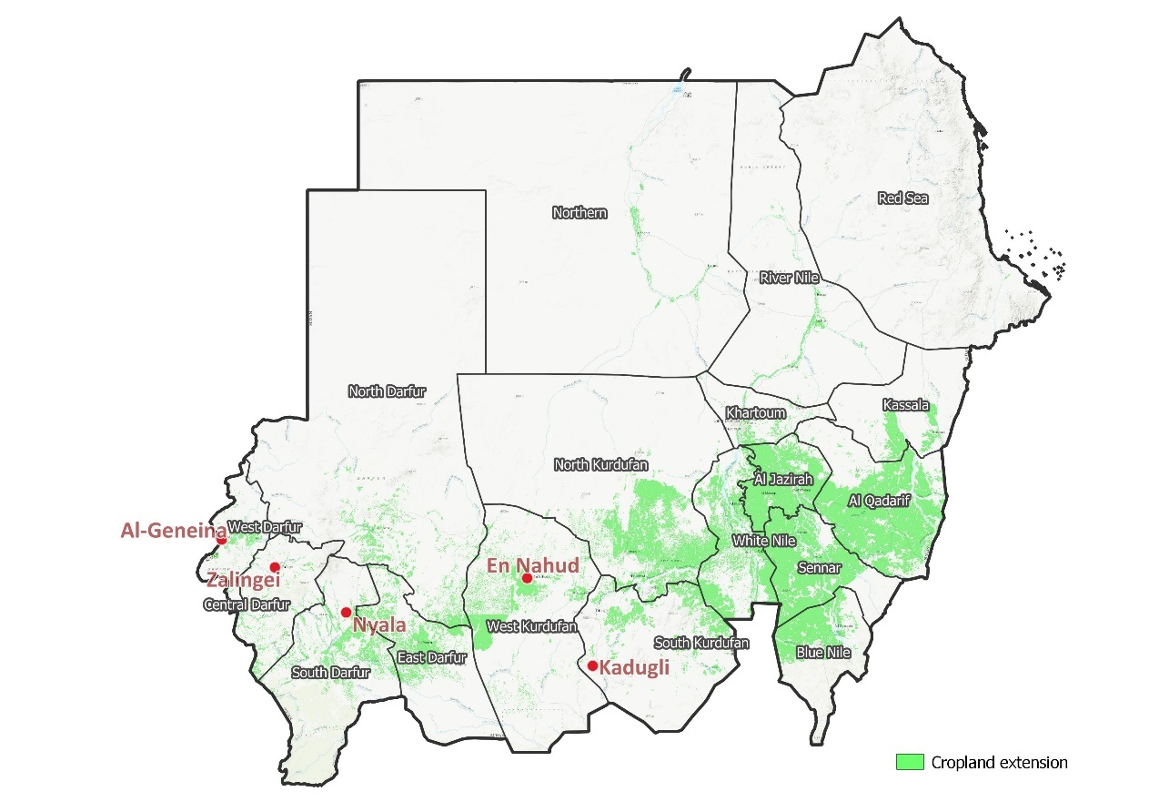
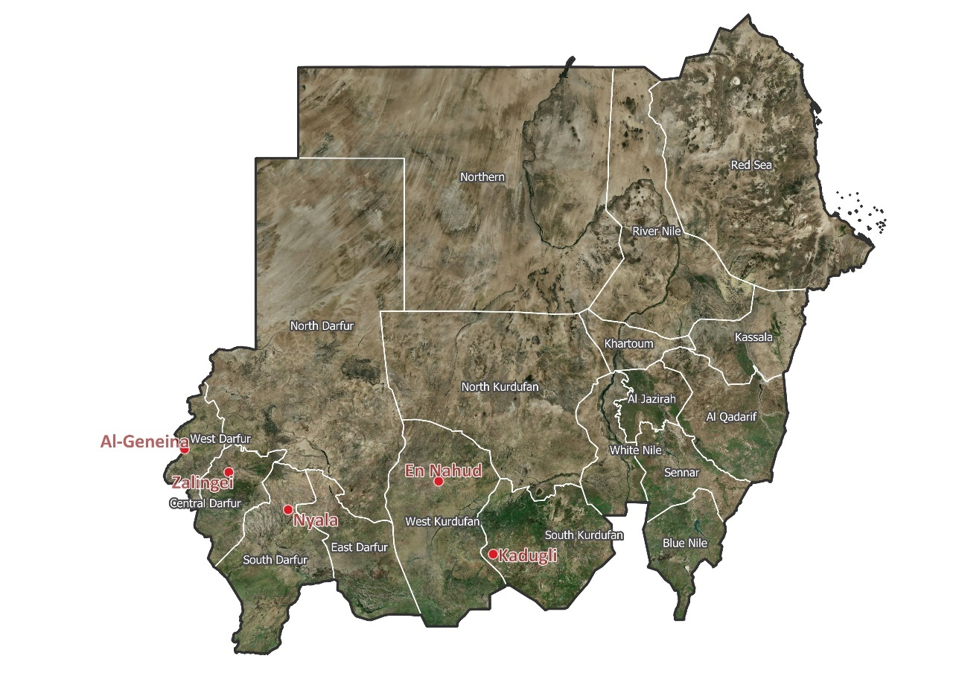

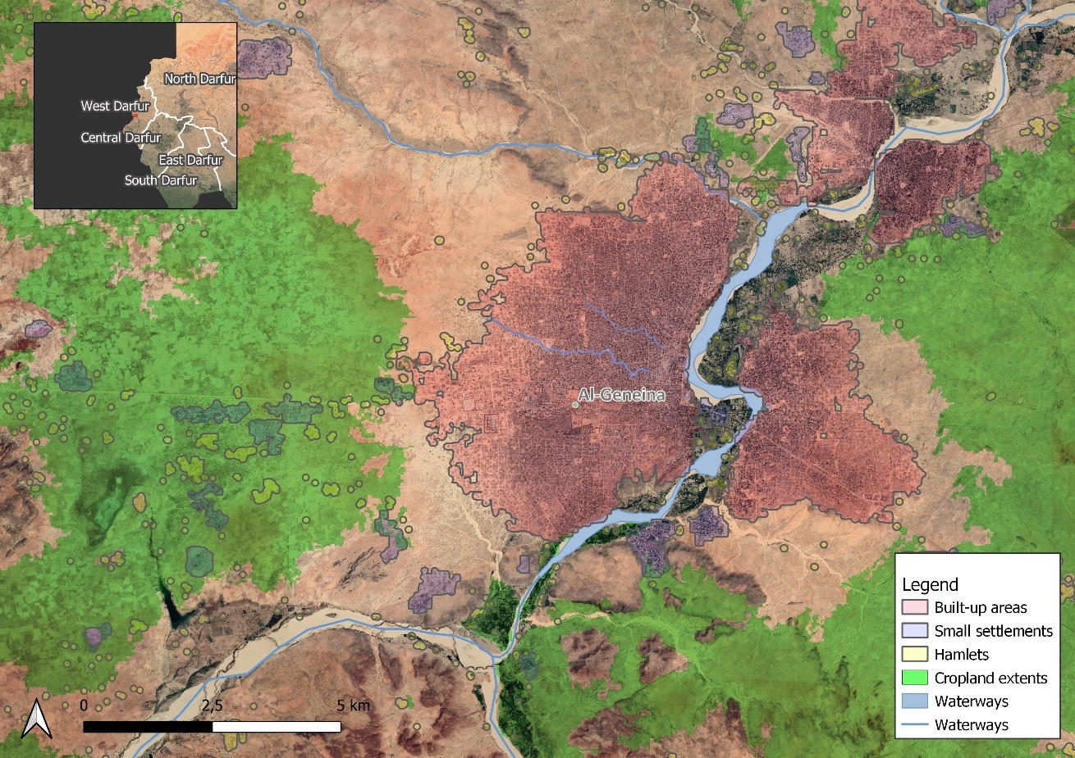

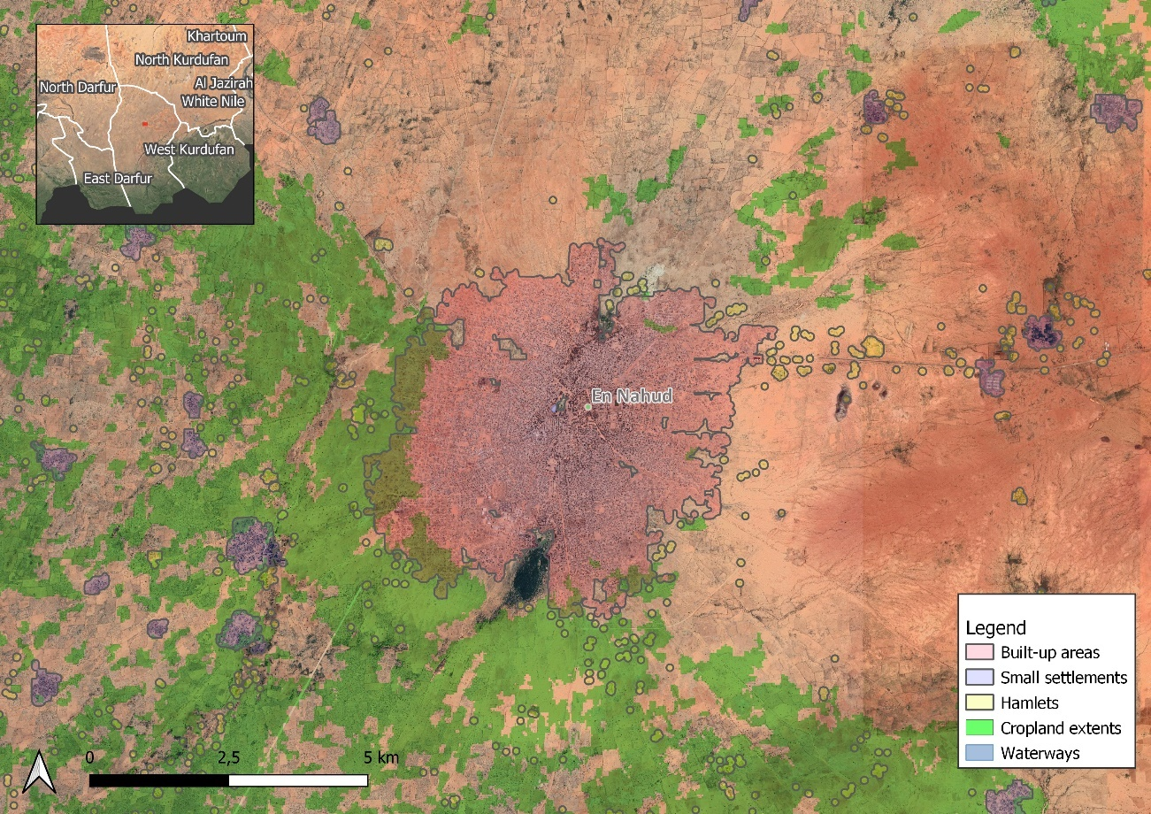

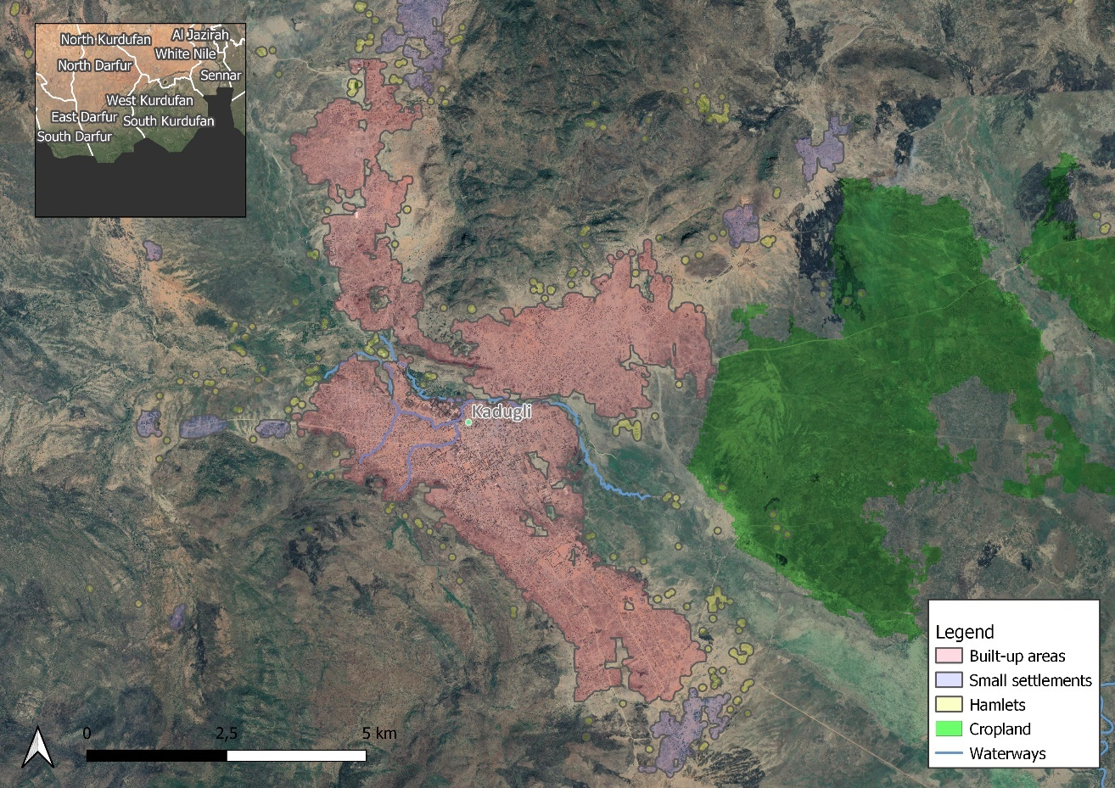

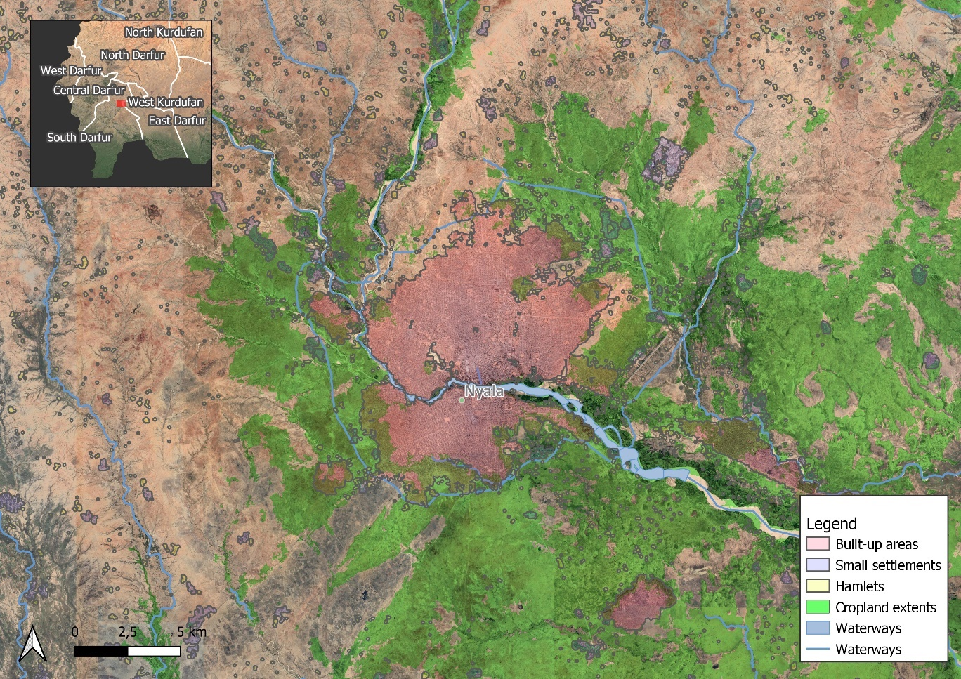
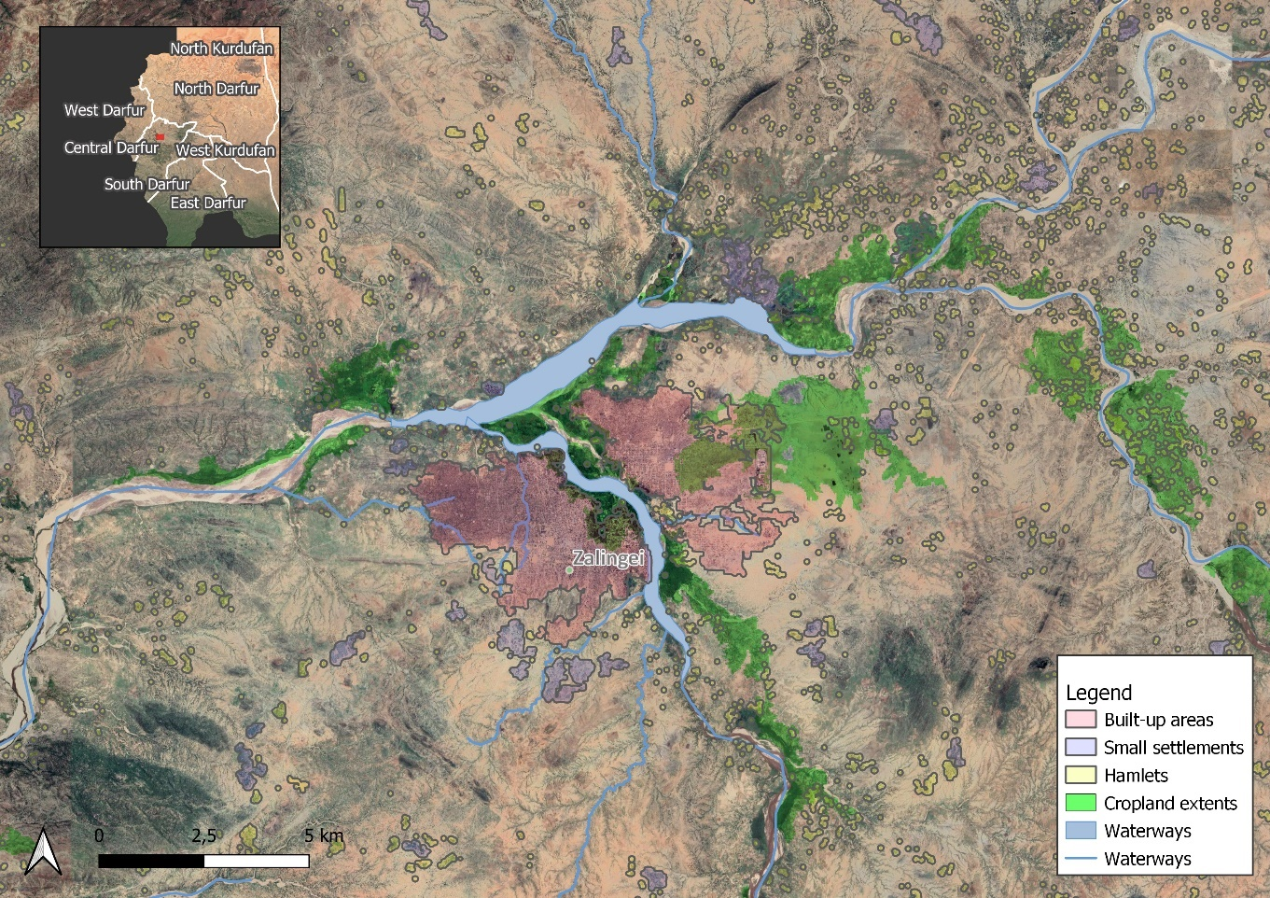

Separate to this Annex the above images are provided in high resolution.

Annex 3: Multi Year Work Plan

Output multi-year Work Plan
 |  |  | Year 1 |  |  |  | Year 2 |  |  |  | Year 3 |  |  |  | Year 4
 |  |  | Q1 | Q2 | Q3 | Q4 | Q1 | Q2 | Q3 | Q4 | Q1 | Q2 | Q3 | Q4 | Q1 | Q2 | Q3 | Q4
Outcome 1.1.  Stakeholder ownership in a national minigrid delivery model is advanced, and appropriate policies and regulations are adopted to facilitate investment in low-carbon minigrids | 1.1.1 | Mini-grid delivery model(s) identified from national dialogues on minigrid delivery models
 | 1.1.2 | Registration process for Low Voltage minigrids in place and disseminated
 | 1.1.3 | A full minigrid regulatory framework is in place and adopted by MoEM and ERA through a series of inclusive national dialogues, with a streamlined licensing process and clear rules and requirements defined.
 | 1.1.4 | Minigrid DREI techno-economic analyses carried out to propose most cost-effective basket of policy and financial de-risking instruments and contribute to AMP Flagship Report on Cost Reduction
 | 1.1.5 | Pre-feasibility studies for mini-grid sites to enhance sector planning and decision-making on a delivery model
 | 1.1.6 | Capacitate public institutions, in particular MEM and ERA on technical, managerial, and regulatory issues
Outcome 2.1.  Innovative business models based on cost reduction are operationalized, with strengthened private sector participation in solar PV-battery or low-carbon minigrid development | 2.1.1 | Two to four solar PV diesel hybrids successfully implemented, operational, and maintained by the private sector, involving women’s vocational training and participation. Leading to a cost reduction in minigrids
 | 2.1.2 | Capacity of potential tender bidders (private sector developers) strengthened to consider innovative business models and cost-reduction levers. This output will also benefit from Activity 3.1.2.1 (hands-on coaching on minigrid developers)
 | 2.1.3 | A “solar sister” programme is in place, that supports and capacitates Sudanese women on technical, managerial, and economic aspects of solar hybrid minigrids
Outcome 3.1.  Innovative financing mechanisms explored at local and regional level, and final design options with recommendations on financing needs and opportunities for the uptake of both (i) solar PV greenfield minigrids, and (ii) solar PV hybridization in brownfield minigrids | 3.1.1 | Design support for minigrid innovative financing mechanisms
 | 3.1.2 | Financing needs to support the uptake of minigrids are assessed and identified
 | 3.1.3 | A pipeline of investible assets in unelectrified communities in Sudan
Outcome 4.1.  Digitalization and data mainstreamed, across stakeholders, in particular into the existing public minigrid infrastructure where digital data is non existing. Increased knowledge, awareness and network opportunities in the minigrid market among stakeholders, including benefiting from linkages to international good practices | 4.1.1 | A Digital Strategy is developed and implemented, including linkages to an following guidance from the regional project
 | 4.1.2 | Minigrids digital platform implemented to run tenders and manage data from pilots, and to support minigrids scale-up and cost-reduction
 | 4.1.3 | A Quality Assurance and Monitoring Framework (QAMF) for measuring, reporting and verification of the sustainable development impacts of all minigrids pilots supported, including GHG emission reductions, is adopted an operationalized based on standardized guidance from the regional project

Annex 4: Monitoring Plan
This Monitoring Plan and the M&E Plan and Budget in Section VI of this project document will both guide monitoring and evaluation at the project level for the duration of project implementation.

Monitoring | Indicators | Targets | Description of indicators and targets | Data source/Collection Methods | Frequency | Responsible for data collection | Means of verification | Risks/Assumptions
Project objective from the results framework | Mandatory Indicator 1:  Greenhouse gas emissions mitigated (metric tons of carbon dioxide equivalent)  (Units of measure: metric tons of CO2e) | Mid Term: Zero, since the pilot project won’t be commissioned  End Term  Direct: 61,932 tCO2e  Indirect: 1,944,000 tCO2e (90% of the total estimation for this project) | GHG emissions mitigation will be achieved by the installation of solar PV power plants into existing diesel off-grid stations | Generation and consumption data from the meters and monitoring platform | Quarterly after pilot project completion | - Project M&E Officer, Ministry of Energy and Petroleum  - STGC  - Private sector operator | - Mini-grid monitoring platform  - Consultant reporting on Mid-Term Report  - kWh produced by solar PV plant that have displaced diesel usage  - National statistics report | The potential for reducing diesel consumption and displacing CO2 emissions within the existing off-grid stations in Sudan is very high. Through the phased-approach this project aims at reducing (i) 20-30% of the existing diesel consumption by year 2 by only adding a solar PV plant and (ii) 30-75% diesel consumption reduction by expanding the solar PV power plant and adding storage
Project objective from the results framework | Mandatory Indicator 2: Number of direct beneficiaries disaggregated by gender (and customer segment) as co-benefit of GEF investment | Mid-term  -------  End-term  144,002 people (of which 50% women)  -------  136,521  people (residential)  1,298  people (social)  6,183  people (commercial/PUE)  144,002 people (total)  ---  22,754  connections (residential)  433  connections (social)  1,546  connections (commercial/PUE)  24,732  connections (total) | The targets reflect the direct beneficiaries targeted by outcomes involving the project pilots. The mid term target number comes from the existing number of connections in both sites | Generation and consumption data from the monitoring platform Number of meters active in each location after the commissioning of the PV plans in each location | Quarterly after pilot project completion | - Project M&E Officer, Ministry of Energy and Petroleum  - SEDG  - Private sector operator | - Consultant reporting on Mid-Term Report  - Mini-grid monitoring platform  - Active meters registry by SEDG  - National statistics report | This indicator aims at monitoring the number of beneficiaries that are directly impacted by the pilot project intervention, reducing the diesel consumption of the existing energy infrastructure in the selected places.  1 HH is composed of 6 people, 3 females and 3 males
Project objective from the results framework | Indicator 3: Sub-indicator 6.4: Increase in installed solar PV capacity (MW) and battery storage (MWh) | Mid Term  2.5MW  End Term  2.5 MW installed PV capacity  6.93 MWh installed batter storage | The target is the installed capacity of solar PV in the selected 2 pilots (Mid term) and other sites as a replication of the model or expansion within the 2 pilots (End term) | - Commissioning reports of the PV power plants by STGC and private sector  - Remote monitoring data collected on the power generation side | Annually | - Project M&E Officer, Ministry of Energy and Petroleum  - STGD  - Private sector operator | - Mini-grid monitoring platform  - Consultant reporting on Mid-Term Report  - National statistics report | Risk: If the private sector does not respond positively to the CfP for co-investing and operating the solar PV plants in the selected sites these targets won’t be achieved  Assumption: project will happen in the phased-approach detailed above. In the first phase only solar PV power plants will retrofit the diesel generators (quick) and during the second phase more solar PV and electrical storage will be added
Project objective from the results framework | Additional Indicator 4: Jobs directly created by the programme disaggregated by gender(number of jubs) | Mid-Term  Female:6  Male: 6  Total: 12  End-Term  Female: 20  Male: 20  Total: 40 | This indicator measures the directly new jobs created by this programme intervention. | - Number of people employed by IP through contracts  - Number of people employed by the private sector for this project | Annually | Project M&E Officer, Ministry of Energy and Petroleum  Private sector reporting | - Consultant reporting on Mid-Term Report  - Consultant reporting on End-Term Report  - National statistics report | Only through the execution of pilot projects there will be jobs created during the installation of the infrastructure and after its commissioning during O&M.
Project Outcome 1 | Indicator 5: Number of policy derisking instruments for minigrid investments identified and endorsed by the national government (number of policy derisking instruments) | Mid Term:  2 policy derisking instrument(s)  End Term:  4 policy derisking instrument(s) | This indicator will measure policy instruments such us policy regulations, call for proposals, declaration of intentions, analysis that will derisk the investment in minigrids | DREI analysis  Feasibility analysis  Increase in overall data availability and transparency by the sector | Annually | - Project M&E Officer, Ministry of Energy and Petroleum  - ERA | - Consultant reporting on Mid-Term Report  - Consultant reporting on End-Term Report | The minigrid sector in Sudan can be easily de-risked by the overall AMP Sudan intervention and the appetite from developers/private sector/non profit is expected to be high
Project Outcome 1 | Indicator 6: Indicator 6: A mini-grid delivery model and roadmap to enable minigrid development is endorse/adopted by the national government through a consultative process involving key stakeholders (MoEP, ERA, private sector, gender representatives, community representatives, PA, WB, etc.)  (binary (1/0)) | Mid Term:  Multi-stakeholder, national dialogue platform on minigrid delivery models established and active (1)  End Term: 1  At least one minigrid delivery model is identified and endorsed by the government through the work of the multi-stakeholder platform and dialogue (1) | A roadmap clearly outlining how MoEP and GoS intend to deploy minigrids in Sudan to achieve SDG and the role of various stakeholders, including the private sector | - | Annually | - Project M&E Officer, Ministry of Energy and Petroleum  - ERA | - Consultant reporting on Mid-Term Report  - Consultant reporting on End-Term Report
Project Outcome 1 | Indicator 7: Number of bottom-up minigrid proposals put forward to MoEP and ERA (number of proposals) | Mid term:  5  End term:  30 | This indicator measures the proposals to develop new mini-grids by the private sector, NGO or state governments to ERA/MoEP as a result of the light-handed regulations activity (1.1.1.1) | Proposals submitted to MoEP and ERA | Bi-annually | - Project M&E Officer, Ministry of Energy and Petroleum  - ERA | - Mini-grid monitoring platform  - Consultant reporting on Mid-Term Report  - Consultant reporting on End-Term Report | Risk: despite the regulatory initial efforts of this project, there is not enough incentive to develop minigrids in Sudan because of macro issues (currency exchange, political, etc)
Project Outcome 1 | Indicator 8: Mini-grid DREI applications and geospatial modeling least-cost off-grid electrification options | Mid term:  A full quantitative DREI application is conducted  End term:  DREI analyses refreshed to track evolutions in financing costs as well as in hardware and soft costs and presented for government endorsement. |  | DREI analysis conducted | Annually | - Project M&E Officer, Ministry of Energy and Petroleum | - Mini-grid monitoring platform  - Consultant reporting on Mid-Term Report  - Consultant reporting on End-Term Report
Project Outcome 2 | Indicator 9: Minigrid pilots with private sector engagement implemented that demonstrate a delivery model, cost-reduction measure(s) and/or productive use of electricity (binary (1/0)) | Mid-term:  The project’s detailed design plan (the ‘Minigrid Pilot Plan’) for advancing the minigrid pilots is developed, and cleared by UNDP and the Project Board. (1)  Any project tendering process, as applicable, for minigrid pilots is launched. (1)  End-term:  100% of the planned minigrid pilots, as identified in the project’s Minigrid Pilot Plan, are commissioned. (1) | Number of solar PV power plants that are retrofitting existing diesel-based minigrids with private sector engagement out of the total number of f power plants as per the ‘Minigrid Pilot Plan’  2 is the indicative number of PV power plants the pilot project targets. 4 is the foreseen immediate replication if pilots are successful within the project timeline’s horizon. | - Commissioning repots of the PV power plants by STGC and private sector  - Remote monitoring data collected on the power generation side | Annually | - Project M&E Officer, Ministry of Energy and Petroleum  - STGD  - Private sector operator | - Consultant reporting on Mid-Term Report  - Consultant reporting on End-Term Report  - Mini-grid monitoring platform | Risk is that the private sector do not find enough to co-invest and operate these assets  Assumption is that after the two proposed pilots more projects will follow a similar arrangement and delivery model
Project Outcome 2 | Indicator 10: Number of women trained in design, O&M and other aspects of solar PV minigrids | Mid term:  40  End term:  100 |  | - Reports submitted by the Consultants engaged in capacity building activities.  - Records of training attendance. | Annually | - Project M&E Officer, Ministry of Energy and Petroleum  - Women’s group | - Consultant reporting on Mid-Term Report  - Consultant reporting on End-Term Report
Project Outcome 2 | Indicator 11: Capacity of minigrid developers and operators is enhanced to implement innovative business models and incorporate cost-reduction levers in minigrid projects | Mid term:  Planned capacity building activities for year 1 and 2 are implemented. (1)  + The capacity of targeted recipients is assessed by survey towards the end of year 2. On a scale of 1 to 5, an average score of at least 2 is achieved.  - 1 represents a low level of capacity  - 5 represents a strong capacity to understand relevant issues and apply knowledge and skills to find effective solutions. (1)  End term:  Planned capacity building activities for year 3 and 4 are implemented. (1)  + The capacity of targeted recipients is assessed by survey towards the end of the project. On a scale of 1 to 5, an average score of at least 4 is achieved.  - 1 represents a low level of capacity  - 5 represents a strong capacity to understand relevant issues and apply knowledge and skills to find effective solutions. (1) |  | - Reports submitted by the Consultants engaged in capacity building activities.  - Records of training attendance. | Annually | - Project M&E Officer, Ministry of Energy and Petroleum  - Private sector self-reporting
Project Outcome 3 | Indicator 12: Capacity of financial institutions is enhanced through training, knowledge sharing, and/or awareness raising events aimed at increasing the financial sector’s capacity to evaluate investment in MG | Mid term:  Planned capacity building activities for year 1 and 2 are implemented. (1)  + The capacity of targeted recipients is assessed by survey towards the end of year 2. On a scale of 1 to 5, an average score of at least 2 is achieved.  - 1 represents a low level of capacity  - 5 represents a strong capacity to understand relevant issues and apply knowledge and skills to find effective solutions. (1)  End term:  Planned capacity building activities for year 3 and 4 are implemented. (1)  + The capacity of targeted recipients is assessed by survey towards the end of the project. On a scale of 1 to 5, an average score of at least 4 is achieved.  - 1 represents a low level of capacity  - 5 represents a strong capacity to understand relevant issues and apply knowledge and skills to find effective solutions. (1) |  | - Reports submitted by the Consultants engaged in capacity building activities.  - Records of training attendance. | Annually | - Project M&E Officer, Ministry of Energy and Petroleum  - Financial institutions self reporting | - Consultant reporting on Mid-Term Report  - Consultant reporting on End-Term Report
Project Outcome 3 | Indicator 13: Number of government or impact investor-supported financing mechanisms offering concessional finance for low carbon minigrids | Mid term:  Zero, since the activities for this indicator won’t be reached yet  End term:  The capacity of targeted recipients is assessed by survey towards the end of the project. On a scale of 1 to 5, an average score of at least 4 is achieved.  - 1 represents a low level of capacity  - 5 represents a strong capacity to understand relevant issues and apply knowledge and skills to find effective solutions. (1) |  | Reports produced coming out of Component 3 | On year 3 | MoEP  Project board | - Consultant reporting on End-Term Report
Project Outcome 3 | Indicator 14: Number of market intelligence reports completed (disaggregated by geographical location) | Mid term:  1  End term:  3 |  | - Report submitted by the Consultants engaged in the market intelligence report  - Through the mini-grid digital platform | On year 3 | MoEP  ERA | - Consultant preparing the market intelligence report  Consultant reporting on Mid-Term Report  - Consultant reporting on End-Term Report
Project Outcome 4 | Indicator 15: A Digital strategy for the project is prepared and implemented by the relevant PMU to contribute to project implementation and local minigrid market development | Mid-term:  Digital strategy is prepared, in consultation with public and private parties, and close collaboration with the AMP Regional Project.  End-term:  The strategy is implemented and staff members in public authorities, including women, are capacitated to utilize the associating tools and reporting procedure.  Recommendations for rolling out digital solutions for minigrids at national level have been shared with key national stakeholders. (1)
Project Outcome 4 | Indicator 16: Number of replication plans, including detailed budgets, for scaling up the deployment of sustainable minigrids in Sudan | Mid-term:  1  End-term:  2 |  | Reports coming out of the various consultancies/assignments | Annually, after year 2 | - Project M&E Officer, Ministry of Energy and Petroleum | - End-Term Report  - Minigrid digital platform | If the pilot project delivery model is successful there are many other off-grid stations that can be retrofitted  Outside the hybridization model, it is assumed green minigrids (newly developed minigrids) will also happen
Project Outcome 4 | Indicator 17: Minigrid pilots sharing data on minigrid performance with the regional project and other stakeholders following best practices and guidance provided by the AMP regional project (binary (1/0)) | Mid-term:  The project’s ‘Minigrids Digital and Data Management Platform’ is procured and operational, ready for data collection from the project’s mini-grid pilot(s), and for data sharing with the AMP regional project’s digital platform. (1)  30% of the planned minigrid pilots, as identified in the project’s Minigrid Pilot Plan, are collecting and sharing data with the AMP Regional Project [at least on a quarterly basis] using the project’s ‘digital & data management platform’ (1)  End-term:  100% of the planned minigrid pilots, as identified in the project’s Minigrid Pilot Plan, are collecting and sharing data with the AMP Regional Project [at least on a quarterly basis] using the project’s ‘digital & data management platform’ (1) |  |  | Annually | - Project M&E Officer, Ministry of Energy and Petroleum | - Minigrid digital platform  - Reports

Annex 5: UNDP Social and Environmental Screening Procedure (SESP)

Project Information

Project Information
1. Project Title | National child project under the GEF Africa Mini-grids Program
2. Project Number r (i.e. Atlas project ID, PIMS+) | UNDP ID 6321
3. Location (Global/Region/Country) | Sudan
4. Project stage (Design or Implementation) | Design stage
5. Date | 19-03-2021

Part A. Integrating Programming Principles to Strengthen Social and Environmental Sustainability

QUESTION 1: How Does the Project Integrate the Programming Principles in order to Strengthen Social and Environmental Sustainability?
Briefly describe in the space below how the project mainstreams the human-rights based approach
Rights holders are women and men, a great number belongs to the poor and marginalized sector such as customary community groups, rural population and resource dependent groups. This project will ensure that their rights are exercised by facilitating their own capacity to think, act, organize, and advocate these rights; and

Primary duty-bearers comprise the State, with all its provincial agencies and institutions, and the staff dedicated to the project. This project will ensure their mandate will respect, protect, promote and fulfill the rights of the poor and marginalized sectors/groups in all spheres of life.

The project addresses the human rights to sustainable development through the provision of measures to prevent the potential pollution from batteries and e-waste used at the project, as well as the monitored reduction of greenhouse gases emissions. Likewise, the project addresses the human rights to poverty alleviation and sustaining peace by taking into account the local communities as a workforce, including the fuel/energy sellers from the informal sector. Similarly, the project will ensure fair distribution of development opportunities and benefits through the empowerment of disadvantaged groups for example by capacity building.

Altogether, the project fully incorporates the human Leave No One Behind approach, in particular through ensuring the participation, inclusion, equality and non-discrimination of disadvantaged groups (marginalized, discriminated and excluded), including the informal sector. This is achieved by design in the project, to empower them as active agents of the development process, facilitating their participation on the project design and implementation through the requirements established in this report. Similarly, the requirements here include actions to be taken related to advocacy, creating enabling environments, capacity development and support for civil society, community empowerment, and enhancing the quality and accessibility of services.

Across all project components, activities include the participation of varied stakeholders through capacity building strategies at the policy, program, monitoring and evaluation, knowledge management on environmental conservation, human rights, gender equality, and social protection perspectives so that the intended project results are achieved also beyond the project cycle.

Briefly describe in the space below how the project is likely to improve gender equality and women’s empowerment
As the implications of gender in the sector are not fully understood or appreciated, a gender analysis has been conducted during project preparation to fully gauge the gender implications, identify possible interventions that can meaningfully improve and enhance women’s participation, and develop specific indicators and targets related to gender equality. Based on that a gender action plan has been established at the same phase for the preparation of specific investment interventions that will include along the whole project cycle special attention for vulnerable groups, especially women and girls, who face multiple and intersecting forms of discrimination in the energy sector and in general in the society. Women are often marginalized and excluded from other forms of formal participation in the sector and the economy; often, they are reduced to the lower positions in the job market and as beneficiaries.

Briefly describe in the space below how the project mainstreams sustainability and resilience
The project is primarily focused on environmental sustainability. It should be noted that no activities that could cause harm may proceed until assessments are undertaken and management plans are in place for specific sites. The monitoring, reporting and verification (MRV) system that will be set up by the project will include social, environmental and financial indicators to safeguard the improvement of the individuals and local communities, with an emphasis on the most vulnerable groups and individuals identified. Additionally, a comprehensive Quality Assurance Framework (QAF) is expected to be operationalized through technical support from the regional AMP. Finally, the mechanisms established in this report will help to strengthen the enforcement of existing laws interacting with the energy sector in order to fulfil public services while promoting the vulnerable groups and their human rights involved to achieve such task.

Briefly describe in the space below how the project strengthens accountability to stakeholders
The stakeholder engagement plan, the information disclosure process, the grievance redress and the accountability mechanisms will strengthen remarkably the accountability of the most vulnerable groups and individuals affected by the Project both directly and indirectly at a fair level to the conventional groups. These processes and mechanisms have been established at the design phase and will continue along the project cycle. For example, to achieve this a multi-stakeholder platform will be set up to enhance horizontal participation and will include representatives from a varied range of groups in society.

Part B. Identifying and Managing Social and Environmental Risks

Project Information

Project Information
1. Project Title | National child project under the GEF Africa Mini-grids Program
2. Project Number r (i.e. Atlas project ID, PIMS+) | UNDP ID 6321
3. Location (Global/Region/Country) | Sudan
4. Project stage (Design or Implementation) | Design stage
5. Date | 19-03-2021

Part A. Integrating Programming Principles to Strengthen Social and Environmental Sustainability

QUESTION 1: How Does the Project Integrate the Programming Principles in order to Strengthen Social and Environmental Sustainability?
Briefly describe in the space below how the project mainstreams the human-rights based approach
Rights holders are women and men, a great number belongs to the poor and marginalized sector such as customary community groups, rural population and resource dependent groups. This project will ensure that their rights are exercised by facilitating their own capacity to think, act, organize, and advocate these rights; and

Primary duty-bearers comprise the State, with all its provincial agencies and institutions, and the staff dedicated to the project. This project will ensure their mandate will respect, protect, promote and fulfill the rights of the poor and marginalized sectors/groups in all spheres of life.

The project addresses the human rights to sustainable development through the provision of measures to prevent the potential pollution from batteries and e-waste used at the project, as well as the monitored reduction of greenhouse gases emissions. Likewise, the project addresses the human rights to poverty alleviation and sustaining peace by taking into account the local communities as a workforce, including the fuel/energy sellers from the informal sector. Similarly, the project will ensure fair distribution of development opportunities and benefits through the empowerment of disadvantaged groups for example by capacity building.

Altogether, the project fully incorporates the human Leave No One Behind approach, in particular through ensuring the participation, inclusion, equality and non-discrimination of disadvantaged groups (marginalized, discriminated and excluded), including the informal sector. This is achieved by design in the project, to empower them as active agents of the development process, facilitating their participation on the project design and implementation through the requirements established in this report. Similarly, the requirements here include actions to be taken related to advocacy, creating enabling environments, capacity development and support for civil society, community empowerment, and enhancing the quality and accessibility of services.

Across all project components, activities include the participation of varied stakeholders through capacity building strategies at the policy, program, monitoring and evaluation, knowledge management on environmental conservation, human rights, gender equality, and social protection perspectives so that the intended project results are achieved also beyond the project cycle.

Briefly describe in the space below how the project is likely to improve gender equality and women’s empowerment
As the implications of gender in the sector are not fully understood or appreciated, a gender analysis has been conducted during project preparation to fully gauge the gender implications, identify possible interventions that can meaningfully improve and enhance women’s participation, and develop specific indicators and targets related to gender equality. Based on that a gender action plan has been established at the same phase for the preparation of specific investment interventions that will include along the whole project cycle special attention for vulnerable groups, especially women and girls, who face multiple and intersecting forms of discrimination in the energy sector and in general in the society. Women are often marginalized and excluded from other forms of formal participation in the sector and the economy; often, they are reduced to the lower positions in the job market and as beneficiaries.

Briefly describe in the space below how the project mainstreams sustainability and resilience
The project is primarily focused on environmental sustainability. It should be noted that no activities that could cause harm may proceed until assessments are undertaken and management plans are in place for specific sites. The monitoring, reporting and verification (MRV) system that will be set up by the project will include social, environmental and financial indicators to safeguard the improvement of the individuals and local communities, with an emphasis on the most vulnerable groups and individuals identified. Additionally, a comprehensive Quality Assurance Framework (QAF) is expected to be operationalized through technical support from the regional AMP. Finally, the mechanisms established in this report will help to strengthen the enforcement of existing laws interacting with the energy sector in order to fulfil public services while promoting the vulnerable groups and their human rights involved to achieve such task.

Briefly describe in the space below how the project strengthens accountability to stakeholders
The stakeholder engagement plan, the information disclosure process, the grievance redress and the accountability mechanisms will strengthen remarkably the accountability of the most vulnerable groups and individuals affected by the Project both directly and indirectly at a fair level to the conventional groups. These processes and mechanisms have been established at the design phase and will continue along the project cycle. For example, to achieve this a multi-stakeholder platform will be set up to enhance horizontal participation and will include representatives from a varied range of groups in society.

Part B. Identifying and Managing Social and Environmental Risks

QUESTION 2: What are the Potential Social and Environmental Risks?  Note: Complete SESP Attachment 1 before responding to Question 2. | QUESTION 3: What is the level of significance of the potential social and environmental risks?  Note: Respond to Questions 4 and 5below before proceeding to Question 5 |  |  | QUESTION 6: Describe the assessment and management measures for each risk rated Moderate, Substantial or High
Risk Description  (broken down by event, cause, impact) | Impact and Likelihood (1-5) | Significance (Low, Moderate, Substantial, High) | Comments (optional) | Description of assessment and management measures for risks rated as Moderate, Substantial or High
RISK 1: Risk on lack of capacities. The scope of this risk belongs to Overarching Principle 1 and Programmatic Principle 2.  Event: It may occur that the capacity of duty-bearers (e.g. government agencies, local skilled staff) for implementation of some project activities may be insufficient. Similarly occurs with the capacity of rights-holders (e.g. project-affected persons) to claim their rights. Cause: The project activities considered involve innovation and so that may be relatively new in the project's area of influence for both duty-bearers and right-holders. Also, the UNDP Universal Human Rights Index informs concerns in this country regarding the capacities of right-holder related groups and public officials/institutions. Impact: This may pose a potential harm to meeting the rights of right-holders. | I = 4  L = 3 | Substantial | This risk is relevant to the project activities supporting all components:  - Policy and regulations  - Project and Business Model Innovation with Private Sector Engagement  - Innovative Financing  - Digital, Knowledge management and M&E  This risk is not covered by the national legal requirements to conduct the project activities and/or when requirements are in place there are signs of been inconsistently enforced to the UNDP SES level. | As the project is Substantial risk, an ESMF has been prepared and annexed to the ProDoc. The ESMF covers all project risks. It contains procedures for the further screening, assessment and management measures that are required during the project’s implementation for compliance with the SES.  A Stakeholder Engagement Plan has been prepared to manage this risk. See ESMF Attachment II (Risks A&M specifications) for details of assessment and management of this risk and all others.
RISK 2: Risk of project activities not being safeguards responsive during the project life cycle.  . The scope of this risk belongs to Overarching Principle 1 and Programmatic Principle 2.  Risk description: See tools implemented for the Programmatic Principles 3 and 5, Standards 3-7. | I = 3  L = 4 | Moderate | Note that prohibited grounds of discrimination include race, ethnicity, sex, age, language, disability, sexual orientation, gender identity, religion, political or other opinion, national or social or geographical origin, property, birth, health status or other status including as an indigenous person or as a member of a minority.  Unless safeguard measures are applied and enforced in terms of project interventions and future replicates when market escalates, the reality on the ground is that government policy decisions and investment promotion strategies take limited consideration of certain environmental and social aspects. A transversal aspect that could pose an unintended impact, particularly from the duty-bearers end. Therefore, this risk is relevant to the project activities supporting all components:  - Policy and regulations  - Project and Business Model Innovation with Private Sector Engagement  - Innovative Financing  - Digital, Knowledge management and M&E | See ESMF Attachment II for details of assessment and management of this risk.
RISK 3: Risk of exclusion of affected stakeholders due to their vulnerability and/or potential concerns about the project. The scope of this risk belongs to Programmatic Principle 5.  Event: Stakeholders may be excluded at the participatory/beneficial activities of the project, and/or retaliation/reprisals may occur based on their grievances and objections . Cause: The UNDP Universal Human Rights Index informs concerns in this country regarding the situation of vulnerable groups/persons and some forms of freedom. And, there is no evidence that the national regulatory framework requires and/or implements clear practices at mini-grid projects for the inclusion of all potentially affected stakeholders, in particular disadvantaged groups, to fully participating in decisions that may affect them for the type of activities included in this project. Similarly, there is no evidence that grievances or objections from these same stakeholders are being managed and resolved as a usual practice through internationally recognized methods. Impact: This may pose a challenge to ensure that affected stakeholders will fully participate in decisions that will affect them, they will feel safe to express grievances or objections, these will be taken into account, and no retaliation or reprisals will take place against those stakeholders who express concerns or grievances or seek to participate or obtain information on the project. | I = 3  L = 4 | Moderate | This risk is relevant to the project activities supporting the following components:  - Policy and regulations  - Project and Business Model Innovation with Private Sector Engagement  - Innovative Financing  - Digital, Knowledge management and M&E  This risk is not covered by the national legal requirements to conduct the project activities and/or when requirements are in place there are signs of been inconsistently enforced to the UNDP SES level. | A Stakeholder Engagement Plan has been prepared to manage this risk. A project-level GRM will be put in place.  See ESMF Attachment II for details of assessment and management of this risk.
RISK 4: Risk on Women. The scope of this risk belongs to Programmatic Principle 3.  Event: Women may be excluded at the participatory/beneficial activities of the project. Cause: The male oriented nature of energy and the limited social statues and opportunities identified for women. Impact: This may pose a challenge to ensure that women will have the chance to participate at the decisions-making level. | I = 4  L = 4 | Substantial | Unless safeguard measures are applied and enforced in terms of project interventions and future replicates when market escalates, the reality on the ground is that decisions and investment promotion strategies take limited consideration on the involvement of women from the participatory and beneficial aspects. A transversal aspect that could pose an unintended impact, particularly from the duty-bearers end. Therefore, this risk is relevant to the project activities supporting all components:  - Policy and regulations  - Project and Business Model Innovation with Private Sector Engagement  - Innovative Financing  - Digital, Knowledge management and M&E  Gender empowerment is a core objective of the project. If no mitigation or management measures within the Environmental and Social safeguards were to be put in place this risk would be important given the male oriented nature of energy and the limited social statues and opportunities identified for women. | Measures have been established through the Gender Analysis and Action Plan established at the PPG phase, to manage and reduce the risks identified on women.  See ESMF Attachment II for details of assessment and management of this risk.
RISK 5: Risk of damage to biodiversity and natural resources due to land changes and new productive uses of the energy. The scope of this risk belongs to Project Standard 1.  Event: It may occur that they are within critical habitats and/or environmentally sensitive areas, will require changes to the use of lands and resources, and therefore will affect the ecosystems in it. This may be particularly important for productive use of the energy generated depending on the type of sector and activity to support. Cause: All mini-grids involve the construction of new infrastructure, and this is especially the case where mini-grids are “greenfield” (i.e. where there was little to no preexisting infrastructure.). New built structures alien to the pre-existing conditions in the area are an alteration, in essence, of the biodiversity and natural resources in the project area of influence. Impact: At the construction stage, expected impacts related to the removal and displacement of the existing natural resources to allow the new structures to be built. At the operational stage, expected impacts related to, for example, maintaining natural resources not needed by the project to a minimal despite their natural reproduction/growth. Furthermore, mini-grids with a productive use entail unforeseen impacts should be expected according to the type of sector and activity to develop. And at the decommission stage, since the project will leave in place a built structure alien to pre-existing conditions in the area, the recovery of the original habitat and/or ecosystems and/or ecosystem services will be challenged. | I = 3  L = 4 | Moderate | This risk is relevant to the project activities supporting the following components:  - Policy and regulations  - Project and Business Model Innovation with Private Sector Engagement  - Innovative Financing  - Digital, Knowledge management and M&E  Sudan involves higher risk because more complexity due to the potential involvement of hybrid mini-grids with existing fossil fuels (i.e. diesel) systems, its national legal framework on environmental safeguards underdevelopment.  Output specifics:  - This risk applies to activities related to implementing pilots and their M&E but also to policy and regulatory activities due to the indirect potential impacts, for example, if they lead to expanded minigrid coverage after the project across the country. | Country specifics:  - At the time of this document no information was yet available to study this risk at the site level. Therefore, to be conservative, it is realistic to assume that each site will require assessment and management. Potential gaps to be addressed will be identified through the gap analysis as indicated in the ESMF.  The necessary management plan/measures will be put in place as part of ESMP(s), based on the ESIAs.  See ESMF Attachment II and XIV for details of assessment and management of this risk.
RISK 6: Adverse transboundary environmental concerns. The scope of this risk belongs to Project Standard 1.  Event: It may occur that the equipment/materials for the project will affect the ecosystems at a transboundary level. Cause: All mini-grids involve the procurement and management of new equipment/chemicals outsourced internationally and are regarded as very challenging from the sustainability perspective. Impact: Expected environmental impacts related to the procurement of equipment/materials outside the project influence | I = 3  L = 3 | Moderate | This risk is relevant to the project activities supporting the following components:  - Policy and regulations  - Project and Business Model Innovation with Private Sector Engagement  - Innovative Financing  - Digital, Knowledge management and M&E  Sudan involves higher risk because national legal framework on environmental safeguards under development.  Output specifics:  - This risk applies to activities related to implementing pilots and their M&E but also to policy and regulatory activities due to the indirect potential impacts, for example, if they lead to expanded minigrid coverage after the project across the country. | Country specifics:  - At the time of this document no information was yet available to study this risk at the site level. Therefore, to be conservative, it is realistic to assume that each site will require assessment and management. Potential gaps to be addressed will be identified through the gap analysis as indicated in the ESMF.  The necessary management plan/measures will be put in place as part of ESMP(s), based on the ESIAs.  See ESMF Attachment II for details of assessment and management of this risk.
RISK 7: Risk due to electrical shocks/effects on fauna, flora and people. The scope of this risk belongs to Project Standard 1 and 3.  Event: Electrical shocks/effects may occur in fauna, flora and people. Cause: All mini-grids involve electrical equipment. Impact: At the operational stage, the electrical structure alien to pre-existing conditions in the area, may cause the damage/death/fire/etc… due to the interaction with fauna and flora. | I = 3  L = 4 | Moderate | This risk is relevant to the project activities supporting the following components:  - Policy and regulations  - Project and Business Model Innovation with Private Sector Engagement  - Innovative Financing  - Digital, Knowledge management and M&E  Sudan involves higher risk because more complexity due to the involvement of hybrid mini-grids and the national legal framework on environmental safeguards underdevelopment.  Output specifics:  - This risk applies to activities related to implementing pilots and their M&E but also to policy and regulatory activities due to the indirect potential impacts, for example, if they lead to expanded minigrid coverage after the project across the country. | Country specifics:  - At the time of this document no information was yet available to study this risk at the site level. Therefore, to be conservative, it is realistic to assume that each site will require assessment and management. Potential gaps to be addressed will be identified through the gap analysis as indicated in the ESMF.  The necessary management plan/measures will be put in place as part of ESMP(s), based on the ESIAs.  See ESMF Attachment II for details of assessment and management of this risk.
RISK 8: Risk of local climate change events, and weather & hydro related disasters. The scope of this risk belongs to Project Standard 2.  Event: It is realistic to consider that climate events (i.e. earthquakes, floods, landslides, severe winds…) may occur in the project’s area of influence and may affect to the built structures. Cause: The global increase of future climate change and subsequent disaster. And, all mini-grids are open air structures exposed to climate events and involve build structures that may be vulnerable to the impacts of climate change or disasters. Impact: They could increase climate related effects and the number of disasters in the project area. | I = 3  L = 3 | Moderate | This risk is relevant to the project activities supporting the following components:  - Policy and regulations  - Project and Business Model Innovation with Private Sector Engagement  - Innovative Financing  - Digital, Knowledge management and M&E  Output specifics:  This risk applies to activities related to implementing pilots and their M&E but also to policy and regulatory activities due to the indirect potential impacts, for example, if they lead to expanded minigrid coverage after the project across the country. | Country specifics:  - At the time of this document no information was yet available to study this risk at the site level. Therefore, to be conservative, it is realistic to assume that each site will require assessment and management. Potential gaps to be addressed will be identified through the gap analysis as indicated in the ESMF.  The necessary management plan/measures will be put in place as part of ESMP(s), based on the ESIAs.  See ESMF Attachment II for details of assessment and management of this risk.
RISK 9: Risk of overestimated emissions due to embedded activities. The scope of this risk belongs to Project Standard 2.  Event: The procurement of equipment for the project will probably be outsourced internationally resulting in embedded emissions. Cause: All mini-grids involve solar panels and other activities that be imply indirect carbon emissions due to the project. Impact: They could decrease the calculated climate impact related to emissions avoided by the project. | I = 3  L = 3 | Moderate | This risk is relevant to the project activities supporting the following components:  - Policy and regulations  - Project and Business Model Innovation with Private Sector Engagement  - Innovative Financing  - Digital, Knowledge management and M&E  Country specifics:  - No project activities involving the implementation of concerning minigrid equipment (i.e. no batteries, no solar panels…)  Output specifics:  - This risk applies to activities related to implementing pilots and their M&E but also to policy and regulatory activities due to the indirect potential impacts, for example, if they lead to expanded minigrid coverage after the project across the country. | See ESMF Attachment II for details of assessment and management of this risk.
RISK 10: Risk of overestimated emissions due to aggregation to a third-party project. The scope of this risk belongs to Project Standard 2.  Event: The aggregation of the activities within the AMP to a third-party project may be accounted as reductions assigned to the AMP activities instead of the third-party project. Cause: Third party activities may be difficult to discern between projects. Impact: Assigning the achievements of the overall project (including third party activities) to which the AMP activities are aggregated would lead to an increase of carbon emission avoided to the atmosphere. | I = 3  L = 2 | Moderate | This risk is relevant to the project activities supporting the following components:  - Policy and regulations  - Project and Business Model Innovation with Private Sector Engagement  - Innovative Financing  - Digital, Knowledge management and M&E  Output specifics:  - This risk applies to activities related to implementing pilots and their M&E but also to policy and regulatory activities due to the indirect potential impacts, for example, if they lead to expanded minigrid coverage after the project across the country. | There are project activities potentially considering to act as an aggregation to third-party initiatives. Therefore, to be conservative, it is realistic to assume that each site will require assessment and management.  See ESMF Attachment II for details of assessment and management of this risk.
RISK 11: Risk on the community due to hazardous materials (mainly batteries, e-waste, chemicals for land clearance). The scope of this risk belongs to Project Standard 3.  - Event: It may occur that activities and/or structures result hazardous to the community. Cause: The use of hazardous materials by the project. Impact: This may lead to non-desired effects to the community. | I = 3  L = 4 | Moderate | This risk is relevant to the project activities supporting the following components:  - Policy and regulations  - Project and Business Model Innovation with Private Sector Engagement  - Innovative Financing  - Digital, Knowledge management and M&E  Sudan involves higher risk because more complexity due to the potential connection of mini-grids to national grid and the potential involvement of hybrid mini-grids with existing fossil fuels (i.e. diesel) systems.  Output specifics:  - This risk applies to activities related to implementing pilots and their M&E but also to policy and regulatory activities due to the indirect potential impacts, for example, if they lead to expanded minigrid coverage after the project across the country. | Country specifics:  - At the time of this document no information was yet available to study this risk at the site level. Therefore, to be conservative, it is realistic to assume that each site will require assessment and management. Potential gaps to be addressed will be identified through the gap analysis as indicated in the ESMF.  The necessary management plan/measures will be put in place as part of ESMP(s), based on the ESIAs.  See ESMF Attachment II for details of assessment and management of this risk.
RISK 12: Ambient perturbance on the community due to intense works locally at construction and decommissioning, and new economic activities subsequent from productive use of the energy. The scope of this risk belongs to Project Standard 3.  - Event: It may occur that some new activities and/or structures may interact with the surrounding area and/or involve the alteration of the normal functioning of the community health, safety and/or security in the project’s area of influence, mainly as noise and physical hazards. Cause: The construction or/and decommissioning of the mini-grid and the energy generated by the project will raise new activities and/or new built structures. Impact: This may lead to the perturbance of the community’s health, safety and/or security. | I = 3  L = 4 | Moderate | This risk is relevant to the project activities supporting the following components:  - Policy and regulations  - Project and Business Model Innovation with Private Sector Engagement  - Innovative Financing  - Digital, Knowledge management and M&E  Sudan involves higher risk because more complexity due to the potential connection of mini-grids to national grid and the potential involvement of hybrid mini-grids with existing fossil fuels (i.e. diesel) systems.  Output specifics:  - This risk applies to activities related to implementing pilots and their M&E but also to policy and regulatory activities due to the indirect potential impacts, for example, if they lead to expanded minigrid coverage after the project across the country. | Country specifics:  - At the time of this document no information was yet available to study this risk at the site level. Therefore, to be conservative, it is realistic to assume that each site will require assessment and management. Potential gaps to be addressed will be identified through the gap analysis as indicated in the ESMF.  The necessary management plan/measures will be put in place as part of ESMP(s), based on the ESIAs.  See ESMF Attachment II for details of assessment and management of this risk.
RISK 13: Risk on community health, safety and/or security due to the influx of people, mainly project workers and other new comers subsequent to the new economic activities resulting from the productive use of the energy. The scope of this risk belongs to Project Standard 3.  Event: It may occur that the new activities in the local area will attract new comers in the project’s area of influence. Cause: The project construction/decommissioning and the energy generated by the project will raise new activities and/or new built structures. Impact: This may lead to effects on community health, safety and/or security as this new influx of people, expected to be mainly men, may interact with the local residents and/or involve the alteration of the normal functioning of the community leading to new diseases and/or gender safety concerns. | I = 3  L = 3 | Moderate | This risk is relevant to the project activities supporting the following components:  - Policy and regulations  - Project and Business Model Innovation with Private Sector Engagement  - Innovative Financing  - Digital, Knowledge management and M&E  Output specifics:  - This risk applies to activities related to implementing pilots and their M&E but also to policy and regulatory activities due to the indirect potential impacts, for example, if they lead to expanded minigrid coverage after the project across the country.  This risk is not covered by the national legal requirements to conduct the project activities and/or when requirements are in place there are signs of been inconsistently enforced to the UNDP SES level. | Country specifics:  - At the time of this document no information was yet available to study this risk at the site level. Therefore, to be conservative, it is realistic to assume that each site will require assessment and management. Potential gaps to be addressed will be identified through the gap analysis as indicated in the ESMF.  The necessary management plan/measures will be put in place as part of ESMP(s), based on the ESIAs.  See ESMF Attachment II for details of assessment and management of this risk.
RISK 14: Risk on damage of cultural heritage. The scope of this risk belongs to Project Standard 4.  Event: It may occur that excavations and other environmental changes take place, and they may be within or adjacent to project’s areas of influence containing some form of cultural heritage (i.e. sacred places). Cause: built structures involve excavations and are alien to the pre-existing conditions in the area are an alteration. Impact: At the construction stage, this may lead to impacts related to the removal and displacement of the existing cultural heritage to allow the new structures to be built. Furthermore, mini-grids with a productive use entail unforeseen impacts should be expected according to the type of sector and activity to develop. And at the decommission stage, since the project will leave in place a built structure and/or new activities alien to pre-existing conditions in the area, the recovery of the original cultural heritage will be challenged. | I = 3  L = 3 | Moderate | This risk is relevant to the project activities supporting the following components:  - Policy and regulations  - Project and Business Model Innovation with Private Sector Engagement  - Innovative Financing  - Digital, Knowledge management and M&E  Output specifics:  - This risk applies to activities related to implementing pilots and their M&E but also to policy and regulatory activities due to the indirect potential impacts, for example, if they lead to expanded minigrid coverage after the project across the country.  This risk is not covered by the national legal requirements to conduct the project activities and/or when requirements are in place there are signs of been inconsistently enforced to the UNDP SES level. | Country specifics:  - At the time of this document no information was yet available to study this risk at the site level. Therefore, to be conservative, it is realistic to assume that each site will require assessment and management. Potential gaps to be addressed will be identified through the gap analysis as indicated in the ESMF.  The necessary management plan/measures will be put in place as part of ESMP(s), based on the ESIAs.  See ESMF Attachment II for details of assessment and management of this risk.
RISK 15: Risk of physical displacement and loss of livelihood due to eviction from land. The scope of this risk belongs to Project Standard 5.  Event: All mini-grid systems involve the acquisition of land, and they may be within or adjacent areas containing existing energy/fuel providers, including those from the informal/traditional sectors. Cause: All mini-grids involve the construction of new infrastructure. New built structures occupy land, and access to the area may be restricted, and new energy service options for consumers arise. Also, the UNDP Universal Human Rights Index informs concerns in this country regarding forced evictions and/or land rights. Impact: At the construction stage, expected impacts related to the displacement of the existing legal or illegal inhabitants to allow the new structures to be built. And at the decommission stage, since the project will leave in place built structure and/or new activities alien to pre-existing conditions in the area, the return of the inhabitants and their livelihood will be challenged. | I = 4  L = 4 | Substantial | This risk is relevant to the project activities supporting the following components:  - Policy and regulations  - Project and Business Model Innovation with Private Sector Engagement  - Innovative Financing  - Digital, Knowledge management and M&E  Output specifics:  This risk applies to activities related to implementing pilots and their M&E but also to policy and regulatory activities due to the indirect potential impacts, for example, if they lead to expanded minigrid coverage after the project across the country.  This risk is not covered by the national legal requirements to conduct the project activities and/or when requirements are in place there are signs of been inconsistently enforced to the UNDP SES level. | Country specifics:  - At the time of this document no information was yet available to study this risk at the site level. Therefore, to be conservative, it is realistic to assume that each site will require assessment and management. Potential gaps to be addressed will be identified through the gap analysis as indicated in the ESMF.  The necessary management plan/measures will be put in place as part of ESMP(s), based on the ESIAs.  See ESMF Attachment II for details of assessment and management of this risk.
RISK 16: Risk of economic displacement due to loss of income from fuel selling. The scope of this risk belongs to Project Standard 5.  Event: Traditional fuels supplied by local providers, including those from the informal/traditional sectors see their market diminished. Cause: Some mini-grid systems and project appliances to be implemented may replace an activity that was fueled with other energy sources like wood charcoal, paraffin, kerosene, diesel. For example in the households these activities may be cooking and lighting while in the community/commercial scope it may be diesel for the existing mini-grids. Impact: the change on the fuel used (i.e. from charcoal, private diesel mini-grids… to the service the renewable energy mini-grid provides) would lead to the loos of income for fuel suppliers, potentially these are mainly poor women selling in the informal market. | I = 4  L = 4 | Substantial | This risk is relevant to the project activities supporting the following components:  - Policy and regulations  - Project and Business Model Innovation with Private Sector Engagement  - Innovative Financing  - Digital, Knowledge management and M&E  Output specifics:  - This risk applies to activities related to implementing pilots and their M&E but also to policy and regulatory activities due to the indirect potential impacts, for example, if they lead to expanded minigrid coverage after the project across the country.  This risk is not covered by the national legal requirements to conduct the project activities and/or when requirements are in place there are signs of been inconsistently enforced to the UNDP SES level. | Country specifics:  - At the time of this document no information was yet available to study this risk at the site level. Therefore, to be conservative, it is realistic to assume that each site will require assessment and management. Potential gaps to be addressed will be identified through the gap analysis as indicated in the ESMF.  The necessary management plan/measures will be put in place as part of ESMP(s), based on the ESIAs.  See ESMF Attachment II for details of assessment and management of this risk.
RISK 17: Risk of economic displacement towards the payment of energy services replacing the previous options. The scope of this risk belongs to Project Standard 5.  Event: Electricity supplied by the project represents a higher cost to users that previously. Cause: Poor users have no economic means to face the increased costs of the energy provided by the project. Impact: this would lead to the increase of debt due to electricity buying. | I = 4  L = 4 | Substantial | This risk is relevant to the project activities supporting the following components:  - Policy and regulations  - Project and Business Model Innovation with Private Sector Engagement  - Innovative Financing  - Digital, Knowledge management and M&E  Output specifics:  - This risk applies to activities related to implementing pilots and their M&E but also to policy and regulatory activities due to the indirect potential impacts, for example, if they lead to expanded minigrid coverage after the project across the country.  This risk is not covered by the national legal requirements to conduct the project activities and/or when requirements are in place there are signs of been inconsistently enforced to the UNDP SES level. | Country specifics:  - At the time of this document no information was yet available to study this risk at the site level. Therefore, to be conservative, it is realistic to assume that each site will require assessment and management. Potential gaps to be addressed will be identified through the gap analysis as indicated in the ESMF.  The necessary management plan/measures will be put in place as part of ESMP(s), based on the ESIAs.  See ESMF Attachment II for details of assessment and management of this risk.
RISK 18: Risk to indigenous peoples. The scope of this risk belongs to Project Standard 6.  Event: Indigenous Peoples may be excluded at the participatory/beneficial activities of the project. Cause: The formal oriented nature of energy and the limited social statues and opportunities identified for Indigenous Peoples. Impact: This may pose a challenge to ensure that Indigenous Peoples will have the chance to participate at the decisions-making level. | I = 4  L = 4 | Substantial | Due to the relative nature of the term “indigenous” a generic concept is considered. This may include tribes, first peoples/nations, aboriginals, ethnic groups, occupational and geographical related groups like hunter-gatherers, nomads, peasants, hill people, etc., are also considered for all practical purposes as “indigenous peoples”.  This risk is relevant to the project activities supporting the following components:  - Policy and regulations  - Project and Business Model Innovation with Private Sector Engagement  - Innovative Financing  - Digital, Knowledge management and M&E  Output specifics:  This risk applies to activities related to implementing pilots and their M&E but also to policy and regulatory activities due to the indirect potential impacts, for example, if they lead to expanded minigrid coverage after the project across the country.  This risk is not covered by the national legal requirements to conduct the project activities and/or when requirements are in place there are signs of been inconsistently enforced to the UNDP SES level. Therefore, if no mitigation or management measures within the Environmental and Social safeguards were to be put in place this risk would be important. | At the PPG phase, Sudan PPG team has found indigenous groups at the national level. This increases the risks of the project on indigenous peoples. At the time of this document Indigenous Peoples studies have been conducted by an Indigenous Peoples expert, and the equivalent of an Indigenous Peoples Planning Framework (IPPF) is being prepared with the ESMF. Therefore, it is expected that the risks identified here will be mitigated and managed during the project cycle.  As part of the ESIA/ESMP, an Indigenous Peoples Plan will be put in place and FPIC secured, if necessary for SES compliance.  See ESMF Attachment II for details of assessment and management of this risk.
RISK 19a: Risk on labour conditions. The scope of this risk belongs to Project Standard 7.  Event: It may occur that working conditions are not meeting the minimum criteria to satisfy UNDP’s requirements. Cause: all project stages (i.e. construction, operation, decommissioning) will require labour, some of which may be sourced to unskilled/manual labourers who could be less familiar with the type of installations considered for this project and the concomitant occupational health and safety (OHS) requirements and risks. Maintenance of the right-of-way and bush-clearing under transmission lines by manual labourers is especially relevant in this context. Impact: This may lead to untrained manual laborers (in particular but not exclusively) suffering accidents stemming from lack of training, awareness or availability of adequate tools or individual protective equipment (IPE).  (NB: the UNDP Universal Human Rights Index informs concerns in this country regarding labour rights, employment rates and/or working conditions for some of the stakeholder groups relevant to this project) | I = 4  L = 4 | Substantial | This risk is relevant to the project activities supporting the following components:  - Policy and regulations  - Project and Business Model Innovation with Private Sector Engagement  - Innovative Financing  - Digital, Knowledge management and M&E  Output specifics:  - This risk applies to activities related to implementing pilots and their M&E but also to policy and regulatory activities due to the indirect potential impacts, for example, if they lead to expanded minigrid coverage after the project across the country.  This risk is not covered by the national legal requirements to conduct the project activities and/or when requirements are in place there are signs of been inconsistently enforced to the UNDP SES level. | Country specifics:  - At the time of this document no information was yet available to study this risk at the site level. Therefore, to be conservative, it is realistic to assume that each site will require assessment and management. Potential gaps to be addressed will be identified through the gap analysis as indicated in the ESMF.  The necessary management plan/measures will be put in place as part of ESMP(s), based on the ESIAs. In particular, operators, contractors and owners of sites shall be required to abide by OHS measures identified in the ESMP, including for instance operational procedures manual(s), safety information, training program for all workers, the provision of adequate safety equipment, and the clarification of roles and responsibilities at each phase of the project.  See ESMF Attachment II for details of assessment and management of this risk.
RISK 19b: Risk on labour opportunities. The scope of this risk belongs to Project Standard 7.  Event: It may occur that unskilled/manual laborers see their jobs displaced. Cause: some project investment (productive machinery, minigrids) could displace unskilled/manual labour Impact: This may lead manual laborers whose labour is made redundant to seek out alternative income-generating activities which may involve greater risk.  (NB: the UNDP Universal Human Rights Index informs concerns in this country regarding labour rights, employment rates and/or working conditions for some of the stakeholder groups relevant to this project) | I = 4  L = 4 | Substantial | This risk is relevant to the project activities supporting the following components:  - Policy and regulations  - Project and Business Model Innovation with Private Sector Engagement  - Innovative Financing  - Digital, Knowledge management and M&E  Output specifics:  - This risk applies to activities related to implementing pilots and their M&E but also to policy and regulatory activities due to the indirect potential impacts, for example, if they lead to expanded minigrid coverage after the project across the country.  This risk is not covered by the national legal requirements to conduct the project activities and/or when requirements are in place there are signs of been inconsistently enforced to the UNDP SES level. | Country specifics:  - At the time of this document no information was yet available to study this risk at the site level. Therefore, to be conservative, it is realistic to assume that each site will require assessment and management. Potential gaps to be addressed will be identified through the gap analysis as indicated in the ESMF.  The necessary management plan/measures, if any given that this risk is considered low, will be put in place as part of ESMP(s), based on the ESIAs.  See ESMF Attachment II for details of assessment and management of this risk.
RISK 20: Risk on pollution and resource efficiency. The scope of this risk belongs to Project Standard 8.  Event: Pollution may occur and resource efficiency is not practiced to meet the minimum criteria to satisfy the UNDP’s requirements. Cause: All mini-grids will require resources and/or will lead with materials, waste and/or chemicals. And the UNDP Universal Human Rights Index informs concerns in this country regarding responsible consumption and production, clean water and sanitation, and life on land. Impact: This may lead to the significant consumption of raw materials, energy and/or waste, and the release of pollutants, generation of waste, hazardous/phase-outs materials, chemicals, pesticides. | I = 4  L = 4 | Substantial | This risk is relevant to the project activities supporting the following components:  - Policy and regulations  - Project and Business Model Innovation with Private Sector Engagement  - Innovative Financing  - Digital, Knowledge management and M&E  Sudan involves higher risk because more complexity due to the potential connection of mini-grids to national grid, the potential involvement of hybrid mini-grids with existing fossil fuels (i.e. diesel) systems, and because national legal framework on environmental safeguards underdevelopment.  Output specifics:  This risk applies to activities related to implementing pilots and their M&E but also to policy and regulatory activities due to the indirect potential impacts, for example, if they lead to expanded minigrid coverage after the project across the country. | Country specifics:  - At the time of this document no information was yet available to study this risk at the site level. Therefore, to be conservative, it is realistic to assume that each site will require assessment and management. Potential gaps to be addressed will be identified through the gap analysis as indicated in the ESMF.  The necessary management plan/measures will be put in place as part of ESMP(s), based on the ESIAs.  See ESMF Attachment II for details of assessment and management of this risk.
RISK 21: Upstream risks due to policy or regulatory changes  Event: It may occur that changes to the current policies and regulations will have an upstream effect. Cause: New policies and regulations alien to the pre-existing conditions are an alteration, in essence. Impact: Expected unforeseen impacts should be expected according to the type of sector and activity to develop. | I = 4  L = 4 | Substantial | This risk is relevant to the project activities supporting the following components:  - Policy and regulations  - Project and Business Model Innovation with Private Sector Engagement  - Innovative Financing  - Digital, Knowledge management and M&E | A SESA will be conducted on activities supporting policy and/or sector reforms to include the requirements and measures in order to minimize these unforeseen risks of future projects across the country during the scale-up of activities.  - See ESMF Attachment II for details of assessment and management of this risk.

 | QUESTION 4: What is the overall project risk categorization?
 | Low Risk | ☐
 | Moderate Risk | ☐
 | Substantial Risk | X | Note:  - Requirements from Question 5 apply to this level of risk, for each Programmatic Principle and Project Standard triggered at this level of risk, a scoped study on key risks is required.
 | High Risk | ☐
 | QUESTION 5: Based on the identified risks and risk categorization, what requirements of the SES are triggered? (check all that apply)
 | Question only required for Moderate, Substantial and High Risk projects
 | Is assessment required? (check if “yes”) | X |  |  | Status? (completed, planned)
 | if yes, indicate overall type and status |  | X | Targeted assessment | Stakeholder Analysis  - Completed, a Stakeholder Engagement Plan has been conducted at the PPG phase before PAC approval of the project.  - Planned, a Stakeholder Engagement Plan for each sub-project (if needed for compliance) and will need to the completed previous to the approval of the sub-project.  Gender Analysis: See ProDoc; completed during PPG.  Capacity assessment for duty-bearers  - Ongoing, a Capacity Assessment for duty-bearers (top and bottom, i.e. government and security personnel) at the project has been initiated at the PPG phase before PAC approval of the project. See ProDoc.  - Additionally, at the sub-project level, further capacity assessment for duty-bearers locally is planned and will need to the completed previous to the approval of each sub-project.  Capacity assessment for right-holders  - Ongoing, a Capacity Assessment for rights-holders (top and bottom, i.e. pan-African/national and local) at the project has been initiated at the PPG phase before PAC approval of the project. See ProDoc.  - Additionally, at the sub-project level, further capacity assessment for right-holders locally is planned and will need to the completed previous to the approval of each sub-project.  Indigenous Peoples, initial analysis:  Completed, an Indigenous Peoples Analysis has been completed at the PPG phase before PAC approval of the project.  Other targeted assessments might be required (separate from the ESIA requirements noted below), and will be determined during implementation of the ESMF. That could include (inter alia):  - A Cultural Heritage Analysis  - A climate risk assessment,  - A disaster risk assessment,  - A hazard assessment,  - A health impact assessment
 | if yes, indicate overall type and status |  | X | ESIA (Environmental and Social Impact Assessment) | Planned, as noted in the ESMF.
 | if yes, indicate overall type and status |  | X | SESA (Strategic Environmental and Social Assessment) | Planned.
 | Are management plans required? (check if “yes) | X
 | If yes, indicate overall type |  | X | Targeted management plans (e.g. Gender Action Plan, Emergency Response Plan, Waste Management Plan, others) | Capacity Management Plan: Planned, for each sub-project and will need to the completed previous to the approval of the sub-project.  Stakeholder Engagement Plan  - Completed, a Stakeholder Engagement Plan has been conducted at the PPG phase before PAC approval of the project.  - Planned, a Stakeholder Engagement Plan for each sub-project and will need to the completed previous to the approval of the sub-project.  Gender Action Plan: See ProDoc; completed during PPG  Indigenous Peoples:  - Indigenous Peoples Planning Framework (named Minority Groups Planning Framework): under development, will be completed at the PPG phase before PAC approval of the project.  - Indigenous Peoples Plan (named Minority Groups Plan): Planned, scope and number of IPPs to be confirmed.  Other targeted management plans might be required (separate from the ESMP requirements noted below), and will be determined during implementation of the ESMF. That could include (inter alia):  - Emergency Response Plan  - Waste Management Plan  - Labor Management Procedures (LMP)  - Biodiversity Action Plan
 |  |  | X | ESMP (Environmental and Social Management Plan which may include range of targeted plans) | Planned, sas noted in the ESMF.
 |  |  | X | ESMF (Environmental and Social Management Framework) | Under development and to be finalized before the end of the PPG.
 | Based on identified risks, which Principles/Project- level Standards triggered? |  | Comments (not required)
 | Overarching Principle 1: Leave No One Behind | n/a
 | Programming Principle 2: Human Rights | X
 | Programming Principle 3: Gender Equality and Women’s Empowerment | X
 | Programming Principle 5: Accountability | X
 | 1. Project- level Standard 1. - Biodiversity Conservation and Sustainable Natural Resource Management | X
 | Project- level Standard 2. Climate Change and Disaster Risks | X
 | Project- level Standard 3. Community Health, Safety and Security | X
 | Project- level Standard 4. Cultural Heritage | X
 | Project- level Standard 5. Displacement and Resettlement | X
 | Project- level Standard 6. Indigenous Peoples | X
 | Project- level Standard 7. Labour and Working Conditions | X
 | Project- level Standard 8. Pollution Prevention and Resource Efficiency | X

Final Sign Off

Signature | Date | Description
QA Assessor |  | UNDP staff member responsible for the Project, typically a UNDP Programme Officer. Final signature confirms they have “checked” to ensure that the SESP is adequately conducted.
QA Approver |  | UNDP senior manager, typically the UNDP Deputy Country Director (DCD), Country Director (CD), Deputy Resident Representative (DRR), or Resident Representative (RR). The QA Approver cannot also be the QA Assessor. Final signature confirms they have “cleared” the SESP prior to submittal to the PAC.
PAC Chair |  | UNDP chair of the PAC. In some cases, PAC Chair may also be the QA Approver. Final signature confirms that the SESP was considered as part of the Project appraisal and considered in recommendations of the PAC.

SESP Attachment 1. Social and Environmental Risk Screening Checklist

Checklist Potential Social and Environmental Risks
Overarching Principle 1: Leave No One Behind  Programming Principle 2: Human Rights | Answer (Yes/No)
P.1 Have local communities or individuals raised human rights concerns regarding the project (e.g. during the stakeholder engagement process, grievance processes, public statements)? | No
P.2 Is there a risk that duty-bearers (e.g. government agencies) do not have the capacity to meet their obligations in the project? | Yes
P.3 Is there a risk that rights-holders (e.g. project-affected persons) do not have the capacity to claim their rights? | Yes
Would the project potentially involve or lead to:
P.4 adverse impacts on enjoyment of the human rights (civil, political, economic, social or cultural) of the affected population and particularly of marginalized groups | Yes
P.5 inequitable or discriminatory impacts on affected populations, particularly people living in poverty or marginalized or excluded individuals or groups, including persons with disabilities? 16 | Yes
P.6 restrictions in availability, quality of and/or access to resources or basic services, in particular to marginalized individuals or groups, including persons with disabilities? | Yes
P.7 exacerbation of conflicts among and/or the risk of violence to project-affected communities and individuals? | No
Programming Principle 3: Gender Equality and Women’s Empowerment
P.8 Have women’s groups/leaders raised gender equality concerns regarding the project, (e.g. during the stakeholder engagement process, grievance processes, public statements)? | No
Would the project potentially involve or lead to:
P.9 adverse impacts on gender equality and/or the situation of women and girls? | Yes
P.10 reproducing discriminations against women based on gender, especially regarding participation in design and implementation or access to opportunities and benefits? | Yes
P.11 limitations on women’s ability to use, develop and protect natural resources, taking into account different roles and positions of women and men in accessing environmental goods and services?  For example, activities that could lead to natural resources degradation or depletion in communities who depend on these resources for their livelihoods and well being | Yes
P.12 exacerbation of risks of gender-based violence?  For example, through the influx of workers to a community, changes in community and household power dynamics, increased exposure to unsafe public places and/or transport, etc. | Yes

16 Prohibited grounds of discrimination include race, ethnicity, sex, age, language, disability, sexual orientation, gender identity, religion, political or other opinion, national or social or geographical origin, property, birth or other status including as an indigenous person or as a member of a minority. References to “women and men” or similar is understood to include women and men, boys and girls, and other groups discriminated against based on their gender identities, such as transgender and transsexual people.

Programming Principle 4: Sustainability and Resilience: Screening questions regarding risks associated with sustainability and resilience are encompassed by the Standard-specific questions below
Programming Principle 5: Accountability
Would the project potentially involve or lead to:
P.13 exclusion of any potentially affected stakeholders, in particular marginalized groups and excluded individuals (including persons with disabilities), from fully participating in decisions that may affect them? | Yes
P.14 grievances or objections from potentially affected stakeholders? | Yes
P.15 risks of retaliation or reprisals against stakeholders who express concerns or grievances, or who seek to participate in or to obtain information on the project? | Yes
Project-Level Standards
Standard 1: Biodiversity Conservation and Sustainable Natural Resource Management
Would the project potentially involve or lead to:
1.1 adverse impacts to habitats (e.g. modified, natural, and critical habitats) and/or ecosystems and ecosystem services?  For example, through habitat loss, conversion or degradation, fragmentation, hydrological changes | Yes
1.2 activities within or adjacent to critical habitats and/or environmentally sensitive areas, including (but not limited to) legally protected areas (e.g. nature reserve, national park), areas proposed for protection, or recognized as such by authoritative sources and/or indigenous peoples or local communities? | Yes
1.3 changes to the use of lands and resources that may have adverse impacts on habitats, ecosystems, and/or livelihoods? (Note: if restrictions and/or limitations of access to lands would apply, refer to Standard 5) | Yes
1.4 risks to endangered species (e.g. reduction, encroachment on habitat)? | Yes
1.5 exacerbation of illegal wildlife trade? | Yes
1.6 introduction of invasive alien species? | Yes
1.7 adverse impacts on soils? | Yes
1.8 harvesting of natural forests, plantation development, or reforestation? | Yes
1.9 significant agricultural production? | Yes
1.10 animal husbandry or harvesting of fish populations or other aquatic species? | Yes
1.11 significant extraction, diversion or containment of surface or ground water?  For example, construction of dams, reservoirs, river basin developments, groundwater extraction | Yes
1.12 handling or utilization of genetically modified organisms/living modified organisms?17 | Yes
1.13 utilization of genetic resources? (e.g. collection and/or harvesting, commercial development)18 | Yes
1.14 adverse transboundary or global environmental concerns? | Yes
Standard 2: Climate Change and Disaster Risks
Would the project potentially involve or lead to:

17 See the Convention on Biological Diversity and its Cartagena Protocol on Biosafety.
18 See the Convention on Biological Diversity and its Nagoya Protocol on access and benefit sharing from use of genetic resources.

2.1 areas subject to hazards such as earthquakes, floods, landslides, severe winds, storm surges, tsunami or volcanic eruptions? | Yes
2.2 outputs and outcomes sensitive or vulnerable to potential impacts of climate change or disasters?  For example, through increased precipitation, drought, temperature, salinity, extreme events, earthquakes | No
2.3 increases in vulnerability to climate change impacts or disaster risks now or in the future (also known as maladaptive or negative coping practices)?  For example, changes to land use planning may encourage further development of floodplains, potentially increasing the population’s vulnerability to climate change, specifically flooding | No
2.4 increases of greenhouse gas emissions, black carbon emissions or other drivers of climate change? | Yes
Standard 3: Community Health, Safety and Security
Would the project potentially involve or lead to:
3.1 construction and/or infrastructure development (e.g. roads, buildings, dams)? (Note: the GEF does not finance projects that would involve the construction or rehabilitation of large or complex dams) | Yes
3.2 air pollution, noise, vibration, traffic, injuries, physical hazards, poor surface water quality due to runoff, erosion, sanitation? | Yes
3.3 harm or losses due to failure of structural elements of the project (e.g. collapse of buildings or infrastructure)? | Yes
3.4 risks of water-borne or other vector-borne diseases (e.g. temporary breeding habitats), communicable and noncommunicable diseases, nutritional disorders, mental health? | No
3.5 transport, storage, and use and/or disposal of hazardous or dangerous materials (e.g. explosives, fuel and other chemicals during construction and operation)? | Yes
3.6 adverse impacts on ecosystems and ecosystem services relevant to communities’ health (e.g. food, surface  water purification, natural buffers from flooding)? | Yes
3.7 influx of project workers to project areas? | Yes
3.8 engagement of security personnel to protect facilities and property or to support project activities? | Yes
Standard 4: Cultural Heritage
Would the project potentially involve or lead to:
4.1 activities adjacent to or within a Cultural Heritage site? | Yes
4.2 significant excavations, demolitions, movement of earth, flooding or other environmental changes? | Yes
4.3 adverse impacts to sites, structures, or objects with historical, cultural, artistic, traditional or religious values or intangible forms of culture (e.g. knowledge, innovations, practices)? (Note: projects intended to protect and conserve Cultural Heritage may also have inadvertent adverse impacts) | Yes
4.4 alterations to landscapes and natural features with cultural significance? | Yes
4.5 utilization of tangible and/or intangible forms (e.g. practices, traditional knowledge) of Cultural Heritage for commercial or other purposes? | Yes
Standard 5: Displacement and Resettlement
Would the project potentially involve or lead to:
5.1 temporary or permanent and full or partial physical displacement (including people without legally recognizable claims to land)? | Yes

5.2 economic displacement (e.g. loss of assets or access to resources due to land acquisition or access restrictions – even in the absence of physical relocation)? | Yes
5.3 risk of forced evictions?19 | Yes
5.4 impacts on or changes to land tenure arrangements and/or community based property rights/customary rights to land, territories and/or resources? | Yes
Standard 6: Indigenous Peoples
Would the project potentially involve or lead to:
6.1 areas where indigenous peoples are present (including project area of influence)? | Yes
6.2 activities located on lands and territories claimed by indigenous peoples? | Yes
6.3 impacts (positive or negative) to the human rights, lands, natural resources, territories, and traditional livelihoods of indigenous peoples (regardless of whether indigenous peoples possess the legal titles to such areas, whether the project is located within or outside of the lands and territories inhabited by the affected peoples, or whether the indigenous peoples are recognized as indigenous peoples by the country in question)?  If the answer to screening question 6.3 is “yes”, then the potential risk impacts are considered significant and the project would be categorized as either Substantial Risk or High Risk | Yes
6.4 the absence of culturally appropriate consultations carried out with the objective of achieving FPIC on matters that may affect the rights and interests, lands, resources, territories and traditional livelihoods of the indigenous peoples concerned? | Yes
6.5 the utilization and/or commercial development of natural resources on lands and territories claimed by indigenous peoples? | Yes
6.6 forced eviction or the whole or partial physical or economic displacement of indigenous peoples, including through access restrictions to lands, territories, and resources?  Consider, and where appropriate ensure, consistency with the answers under Standard 5 above | Yes
6.7 adverse impacts on the development priorities of indigenous peoples as defined by them? | Yes
6.8 risks to the physical and cultural survival of indigenous peoples? | Yes
6.9 impacts on the Cultural Heritage of indigenous peoples, including through the commercialization or use of their traditional knowledge and practices?  Consider, and where appropriate ensure, consistency with the answers under Standard 4 above. | Yes
Standard 7: Labour and Working Conditions
Would the project potentially involve or lead to: (note: applies to project and contractor workers)
7.1 working conditions that do not meet national labour laws and international commitments? | Yes
7.2 working conditions that may deny freedom of association and collective bargaining? | Yes
7.3 use of child labour? | Yes
7.4 use of forced labour? | Yes
7.5 discriminatory working conditions and/or lack of equal opportunity? | Yes
7.6 occupational health and safety risks due to physical, chemical, biological and psychosocial hazards (including violence and harassment) throughout the project life-cycle? | Yes

19 Forced eviction is defined here as the permanent or temporary removal against their will of individuals, families or communities from the homes and/or land which they occupy, without the provision of, and access to, appropriate forms of legal or other protection. Forced evictions constitute gross violations of a range of internationally recognized human rights.

Standard 8: Pollution Prevention and Resource Efficiency
Would the project potentially involve or lead to:
8.1 the release of pollutants to the environment due to routine or non-routine circumstances with the potential for adverse local, regional, and/or transboundary impacts? | Yes
8.2 the generation of waste (both hazardous and non-hazardous)? | Yes
8.3 the manufacture, trade, release, and/or use of hazardous materials and/or chemicals? | Yes
8.4 the use of chemicals or materials subject to international bans or phase-outs?  For example, DDT, PCBs and other chemicals listed in international conventions such as the Montreal Protocol, Minamata Convention, Basel Convention, Rotterdam Convention, Stockholm Convention | Yes
8.5 the application of pesticides that may have a negative effect on the environment or human health? | Yes
8.6 significant consumption of raw materials, energy, and/or water? | Yes

20 Significant displacement and/or resettlement refers here to potential scale. projects involving physical resettlement and/or economic displacement are generally considered High Risk. However where potential displacement and/or resettlement may be minimal, UNDP may determine that its requirements could be met with application of standard best practice and mitigation measures without the need for a full ESIA.
21 Large dams are defined as those with a height of 15 meters or more from the foundation. Dams that are between 5 and 15 meters high and have a reservoir of more than 3 million cubic meters are also classified as large dams.
Complex dams are those of a height between 10 and 15 meters that present special design complexities, including an unusually large flood-handling requirement, location in a zone of high seismicity, foundations that are complex and difficult to prepare, or retention of toxic materials.

Annex 6: UNDP Risk Register

# | Description | Risk Category | Impact &  Probability | Risk Treatment / Management Measures | Risk Owner
1 | IP Capacity to effectively lead the AMP Sudan child project | Operational  Organizational | P = 3  I = 5 | Embedded Senior Minigrid Expert at MoEP  HACT and PCAT assessments done by UNDP already | MoEP
2 | Lack of appropriate private sector involvement | Political  Regulatory  Market Dynamics | P = 3  I = 4 | - Pilots as soon as possible  - Light-handed regulations for minigrids under a certain generation capacity (bottom-up proposals)  - Minigrid digital platform | Project Board
3 | Currency fluctuations | Financial | P = 4  I = 4 | - A hard currency payment guarantee  - Establishment of a financing mechanism with the electricity distribution company | MoEP
4 | The security situation in Sudan may pose some risks or perceived risks. Such perception may hinder investment by main parties. | Political | May slow investment  P = 3  I = 3 | - Data transparency  - Pipeline of projects  - Minigrid digital platform | Project Board
5 | Inability to meet digitalization objectives and activities within component 4. Lack of adequate and reliable market data to facilitate the monitoring of project impacts and planning of further policy measures | Operational and infrastructural | P = 2  I = 3 | - Extensive support from AMP Regional Programme  - Establishment of baseline data through a baseline survey and the results of GIS mapping exercise  - Robust MRV arrangements will be put in place | MoEP
6 | Persistence of COVID-19 throughout the project implementation | Health | P = 4  I = 3 | The implementation of the project during a pandemic can potentially lead to (i) change in national priorities and context, (ii) procurement delays due to restrictions on imports, and (iii) exposure risks for the project team, consultants, partners, and communities during implementation  Mitigation actions;  - Supporting the government with energy access goals readily supports COVID-19 responses by facilitating the stay-home conditions for people, and ensures more reliable energy access for health facilities.  - Supporting digital transformation and promoting remote performance monitoring and consumption tracking serves to increase system efficiency while minimize in-person contact to ensure sustainability during pandemic emergencies without putting the different target groups at exposure risks. | MoEP
7 | Climate risk | Environmental  Climate Change | P =3  I=3 | If anything this project and the project’s proposed pilot intervention will make the targeted communities more resilience against climate change as it will diversify the energy generation and will decrease the diesel consumption (and therefore the CO2 emissions).  This is an external risk to the project that will be mitigated in the context of a variety of other third-party activities from the Government. | MoEP  Project Board
8 | Ethnic conflict and violence, civil unrest | Security, political | P = 2  I = 5 | The ESMF will capture this risk, to be further assessed and managed through the ESIA/ESMP. | MoEP  Project Board
9 | Battery and Hazardous Waste Disposal | environmental, health | P = 3  I = 5 | ESMF | MoEP and Project Board
10 | Land acquisition and resettlements | Environmental, political | P = 2  I = 4 | ESMF  The priority will be to avoid any potential resettlement by emphasizing the use of government owned land for the construction of minigrids.  Stakeholder Engagement Plan captures this  Grievance Redress Mechanism (GRM)
11 | Agriculture and biodiversity | Environmental | P = 2  I = 2 | ESIA  Any critical habitats will be identified and avoided | MoEP and Project Board
12 | Community Health and Safety Issues | Environmental, health | P = 3  I = 2 | ESMF captures prevention for child labor, gender-based violence, sexual harassment and sexual exploitation and risk reduction for communicable disease | MoEP and Project Board
13 | Social exclusion of some potential beneficiaries in project target areas due to social status and/or inter-community relations | Political, security | P = 3  I = 3 | The project will incorporate approaches to avoid or mitigate discrimination and ensure equitable access to project benefits, with risks captured in the ESMF and subsequent ESIA/ESMP providing preventative measures and monitoring. | MoEP and Project Board
14 | Localized pollution | Environmental | I = 2  P = 2 | The ESMF will capture this risk; the ESIA will assess the impact of constructing the minigrids and solar PV power plants, discuss the potential with communities and local stakeholders | MoEP and Project Board
15 | Project might have unintentional impacts that will affect women in terms of access to resources, decision-making, and socio-economic benefits of the project. | Gender | P = 1  I = 3 | The project incorporate gender several gender considerations, including the output “solar sister” programme to promote the inclusion of women in the design, O&M of solar PV mini-grids | MoEP and Project Board
16 | Unidentifiable risks from as yet defined activities and changing economic, health and travel circumstances, for example related to changes in conflict situations and COVID-19. | Political, climate change, security | P = 2  I = 2 | Quarterly reports, annual project implementation reports (PIRs), and the mid-term review (MTR) will screen for additional risks that develop during project implementation.  Any additional risks identified will be added to monitoring, and mitigation measures designed by the Project Management Unit (PMU) and consultants as required, in discussion with the Project Steering Committee and UNDP Country Office. | MoEP and Project Board

Annex 7:

Overview of Project Staff and Technical Consultancies

Consultant | Time Input | Tasks, Inputs and Outputs
For Project Management
Local / National contracting
Project Manager/Coordinator  Rate: $1,200/week | 60 weeks / over 4 years | The Project Manager (PM), together with the Lead Technical Advisor will be responsible for the overall management of the project, including the mobilization of all project inputs, supervision over project staff, consultants and sub-contractors.  Duties and Responsibilities  - Manage the overall conduct of the project.  - Plan the activities of the project and monitor progress against the approved workplan.  - Execute activities by managing personnel, goods and services, training and low-value grants, including drafting terms of reference and work specifications, and overseeing all contractors’ work.  - Monitor events as determined in the project monitoring plan, and update the plan as required.  - Provide support for completion of assessments required by UNDP, spot checks and audits.  - Manage requests for the provision of UNDP financial resources through funding advances, direct payments or reimbursement using the FACE form.  - Monitor financial resources and accounting to ensure the accuracy and reliability of financial reports.  - Monitor progress, watch for plan deviations and make course corrections when needed within project board-agreed tolerances to achieve results.  - Ensure that changes are controlled and problems addressed.  - Perform regular progress reporting to the project board as agreed with the board, including measures to address challenges and opportunities.  - Prepare and submit financial reports to UNDP on a quarterly basis.  - Manage and monitor the project risks – including social and environmental risks - initially identified and submit new risks to the Project Board for consideration and decision on possible actions if required; update the status of these risks by maintaining the project risks log;  - Capture lessons learned during project implementation.  - Prepare revisions to the multi-year workplan, as needed, as well as annual and quarterly plans if required.  - Prepare the inception report no later than one month after the inception workshop.  - Ensure that the indicators included in the project results framework are monitored annually in advance of the GEF PIR submission deadline so that progress can be reported in the GEF PIR.  - Prepare the GEF PIR;  - Assess major and minor amendments to the project within the parameters set by UNDP-GEF;  - Monitor implementation plans including the gender action plan, stakeholder engagement plan, and any environmental and social management plans;  - Monitor and track progress against the GEF Core indicators.  - Support the Mid-term review and Terminal Evaluation process.  - Add technical tasks as necessary  - Liaise with the AMP Regional Project PMU Staff to request and receive operational and technical support as needed, to participate in activities led by the AMP Regional Project, and share data and information with the AMP regional Project as required.  The Terms of Reference (ToR) for this position should include a clear statement indicating that a minimum of 10% of the person’s time will be allocated to AMP Regional Project activities. If the PM is also delegated as the ‘beneficiary(ies) representative’ on the AMP Regional Project board, this should also be included in their ToR.
Project Finance/Amin Assistant  Rate: $733/week | 60 weeks / over 4 years | Duties and Responsibilities  Under the guidance and supervision of the Project Manager, the Project Assistant will carry out the following tasks:  - Assist the Project Manager in day-to-day management and oversight of project activities;  - Assist the M&E officer in matters related to M&E and knowledge resources management;  - Assist in the preparation of progress reports;  - Ensure all project documentation (progress reports, consulting and other technical reports, minutes of meetings, etc.) are properly maintained in hard and electronic copies in an efficient and readily accessible filing system, for when required by PB, TAC, UNDP, project consultants and other PMU staff;  - Provide PMU-related administrative and logistical assistance.  - Keep records of project funds and expenditures, and ensure all project-related financial documentation are well maintained and readily available when required by the Project Manager;  - Review project expenditures and ensure that project funds are used in compliance with the Project Document and GoI financial rules and procedures;  - Validate and certify FACE forms before submission to UNDP;  - Provide necessary financial information as and when required for project management decisions;  - Provide necessary financial information during project audit(s);  - Review annual budgets and project expenditure reports, and notify the Project Manager if there are any discrepancies or issues;  - Consolidate financial progress reports submitted by the responsible parties for implementation of project activities;  - Liaise and follow up with the responsible parties for implementation of project activities in matters related to project funds and financial progress reports.
International / Regional and global contracting
For Technical Assistance
Local / National contracting
Senior Energy Mini-grid Expert  Rate: $3,000/week | 42 weeks / over 3 years | Under close supervision of Lead Technical Advisor and Project Manager (PM) the Protected Area Capacity Development Specialist (PACDS) will work closely with the Protected Area Capacity Development Advisor (PACDA) to conduct protected area capacity building related to the project under Outputs 1.2 and 1.3 and support a working group for improved protected area capacity building and work with that group to:  - Contribute to the development of a capacity development strategy and action plan for increasing the management effectiveness of the PA system.  - Coordinate the establishment of PA management standards and a PA and individual performance monitoring system for different categories of PAs.  - Contribute to the development of a program of training to raise focal competencies of senior and mid-level protected area managers and practioners.  - Contribute to the indentification of incentive mechanisms for increasing the motivation of field staff.  - Contribute to the development and institutionalisation of modernized reporting structure and methods.  - Contribute to the development of law enforcement and habitat/biodiversity monitoring protocols.  - Coordinate the development and institutionalisation of a PA information and knowledge management system enabling learning from, and upscaling of, pilot/individual project activities.  - Coordinate the development of official guidelines for community engagement and co-management.

Annex 8: Stakeholder Engagement Plan

INTRODUCTION

The Stakeholder Engagement Plan (SEP) is designed to ensure effective engagement between various stakeholders throughout the Sudan National Child Project's lifecycle under the GEF Africa Minigrid Programme. This plan will build on other works taking place within the umbrella programme regarding planning and impact processes. This child project will maintain a dialogue with the relevant government ministries, relevant local community groups and NGOs, cooperatives, private sector actors and the international community.
The following SEP will consider a range of good practice stakeholder engagement mechanisms including, but not limited to, targeted consultations, public involvement and inclusive participation during key stages of the project. This document will highlight the various methods for engaging specific groups, frequency with which stakeholders are engaged and indicate who is responsible for initiating and organizing the engagement activities.

LEGAL REQUIREMENTS FOR PUBLIC CONSULTATION IN SUDAN
Sudan is currently revising its constitution, policies and strategies. Draft documents show favorable constitutional and policy back-up to address political participation. However, there is little explicit mention of legislation concerning embedded public participation in decision-making processes at an energy sector level. The Environment (Protection) Act, 2001, The National Investment Encouragement Act 2013 and the draft Electricity Act 2019 do not communicate the necessity to foster public consultation and participation. Nevertheless, current enabling policies, laws and pieces of legislation that include the reference to private sector participation and PPP facilitation can be sited in the following institutional and legal frameworks:
- National Strategic Plan for Sudan 2007 – 2011
- Sudan Renewable Energy Master Plan 2005
- Petroleum Wealth Act, 1998
- Regulation of Protection of the Environment in the Petroleum Industry 2001
IDENTIFICATION OF STAKEHOLDERS FOR ENGAGEMENT AND METHODS OF COMMUNICATION
In order to ensure inclusive participation and consultation, the following stakeholders have been identified for consultation on an on-going basis. The list includes the identified social groups and persons that are associated with the project in different ways at all stages:
- Persons and social groups affected directly or indirectly by the outcomes of the Project implementation,
- Persons and social groups that participate in the project directly or indirectly,
- Persons and social groups who are able to influence and decide the outcomes and the manner of the Project implementation or make decisions based on the outputs of the project.
Stakeholders have been identified in accordance with the above classification as shown below:
Stakeholders to be affected, directly or indirectly, by the outcomes of the Project implementation | Stakeholders that participate in the Project implementation | Stakeholders being able to influence and decide on the Project implementation or use the project outcome for decision making
At the level of Component 1 – Policy and Regulation the project affects the Republic of Sudan and its citizens, who would all be considered stakeholders.  However, local counties in the five locations proposed (Kadugli, El Nahud, Nyala, Zalingei and Geneina) and the inhabitants that will be direct beneficiaries/ end users of RE services will be classified as key stakeholders.  Vulnerable social groups, (the elderly, the disabled, women and children)  Non-governmental organizations (NGOs) operating at the local, regional, national and international level (including energy and environmental organizations)  Local inhabitant-supporting organizations  Local mass media | Project Staff and consultants  GEF secretariat  Ministry of Energy and Petroleum (MoEP)  Energy Regulatory Authority (ERA)  Sudanese Thermal Generation Company (STGC)  Sudanese Electricity Distribution Company (SEDC)  National Sustainable Energy Network  Sudanese Knowledge Society (SKS)  Private Sector Developers  Development Partners (UNDP and Sudan Country Office, BOAD, Carbon Trust/DFID,  World Bank ESMAP, UN Foundation, UNIDO,  UNEP, DBSA, Shell Foundation) | State Government  State Departments  County governments  Local authorities (Traditional Leadership/local Leadership)  Sudan Standards and Metrology Organization (SSMO)  Higher Council for Environment and Natural Resources (HCENR)  National Energy Research Centre (NERC)  Private Sector Focus Group  Practical Action

STAKEHOLDER ANALYSIS MATRIX
The project will aim to collect and analyze stakeholder expectations and concerns and take appropriate responsive measures throughout the project life to ensure that there is enough buy-in. The project has identified the key stakeholder groups' following interests and concerns as presented in the table below.
Stakeholder Group | Name of Stakeholder/s (Where known) | Type | Description of Stakeholder | Key Expectations | Key Concerns | Recommendation
Government Institutional stakeholders | Higher Council for Environment and Natural Resources (HCENR) | Interested | HCENR oversees the application of environmental laws and regulations to all development projects in Sudan and has particular responsibilities in the climate change area. It serves as GEF focal point for Sudan. | The project will uphold HCENR vision to ensure an intact and well-functioning ecosystem and a healthy environment for the wellbeing of current and future generations.  Appropriate policies and regulations are in place that addresses policy, institutional, regulatory, and technical barriers to attract and facilitate investment in solar PV-battery minigrids. | Low level knowledge of innovative business models based on cost reduction considerations that could increase the affordability of electricity. | Continue with pre-project implementation consultations.  Ensure that sectoral focus groups are established with adequate representation from the various parties.  Establish reporting mechanisms at key project milestones and activate transparent project reporting methods.
Government Institutional stakeholders | National Energy Research Centre (NERC) | Interested | NERC has a special department for solar energy and has already participated in the installation of solar pumps around Sudan and is one of the most experienced entities in this regard in the country. NERC is tasked with the development of Sudan’s future energy resources and securing the energy needed for sustainable growth. | Tbd
Government Institutional stakeholders | Electricity Regulatory Authority (ERA) | Affected | Regulates the Sudanese power sector. | A robust Sudan’s legal framework that is open for private investment in the energy sector.  Benefit from technical, managerial, and regulatory capacity training. | ERA, by law, has to license electricity retailers and producers unless a “strategic” project is in question.  Lack of regulatory framework for off-grid electrification, including cost-reflective tariff setting, concessions, transparent and standardized tendering processes and documents.
Government Institutional stakeholders | Sudan Standards and Metrology Organization (SSMO) | Affected | SSMO is a Government body established to coordinate Sudan’s engagement with the International Standards Organization (ISO), the African Regional Organization for Standardization (ARSO) and the Arab Standards and Metrology Organization (ASMO). SSMO operates 15 testing and certification laboratories across Sudan. | The GEF project will build upon SSMO’s mandate and expertise to support SSMO in developing technical standards for the PV pump hardware that will be deployed in Northern State (and subsequently nationally). | Tbd
 | Sudan Customs Authority, under the Ministry of Interior | Interested | Tbd | Tbd | Tbd
State Power Utilities | Ministry of Energy and Petroleum  (MoEP) | Affected | The Ministry is responsible for electric power in Sudan under the new government, managing generation, transmission and distribution of electricity. | A robust Sudan’s legal framework that is open for private investment in the energy sector.  Benefit from technical, managerial, and regulatory capacity training.  Successful implementation of all project outcomes. | - Fragmented decision-making responsibilities in the sector is an obstacle for effective planning and implementation of the project.  - Despite the sanctions being lifted, Sudan does not see any other sectors attracting foreign investments in the last 2/3 years.  - Lack of market visibility (e.g. coherent rural electrification plan)  - Limited access to capital due to lack of knowledge of minigrid sector and weak macroeconomic performance. MoEP does not have financial autonomy and would, therefore, struggle to operate the industry.  - Government envisions high control over energy infrastructure.  - SEDC is in charge of all distribution networks.  - They are not necessarily comfortable with non-thermal generation.  - Low level of public institution capacities in the off-grid electrification market segment  - Low level of knowledge of innovative business models based on cost reduction considerations that could increase the affordability of electricity.  - Green-fields are yet to be identified. | Maintain regular consultations and dialogues  Set Up Delivery Model Working Group and host a series of workshops  Establish measures to share data  Establish reporting mechanisms at key project milestones and activate transparent reporting methods.
State Power Utilities | Sudan Electricity Holding Company (SEHC) | Affected | Ministry of Energy and Petroleum (MoEP) holds the 4 electricity companies by sector (hydropower generation, thermal power generation, transmission, and distribution) under a holding company | Tbd |  | Involve in sectoral focus groups  Establish reporting mechanisms at key project milestones and activate transparent reporting methods.
State Power Utilities | Sudanese Electricity Distribution Company (SEDC)  &  Sudanese Thermal Generation Company (STGC) | Affected | Operates around a handful of the so-called diesel off-grid stations, which are essentially diesel minigrids | Tbd |  | Involve in sectoral focus groups  Establish reporting mechanisms at key project milestones and activate transparent reporting methods.
Other institutional stakeholders | The National Sustainable Energy Network | Interested | Established by RCREEE. The project aimed at facilitating information flow among Sudanese stakeholders. It also helps in improving coordination among different public agencies. The National Sustainable Energy Network could be used as the basis to setup the deliver model working group proposed in the project activities. | Effective facilitation of public private cooperation on issues relating to renewable energy and energy efficiency.  Project outcomes and finding disseminated through online knowledge platforms. | Tbd | Ensure there is free access for information about the project to the various members of the network.
Landowners | Al-Geneina, Kadugli, Nyala, Zalengei and En Nahud | Affected | Land-based solar PV installation may require the use of land that is privately owned, and for which successful engagement with landowners is vital for lease negotiations and or other arrangements for access. | Tbd | Tbd | Ensure there is clear communication with these groups prior to project piloting.
Local authorities | Traditional Leadership | Affected | Tbd | Tbd | Tbd | Ensure there is clear communication and ongoing consultation with these groups prior to project piloting.
Local authorities | Local leadership | Affected
Local authorities | Country government | Affected
Vulnerable Groups | E.g., Solar Sister, youth groups etc. | Affected | A “solar sister” (brand name) programme is in place, that supports and capacitates Sudanese women on technical, managerial, and economic aspects of solar hybrid minigrids | Additional and relevant vulnerable groups to be identified/analysed and given more opportunity to interact with project and air their concerns. | - Impacts on their lifestyles brought about by project.  - Not being given chance to participate in the project. | Ensure that there is clear communication with these groups and project impacts on marginalised groups if any are identified and addressed.
Domestic Financial institutions | Tbd | Interested | Tbd | Tbd | Reluctant to invest in minigrid projects in most cases. There is need to build the case for minigrids to attract more investment, especially local investment | Tbd
Electricity Consumers/Public | Final Pilot regions tbd | Affected | End user/ key beneficiaries (Including households, Institutions – schools, facilities etc.,) | Clean, affordable, reliable and sustainable energy access | Tbd | Early engagement to understand current and potential uses of energy.  Follow up engagement - Post-implementation beneficiary analysis.
NGOs and Associations | Africa Minigrid Developers Association (AMDA) | Interested | The core technical team engaged and consulted with NGOs and associations active in minigrid development space in program design and prioritized activities under the GEF minigrid program. They provide valuable input and will serve as knowledge partners. | Improvements in the quality of the environment/ access to clean, affordable and reliable energy in the region.  Using data collected for future development projects planning and analysing impacts of their initiatives. | Tbd | Ensure there is free access for information about the project to various groups whenever they request for it.
NGOs and Associations | EACREEE
NGOs and Associations | Practical Action
NGOs and Associations | Haggar Foundation
NGOs and Associations | Other un-identified relevant NGOs
NGOs and Associations | Sudanese Knowledge Society (SKS) | Interested | Sudanese Knowledge society diverse groups who aim to work for students, academics, professionals, from a wide array of educational, business, government, and civil society.  We have a goal to take forward he fruits of the hard work of many peoples, in order to contribute to the transformation of our society into one that capitalizes on what it knows. |  | Tbd
NGOs and Associations | Cooperatives | Interested | Local cooperatives could be drawn on as an innovative and adequate financing mechanisms need to be formulated and availed to support the financing needs of eventual projects | Tbd | Tbd | Ensure there is free access for information about the project to various groups whenever they request for it.
Development Partner  UNDP Country Offices | BOAD | Interested | BOAD expressed interest in co-financing the program and lead implementation of participating countries (possibly in 2nd round). The technical core team regularly consulted BOAD and brief them on program progress. | Support access to clean energy by increasing the financial viability and promoting scaled-up commercial investment in minigrids in Africa.  Achieve greater impact by creating new minigrid markets and sharing lessons across the continent. | Tbd | Maintain continued consultations and dialogues.  Project reporting to be transparent.
Development Partner  UNDP Country Offices | Carbon Trust/DFID | Interested | Carbon Trust helps administrate DFID’s Transforming Energy Access program and expressed interest in co-financing the program, collaborating mainly with initiatives around cost reduction and productive use at country level. |  | Tbd
Development Partner  UNDP Country Offices | World Bank ESMAP | Interested | The World Bank ESMAP group is a valuable knowledge partner of the program, providing insights on the state of minigrid market and development in SSA and helped connect the technical core team to World Bank’s country team to conduct gap analysis.  The technical core team regularly consulted ESMAP group and brief them on program progress.  Through the Sudan Energy Transition Access Project (SETAP), World Bank plans to carry out more detail GIS analysis in 2021 in particular a least-cost study for grid extension, minigrid and stand-alone RE technologies |  | Tbd
Development Partner  UNDP Country Offices | UN Foundation | Interested | UN Foundation is a key knowledge partner of the program, its Minigrids Partnership initiative provides report and updates of the state of minigrid market.  The technical core team regularly consulted UN Foundation and brief them on program progress. |  | Tbd
Development Partner  UNDP Country Offices | UNIDO | Interested | The technical core team regularly consulted UNDO and brief them on program progress. They shared helpful experience designing and implementing regional projects of similar size or focus areas. |  | Tbd
Development Partner  UNDP Country Offices | UNEP – | Interested | The technical core team regularly consulted UNEP and brief them on program progress. They shared helpful experience designing and implementing regional projects of similar size or focus areas. |  | Tbd
Development Partner  UNDP Country Offices | DBSA | Interested | The core technical team engaged and consulted with DBSA in program design and they might be interested in co-financing some child projects. |  | Tbd
Development Partner  UNDP Country Offices | Shell Foundation | Interested | The core technical team engaged and consulted with Shell Foundation in program design |  | Tbd
Development Partner  UNDP Country Offices | UNDP – Sudan CO | Affected | The UNDP Country Office (CO) has been the liaison for the core technical team to engage with government counterparts in respective countries, facilitating securing Letters of Endorsement from GEF OFP and providing technical input upon requests (e.g. DREI analysis).  In most cases, UNDP CO will be the implementation agency for child project, with support from the regional child project. It will work in close cooperation and consultation with the government to develop detailed project documents for child projects, implement and monitor project delivery.  Some UNDP also has provided co-financing for the program with their own TRAC resources. |  | Tbd
Private Sector Developers (Sudanese/Foreign Energy Companies) | Solarman Company | Interested  “Affected” if selected as pilot project developer | Local and International actors who are delivering or interested in providing off-grid energy solar solutions. | Tbd | Tbd | Early-stage focus groups  Ensure that there is clear communication with these groups regarding project objectives and opportunities.
 | Nubian Stone,
 | Solar Man Co.,
 | Nubian Stone,
 | Sudatel Company,
 | Switchgroup solar
 | Elrumalya for Trading & Services Co. Ltd.
 | Energy and Waste Management Co. Ltd
 | Unidentified Private Sector Developers
AMP – Sudan Project Staff | UNDP | Affected | Staff and consultants directly involved in project delivery | Project implementation as planned.  Retention of employment | Project failure / closure Job security and transparency of recruitment policy | Continue with consultations and dialogue. Communicate the labour policy early in the process; Establish incentives

ENGAGEMENT METHODS
The project will engage or communicate to various identified stakeholders as outlined below.
Methods for communicating to stakeholders: Achieving meaningful consultation and inclusive participation, including information dissemination.
Stakeholder group | Means of engagement | Rules for communication
Stakeholders to be affected, directly or indirectly, by the outcomes of the Project implementation | Project website Brochures and national reports on AMP | - Communication to be done by persons authorized to communicate.*  - Public communication can be done through national reporting rules.
Internal stakeholders who are involved in project implementation | Meetings, exchange of minutes, memos and official letters | - In accordance with the rules for internal communication, meetings, and the grievance mechanism for workers (employees and contract labor suppliers)
Particularly vulnerable social groups (women, children, marginalized societies) | Consultation meetings – providing information, exchange of documentation and correspondence associated with the project | - In accordance with the rules for internal communication, and the accepted custom.  - Direct communication, indirect through announcements issued to the public.
External stakeholders who participate in the Project implementation | Exchange of correspondence, meetings, training courses, design supervision  Data collection templates and procedures | - In accordance with government procedures for information exchange
County governments and state corporations | - Consultation meetings/ Delivery Model Working Group  - Progress reporting, project decisions and data usage decisions  - Capacity building workshops  - Official letters | - In accordance with administrative procedure requirements
Government ministries | - Consultation meetings/ Delivery Model Working Group – providing information, exchange of documentation and correspondence associated with the project.  - Capacity building workshops.  - Official letters | - In accordance with administrative procedure requirements
Non-governmental organizations (NGOs) interested in the Project | - Direct meetings  - Official letters | - During public meetings and on-demand*
*Virtual means were COVID -19 restriction apply.
Ensuring Availability of Information
The project's main objective is to develop solar PV minigrids as a significant avenue for rural electrification in Sudan’s rural energy landscape. In doing so, the project will endeavour to avail information to the public to allow end-user stakeholders to understand the advantages of solar energy better. Concurrently, the project will strive to attract private sector capital of overall CAPEX investment and bring both public and private sector stakeholders to one discussion table. The minigrid development project cycle intends to embed a dimension of inclusion of women and disadvantaged groups in consultation and planning, leveraging women’s role in commerce and supporting women-owned business to invest and/or engage in the operation and management of hybridized minigrids. All such project actors must be well informed in a transparent and structured manner.
On an ongoing basis, the project will have a routine disclosure and consultation on the project’s performance at an environmental and socio-economic level, tracking results pertaining to impactful policy reform, proven financial engagement from the private sector and fluid exchange of knowledge and findings. Grievances and other new emerging issues on the project will also be logged. The disclosures will be given to all stakeholders through project briefs or annual reporting through brochures. While providing this disclosure, the project will also offer:
- An update on the project achievements and how its contributing to enhancing transparency in reporting;
- An overview of the stakeholder engagement process and how affected parties can participate and provide feedback through meetings or other avenues;
- Project impacts on development and how the government is using the project outputs to enhance the livelihoods of the people, bolster private-public partnership, build a thriving sustainable energy market and demonstrate positive environmental impact on account of implemented solar PV-battery minigrids.

MONITORING AND REPORTING
Monitoring is an integral component of project management as it tracks and assesses progress towards achieving tangible development results associated with the project being implemented. It is an essential management tool that provides an opportunity to know whether results are being achieved as planned, what corrective actions are needed to ensure delivery of the intended results, and how they make positive development contributions. This helps to detect problems earlier and come up with appropriate measures to address them. Therefore, monitoring usually provides data used for analysis and synthesis before reporting for decision making.

Reporting format
 | Parameter | Monitoring and reporting responsibility | Reporting period
1 | Number of government agencies, civil society organizations, private sector, indigenous peoples and other stakeholder groups that have been involved in the project implementation phase | UNDP- Project team | Annual basis
2 | Number persons (sex disaggregated) that have been involved in project implementation phase | UNDP- Project team | Annual basis
3 | Number of engagement (e.g. meeting, workshops, consultations) with stakeholders during the project implementation phase | UNDP- Project team | Annual basis
4 | Percentage of stakeholders who rate as satisfactory the level at which their views and concerns are taken into account by the project | UNDP- Project team | Annual basis
5 | Grievances handling mechanism – how grievances are received and results communicated to all stakeholders | UNDP- Project team | Annual basis

Stakeholder Engagement Programme and indicative budget

Stakeholder group | Engagement method | Location | Responsible organization, person | Date | Budget  ($ USD)
Stage 1: Project Development
External stakeholders:  - County governments  - Vulnerable groups,  - NGOs, CBOs, etc. | - Bilateral meetings  - Consultation  - Discission packs  - Focus Groups | Remote | UNDP – Project Grant Team | Tbd
Internal Stakeholders:  - State Ministries and parastatals (State Power Utilities) |  | Remote | UNDP – Project Grant Team | Tbd
Private Sector Developers |  | Remote | UNDP – Project Grant Team | Tbd
Domestic Financial institutions | - Focus Groups  - Discission/information packs | Remote | UNDP – Project Grant Team | Tbd
Development Partners | - Bilateral meetings  - Forums | Remote | UNDP – Project Grant Team | Tbd
 |  |  |  | Total ($ USD):
Stage 2: Project Preparation
External stakeholders:  - County governments  - Vulnerable groups,  - NGOs, CBOs, etc. | - Information packs  - Webinar  - Consultation  - Interviews  - Participatory planning workshops | Tbd | Project Team | Tbd
Internal Stakeholders:  - State Ministries  - Parastatals  - State Power Utilities) | - Participatory planning Workshops  - Consultation  - Focus Groups  - Drop-in sessions  - Progress reporting | Tbd | Project Team | Tbd
Affected stakeholder:  - Local communities  - Vulnerable groups/women’s groups (end-users)  - Landowners | - Participatory Mapping workshops  - Interviews  - Reference groups  - Site visits  - Digital tools  - Surveys and questionnaires | Tbd | Project Team | Tbd
Private Sector Developers | - Bilateral meetings  - Consultations | Tbd | Project Team | Tbd
Domestic Financial institutions | - Focus Groups  - Discission/information packs | Tbd | Project Team, Project Director | Tbd
Development Partners | - Bilateral meetings  - Detailed reporting | Tbd | Project Team, Project Director | Annual
 |  |  |  | Total ($ USD):
Stage 3: Project Implementation
External stakeholders:  - County governments  - Vulnerable groups,  - NGOs, CBOs, etc. | - Information packages  - Sector Focus groups/ engaging feedback surveys | Tbd | Project team/communications department | Tbd
Internal Stakeholders:  - State Ministries  - Parastatals  - State Power Utilities) | - Bilateral meetings  - Progress reporting  - Sector Focus groups/ engaging feedback surveys | Tbd | Project Team, Project Director | Quarterly
Affected stakeholder:  - Local communities  - Vulnerable groups/women’s groups (end-users)  - Landowners | - Consultation  - Public meetings  - Sensitization drives  - Outreach processes  - Sector focused feedback surveys | Tbd | Project team | Tbd
Private Sector Developers | - Bilateral meetings  - Sector Focus groups/ engaging feedback surveys | Tbd | Project team | Tbd
Domestic Financial institutions | - Sector Focus groups/ engaging feedback surveys Discission/information packages | Tbd | Project team, Project Director | Tbd
Development Partners | - Bilateral meetings  - Detailed reporting  - Sector Focus groups/ engaging feedback surveys | Tbd | Project team, Project Director | Annual
All stakeholders | - Public reporting/notifications | Tbd | Project team/communications department | Tbd
 |  |  |  | Total ($ USD):
Stage 4: Project Closure
External stakeholders:  - County governments  - Vulnerable groups,  - NGOs, CBOs, etc. | - Information packages | Tbd | Project team | Tbd
Internal Stakeholders:  - State Ministries  - Parastatals  - State Power Utilities) | - Workshops/capacity training  - Outcome reporting | Tbd | Project team | Tbd
Affected stakeholder:  - Local communities  - Vulnerable groups/women’s groups (end-users) | - Surveys and questionnaires  - Workshops/capacity training | Tbd | Project team | Tbd
Private Sector Developers | - Workshops/capacity training | Tbd | Project team | Tbd
Development Partners | - Bilateral meetings  - Detailed outcome reporting | Tbd | Project team, Project Director | Tbd
All stakeholders | Public reporting/notifications | Tbd | Project team/communications department | Tbd
 |  |  |  | Total ($ USD):

Annex 9: Environmental Social Management Framework (ESMF) and other SES frameworks/plans if required

Annex 10: Gender Analysis and Gender Action Plan
- Introduction
This gender analysis report aims at providing baseline information about the overall context of gender relations, different needs, roles, benefits, access to/control over resources among women and men in Sudan. By generating such information, it is intended to inform the Africa Mini-grid child project in Sudan to be gender responsive in its effort to increase access to renewable energy by reducing the cost and increasing commercial viability of renewable energy mini-grids. Beyond describing the general gender related context, this report presents gaps and opportunities identified specific to AMP components along with measures to be taken to ensure the project contributes to both gender equality and environmental goals. More so, beyond electrification, there is a need to empower women, make household roles efficient, make gains in education and health and business start-ups overall ensuring benefits of access to electricity equitably shared among different segments of the communities. The gender action plan proposes a framework to achieve……
The gender analysis was framed based on GEF/UNDP guidance on gender equality and women’s empowerment, which references GEF-7 programming directions and focuses on identifying gender related gaps and opportunities in five areas relevant to project intervention. In the case of AMP, the gender analysis is tailored to bring the gender dimensions of energy particularly access to electricity through mini gird. Accordingly, the information generated through the gender analysis is presented under the overall socio-demographic and cultural context, policy and legal frameworks in relation to gender and energy ; patterns of gender division of labor and decision making; access and control over energy resources and the capacity of men and women to access various opportunities.
Based on the findings of the gender analysis, strategic entry points for gender transformative activities were identified across the following AMP components:
- Policy and regulations around mini-grid development
- Innovative business model and private sector engagement
- Innovative financing
- Knowledge management (KM) and monitoring and evaluation(M&E)
The methodology applied to collect secondary data and relevant information included:
- Extensive desk review of available documents such as policies, strategies, program documents, evaluations and studies conducted by UN and Government agencies and others
- Inputs from two rounds of Energy stakeholder consultations
- Inputs from inception workshop held with relevant stakeholders
- Inputs from four bilateral meetings held with government and non-government stakeholders in the energy sector in Sudan including organizations working on gender and energy sector
This gender analysis is by no means representative of the overall context of each of the location in Sudan and even the specific site where the project is going to be implemented as the gender dynamics, institutional readiness, status of implementation of policy and legal frameworks substantially differ from place to place. Most of all, the study heavily relied on secondary sources due to COVID-19 related travel restrictions collecting primary data was totally impossible.
- Socio-demographic and socio-cultural context
The Federal Republic of Sudan located in the North Eastern part of Africa bordering with seven countries Ethiopia, Eretria, Djibouti, South Sudan, Central African Republic, Chad, Libyiaand The Red Sea. The country is strategically located between the Arab and African countries and the third largest country in Africa next to Algeria and Democratic Republic of Congo. Karthum the capital city is also where the White Nile and The Blue Nile rivers meet crossing over 800km. Administratively, the country is divided in to 18 states and the Abyei area with special administrative status. The country has low population density 25 persons per km² characterized as low density.

In 2019, an estimated 41.8 million people lived in the country, with an annual growth rate of 2.4%.About 20% of the total population are pastoralist and semi-pastoralist and as of January 2020, the UNHCR estimated the number of refugees and asylum seekers residing in the country reached 1.1 million. 35% of the Sudanese population lives in urban areas while the majority 65.3% in rural areas. Depending on the agro ecological zone’s and tribal traditions animal husbandry, agriculture, fishing, trade and gathering wild food, with various combinations of these elements making household livelihoods. But agriculture and livestock raising are the main livelihoods for majority of the population.

The average household size in Sudan is six persons. A typical Sudanese family consists of three generations: (1) the eldest couple, (2) their sons, sons' wives and any unmarried daughters, and (3) their grand children.The sex ratio of the total population was 1.020 (1,020 males per 1 000 females) which is higher than global sex ratio. Data is emerging on the growing number of female-headed households (about 25 to 35% depending upon region), due to male migration to large-scale mechanized agricultural schemes and the emerging urban industrial sector, suffer labour shortages and greater poverty.
Sudan has a young population—41% of its total population under the age of 15. In 2019, 20% of Sudanese people are 15 to 24 years old, 31% are between 25 and 54 and just under 4% are 55 to 64 years old. The population over 65 years of age is only 3.3%. Sudan has a very low median age of 18.9 years.The average life expectancy at birth for females’ is 67 years and for males 63 years old in 2020.

Around 34% of girls are married before they reach 18 years old and 12% are married before they are 15 years. There is regional variations in child marriage rates most prevalent in South and East Darfur (where 56% of women aged 20-49 were married before the age of 18), Central Darfur 55%, the Blue Nile 50% and Gadarif 49%.According to The Personal Status of Muslims 1991, legal age for marriage in Sudan for both girls is 10 years and for boys 15 years old. About 25% of Sudanese households are headed by women.

The fertility rate for women of reproductive age(15-49) in Sudan is 4.4 children.About 40% of marriages in Sudan are polygamous executed under the Sheria law and tradition a man can marry up to four wives on condition that all wives are treated equally, both emotionally and materially.

Although recent data is unavailable for births that are attended by skilled professionals, in 2014, only 27.7% of all pregnant women gave birth in the health facility and around 50.7% pregnant women attended four antenatal visits during their pregnancy by any provider. The maternal mortality ratio of the country in 2017was295/100,000.Furthermore, 87% of women and girls have undergone female genital mutilation/cutting. The cutting traditionally happens among young girls and used to be one of the severe types of FGM but a decline in the practice and shifting to the less severe form is observed recently. Just in 2019, the country’s government criminalized FGM making it punishable by 3 years of imprisonment.

Culturally, the country is composed of diverse linguistic, ethnic, and social groups and each group lives in historical locations and has different forms expressing their culture. Almost 97% of the population follows the religion of Islam and influenced by Arab culture. Traditional values and norms play very strong role among members of the community depending on the social group one belongs. The family and kinship patters are well structured and in most social groups follows patrilineal lines, but rights and privileges may differ from one group to another. Three types of marriages are practiced polygeny (a man marrying more than one woman), cousin marriage, sororate(marrying the sister of deceased wife). The place of women inheritance is traced paternally, and women and girls receive lesser share compared to men and boys.
The most recent poverty estimate in Sudan shows 36.1 % of Sudanese live below national poverty line.The country’s poverty situation has been aggravated by prolonged years of conflict, a volatile security situation in the Darfur states, a political transition with the secession of South Sudan, an unsustainable national debt burden, international economic sanctions, and most recently, the overthrow of a political regime through peaceful protests in 2019.
The following table presents the status of Sudan by international human and gender related development measures:
Table 1. International metrics on human and gender related development, Sudan
Measurements | Dimensions of measurement | Score | Rank 2020
Human Development Index | Life expectancy, expected years of schooling, mean years of schooling and Gross National Income | 0.510 | 170/189
Gender Inequality Index | Reproductive health, empowerment, and empowerment | 0.545 | 138/164
Multi-dimensional poverty index | Education, health and living standard | 13 million people, live under conditions of severe multidimensional poverty
Social institutions and gender index | Discrimination in the family, restricted physical integrity, restricted access to productive and financial resources, and restricted civil liberties. | 0.67 Sudan showing the highest level of inequality among Sub Saharan countries
Source: Human Development Report 2020; OECD The Social Institution and Gender Index (SIGI)2019
As the above table shows Sudan’s socio-cultural and economic conditions from gender perspective indicates a lot of remaining gaps in all aspects. The country is identified to be the 2nd most gender unequal state in Africa. Recent developments are promising, and success has been achieved mainly in outlawing FGM, increasing women in political leadership and inclusion of gender dimensions in the revision of policies and strategies by the interim national government. However key informants echoed huge gap remains in Sudan to achieve gender equality in the socio-cultural and economic terms.
Economy
Sudan economy used to highly depend on oil revenue but with the cessation of South Sudan the economy at macro level is facing difficulties with the loss of 75% oil resources and associated revenue since 2011 along with export sanctions, limited foreign direct investment and access to international financing, high inflation etc.
For about two third of the population, the livelihood is based on agriculture and livestock rearing. The agricultural practices are based on different means which include rainfed, irrigation and mechanized based, and some of the major crops produced include sorghum millet, wheat and maize, and are produced for both household consumption and export. Cash crops such as sesame, groundnuts and cotton are also produced in irrigated and semi-mechanized farms and are the leading export items. Different varieties of pulses and horticulture crops are grown depending on the agroecological zones. Agriculture also employs 43% of the labor force and accounts about 30 percent of its GDP.
Livestock is raised in almost all parts of the country by both agrarian and pastoralist families and the majority about 40% of animals are owned primarily by nomadic tribes. Pastoralists in the Sudan efficiently use natural resources, moving herds around the country in response to weather conditions and availability of forage.
Despite women’s contribution in the production process the control over income and decision making over major household resources are controlled by men. Women and girls are central to sustain the family by fully shouldering the routine burden of unpaid care work which refers to all household chores cooking, cleaning, child and elderly care, voluntary community work –all done without remuneration and not accounted for in the national economy.
Data from 2018 shows 51%(31%) of Sudan’s population living in multidimensional poverty and some 13% of the population targeted for humanitarian assistance the majority represented by women and children. The poverty situation gets worse in areas where conflicts are recurring.
- Policy, legal frameworks, and institutional arrangements to address gender gaps
Historically gender issues were neglected until post-independence period between 1956-1970.Women’s issues were given very limited attention in research and any development endeavors made during the period. The real breakthrough started in 1975 when the declaration of the United Nations Decade for Women. From that time onwards, women focused research started with funds from international agencies to set up targeted projects .The projects started as micro-credit projects mainly for business purposes based on women local experience in managing “Sandugs”.In 1983, Women Union and Housewives Organization were established, they all worked in facilitating and accessing some goods with reasonable prices for housewives.
After the 2019 revolution, Sudan is undergoing fundamental changes in revisiting and redesigning its constitution and subsequent policies and legal frameworks to introduce new changes regarding women’s rights. Some of the major policy and legal frameworks that were under operation in the country and under the process of review and probable changes are the following;
- Interim National Constitution of the Republic of Sudan (INC) adopted on 6 July 2005, under Article 32 recognize that ‘women and men have equal entitlement to all civil, political, economic, social and cultural rights. Based on this article, the State must guarantee the right for equal pay, equal work and professional benefits to men and women.
- In Sudan both formal law which is derived from British common law and Islamic law Sharia are operational. The Sharia law does not grantee equal rights to women and men in the areas of inheritance, marriage, and divorce. However, the law strongly prohibits harmful beating and violations of women’s rights.
- Even the context of the formal laws such as, the Public Order Act of 1996 and the Penal Code and Personal Matters Act (both 1991), regulate the behavior and dress of women and girls (setting out harsh punishments for violations).
- Sudan is one of the countries that did not ratify one of the global standard framework on the rights of women- Convention on the elimination of all forms of discrimination against women (CEDAW) as it is not in harmony with existing laws in the country.
- Sudan ratified the Convention on the Rights of the Child (CRC) in 1990 without reservations. Sudan acceded to the Optional Protocol on the involvement of children in armed conflict in 2005 and the Optional Protocol on the sale of children, child prostitution and child pornography in 2004.
- The Sudanese Social Services Strategy’s goal is to provide advanced services in education, health, shelter, water supply, electricity, transportation and communication to all citizens.
- Women’s political participation has increased as a result of provisions within the Interim National Constitution and the Elections Act of 2008, which mandate 25% representation of women in parliament. This has resulted in a marked increase of women parliamentarians now exceeding the quota at 28%, but short of the international threshold of 33% women's representation in parliament.
- The labor code 1997 prohibits the employment of women in occupations that are hazardous or harmful to their health (Article 19). It is forbidden to employ women between 10 pm and 6 am.
- The National Women Empowerment Policy, endorsed by the President in 2007, focused on six pillars for empowering women: education, health (including environment and hygiene), political participation, peace and conflict resolution, economic empowerment, and human rights.
- In terms of realizing Government’s commitment to gender equality in all sectors, The Ministry of Social Welfare, Women, and Child Affairs is responsible for women’s is a responsible institution to follow up other sectors.
Although there are some favorable laws, policies and institutional mechanisms that support gender equality evidences show that there exists a huge implementation gap and discriminatory interpretation of existing law. Furthermore, the socio-cultural diversity and deep-rooted traditions are also contributing factors limiting the realization of women’s right in all aspects of life. Key informants expressed that gaps also exist in institutional capacities to identify and address context specific gender issues across the sectors and accountability is also limited. Though attempts were made for example in the education sector by establishing Girls’ Education Directorate with exclusive responsibility about girls’ and women’s education affairs at primary, secondary schools and vocational training, the directorate was downgraded currently under the umbrella of the General Directorate of Planning in the Ministry of Education.
In the energy sector, Ministry of Energy and Petroleum and National Energy Research Center are the two Government institutions leading the energy sector. So, all laws and legal frameworks that support equality of men and women in their institutions and programs apply in these institutions. In both institutions’, women are employed as per their qualification no application of affirmative action in hiring, promotion and accessing educational opportunities. The Draft Electricity Act 2019 did not stipulate specific actions to bring women to decision making in the governing board, language is not gender responsive “chairman” “He” used when referencing the person across the document. The document in general perceive the only energy actors as men.
the National Energy Research center in collaboration with Appropriate Technology department there is special consideration for women in technology designing to be appropriate for women use especially at community level for example improved stoves, solar cookers and solar dryers. However, there is no policy or specific mandate or strategic action plan to integrate gender in programmes or project preparation, implementation or monitoring and evaluation.
Recently, Sudanese women actively participated in political environment particularly in the movement that overthrow the Albeshir regime they represent up to 70% of the street movement force. The current Transitional Constitution Declaration included improved articles on the rights of women but there is a general observation the reform sidelined gender equality issue despite their contribution.
- Patterns of division of labor and decision making
Depending on the region North (Muslim) or South (Christian) and livelihood types(agriculture or pastoralist) , residence in urban and/or rural gender division of labor shows similarities and differences. In almost all contexts women and girls are responsible for routine household chores such as cooking, collecting firewood, fetching water,washing clothes and childcare. They are particularly expected to have expertise in cooking so that they are highly regarded as real women in the community. Studies show that women spend up to 12 hours performing these drudgeries which are given less value in terms of contributing to the formal economy.
In agricultural areas, there are two types of crop cultivation practices one is market-oriented which is mechanized, large scale and irrigated. The major crops cultivated in these areas are cotton, sesame, peanut, gum arabic and sugarcane. Both men and women participate in land clearance and in the preparation, harvesting, transporting and marketing of crops, while women carry out most of the planting, weeding and food processing. Men are mostly responsible for technical and managerial aspect of these types of farms. According to FAO2016, women are engaged either hired as wage laborers or unpaid family laborer. Their labor contribution in this context estimated to be about49 percent.
The other crop cultivation practice is rainfed, traditional and small-scale type mainly producing sorghum, maize, wheat and vegetables for subsistence. Both men and women take different roles and responsibilities in the farming field while women take support roles such as weeding, watering plants and they are not allowed to manage plots. Men on the other hand plough land, select seeds, harvest, and exclusively manage plots making decisions which area to plough, which crop variety to grow, how much excess to sell etc. In this context the labor contribution of women is estimated up to 85 percent.
In the livestock sector, men have the primary responsibility for cattle and sheep raising, while women participate in milking and processing milk products. Both men and women are involved in raising goats and poultry. In the agro-forestry sector, women participate in all aspects of the work and have the major responsibility for seedling preparation and weeding. Men and women are sometimes responsible for different types of trees.
In agro-pastoral areas mostly in Darfur and Kordofan regions women exceptionally travel three to six kilometers every day to fetch water and collect firewood. They are responsible for farming activities cultivating crops as men and boys travel away from home for long period of time in search of pasture and water for their animals.More so, women raise small animals such as goats for consumption and to generate small income. The area is prone to conflicts over natural resources as a result women and girls are disproportionately suffer from the consequences at times women are forced to take the role of men as a bread winner.
Data is scarce on the participation of women and men in formal labor market in urban areas. However anecdotal evidences suggest that more men are employed in the than women. Those few women in the formal sector play triple role shouldering routine household chores and formal tasks in the workplace. A key informant told that although under the labor act 1991 they are entitled 8 weeks of maternity leave, not to engage in arduous work. The full exercising of such types of rights are sometimes compromised due to deep rooted gender bias and stereotypes.
In general, Sudanese women play a crucial role in both formal and informal ways contributing to both the GDP and to household food security and to the overall economic development process, but their contribution continues to be undervalued. They carry out a major portion of agricultural activities and bear almost the entire burden of household work, including water and fuelwood collection and food processing and preparation with very limited access to technologies that ease such burden.

Access to and control over basic services

In Sudan, access to education, health, economic opportunities, and communication services are limited to all population and access vary by region, sex and socio-economic status. There is a marked difference in gender dynamics in Western and Eastern part of Sudan particularly in access to education, basic services, business opportunities.
Education wise Sudan has the highest rate of out-of-school children in the Middle East and North Africa region. Over 3 million children aged 5 to 13 years are out-of-school – more than half of them are girls.Although the country has progressed well in improving access to primary education and closing gender gaps in primary school enrollment however disparities continue to persist in secondary and tertiary education. The main reason for the persistent gender gap identified in rural areas to be socio-cultural norms that give less value to women’s education, girls provide support to household chores as a result they have less time to study than boys. The school environment itself is reported to be unfriendly to them without separate sanitation facility, experience of harassment and they are also highly likely to dropout.
Data on vocational training and higher education is scarce but generally key informants told fewer number of girls are enrolled than boys. There is also segregation of fields where girls join trainings on tailoring, cooking, secretarial fields and boys join fields of auto mechanics, masonry and other engineering fields.
Access to formal financial services is limited to women due to unavailability of government finance,lack of collateral and women’s distrust of formal financial institutions. Women rather resort to join informal saving and loan groups called“Sandugs”which are composed of small groups of people who trust each other and are thus accountable for each other's creditworthiness. This was an early form of Micro-credit for women who needed money for an unexpected expense or for business purposes. The sandugs in Sudan differ in the number of members, the amount of the contribution, the form of the contribution, and the duration of the loans.
Access to essential health care services particularly maternal health services in rural areas is very limited due to unavailability of infrastructure (including electricity) and trained health workforce.50.1 % of women have fewer than four antenatal care visits (by any provider). 5.2% of women have been tested for HIV/AIDSAs a result the country has the highest maternal and child mortality. Part of accessibility of services is linked with lack of electricity in most rural health facilities to assist laboring mother during nighttime and conduct life-saving obstetric surgeries.
Compared to men, women have very limited access and control over key productive resources such as land studies show that female land ownership is just 4 percent. limited access to land, inputs, extension advice, and technologies; low levels of participation in leadership positions; and limited income generation opportunities, such as access to credit and jobs.Land inheritance is also traced paternally and Sudanese women and girls inherit half of their brothers.
Access to communication services mainly internet and telephone depends on which region and urban or rural one resides including economic status, educational level, and ownership of communication gadgets. In 2017, 31% of the Sudanese population was using internet. Gaps observed in men’s and women’s regular internet use, a recent study showed a 10%-point difference between men (58%) and women (48%) regular use of internet.Furthermore a study from South Kordofan region indicated that women showed a high readiness to engage in mobile financial services. More than four out of five women (83 percent) said they are currently using mobile phones to send or receive funds, including remittances. Many said they feel safer using mobile money transfer than a formal bank account or line of credit. Although difficult to generalize, such studies hint that Sudanese women are equally ready to access communication platforms as their male counterparts given friendly gadgets with the right education are made available.
Access to clean energy
In this era, access to energy is both basic need and a human right issue. Despite this only 54% of the total population in Sudan has access to electricity. The situation gets worse in rural areas where 78% of the rural population is without access to electricity. As a result, rural households are heavily dependent on traditional biomass fuel for cooking, lighting and heating. Almost all electricity is generated and distributed by Government owned on-grid and off-grid facilities.
The demand for energy has distinct gender dimension because of traditionally assigned roles and responsibilities women and girls are responsible for meeting household energy demands related to cooking. Data shows 41% of Sudanese women have access to clean cooking fuels and technologies which include electricity, liquid petroleum gas [LPG], natural gas, biogas, solar, and alcohol fuels. However supply is inconsistent and price is subjected to sudden increase .Such access is enjoyed by women in urban areas, while in rural, semi-urban and refugee contexts majority of women and girls are the one who travel long distances in the ever shrinking forests to collect firewood, fetch water, manage agricultural residues and animal wastes to prepare dung cakes to meet the routine cooking related energy needs. On average, they spend 2-3 hours per day compared to men and boys incurring heavy opportunity cost of time that would have spent for more productive and educational purposes.
Besides women and children are exposed to high concentration of harmful smoke from the burning of solid fuels, increasing their susceptibility to respiratory tract infections, respiratory tract cancers, chronic lung diseases and cataract .In addition, the fact that women and girls carry heavy loads of bundles of firewood to satisfy energy demands in the household increasing their vulnerability to musculoskeletal related disability.
According to key informants, with the limited availability of electricity- powered grinding mills to prepare sorghum and wheat flour which are the stable foods in Sudan, rural women either grind the flour themselves using very traditional and laborious techniques or travel long distance carrying heavy loads to access grinding mills. Overall, one can observe that the energy poverty is heavily shouldered mainly by women and from all regions in Sudan women in North Darfur region are the most vulnerable ones.
With all these dimensions of challenges related access to electricity it is important to note that those with access not only benefits in terms of reduced household drudgeries and lighting but also enjoyed the productive use of electricity to start-up small business such as hair salon, bakery, kiosks to sell cold drinks, mobile charging services and tailor shops. This and all the above discussed conditions entail access to electricity has potential to fundamentally transform gender dynamics in Sudan given the investment is targeted meeting household energy demand and accompanied by effective social norm changes and empowerment of women.
In general, in the context where the country is expanding access to renewable energy the focus comes also with promising opportunities for majority of women in rural areas. Key informants identified successful interventions in production and distribution of fuel-efficient cook stoves, engagement of rural women in solar business and access to micro credits to purchase household and business oriented electrical appliances are areas that can be tapped further in the future.
- Existing energy access programs and gender focus
A review and key informant interviews were made on the existing energy access programs in Sudan whether gender dimensions has been integrated and specific activities to empower women has been considered. The following are the key findings:
- The Sudanese Electricity Distribution Company (SEDC) is undertaking “The Rural Area Electrification by Solar Energy Project”, which aims to serve over one million households by 2031 with solar home systems (SHS).This entails that rural areas are targeted to increase access to electricity where the most disadvantaged groups reside.

- “Solar sister” Program- Supports and capacitates Sudanese women on technical, managerial, and economic aspects of solar hybrid mini-grid. Solar Sister recruit, train and mentor more and more African women as clean tech entrepreneurs to sell a basket of clean energy products - including portable solar lights and mobile phone chargers, larger solar solutions for homes, businesses and institutions, and clean cook stoves. This intervention is no more in Sudan but seen successful in other countries such as Uganda and Rwanda.

- Practical Action Gender and energy program– An international development organization having one of its focus on improving access to energy that transforms the lives of communities with a unique focus on tackling gender gaps introduced minimum standards that ensures equitable participation, increased voice of women and benefit from its energy programs. In collaboration with Kassala Women Associations Network and Women development Association in North Darfur Practical Action had developed two solar projects in North Darfur the main actors are women i) Integrated solar power based on smart village development ii)Solar water pumping. Also, there is low smoke stove project replacing wood and charcoal by LGP this project was implemented in Kassala and North Darfur regions. Success have been documented in this project which AMP can quickly draw on and leverage.

- Sudanese Knowledge Society (SKS) and Barefoot College: Recruited and trained rural illiterate women from South Kordofan in Barefoot college in India in PV system to sell and repair solar products. This was the first experience in Sudan and lessens were drawn that few women became successful in establishing solar retailing and repairing shop.

- National Center for Energy research in collaboration with clean cooking alliance- has been working in renewable energy research and in promoting the use of renewable energy technologies studies were conducted in improved stoves designing and adoption, capacity building training in stove relate business and testing of biofuels and briquette. Beyond conducting researches, the staff profile in the institution between women constitute 30- 50 %.

- Haggar Foundation: Focusing on supporting sustainable development across Africa by accelerating access to conventional and renewable energy through innovative and affordable solutions. According to key informant the organization plan to support investments in gender and energy projects.
Summary of Gender Analysis Findings according to AMP components and recommended actions
Project components | Gender analysis findings
Component 1  Policy and regulations  Appropriate policies and regulations are in place that address policy, institutional, regulatory and technical barriers to facilitate investment in low-carbon mini-grids | Policy and legal context supporting gender equality  -Sudan’s current policy and legal context is favorable to engage women in the energy related policy dialogues ensure their meaningful participation. But the tradition and cultural norms along with the limited number of professional women in the energy sector pause a greater risk in terms of ensuring their meaningful participation  -Interim National Constitution of the Republic of Sudan (INC) adopted on 6 July 2005, under Article 32 recognize that ‘women and men have equal entitlement to all civil, political, economic, social and cultural rights. Based on this article, the State must guarantee the right for equal pay, equal work and professional benefits to men and women. This also applies for the energy sector.  - Ministry of Energy and Petroleum and National Energy Research Center are the two Government institutions having direct role in AMP implementation. So,all laws and legal frameworks that support equality of men and women in their institutions and programs applies. In both institutions’ women are employed as per their qualification (No application of affirmative action).  - The Draft Electricity Act 2019 did not stipulate specific actions to bring women to decision making in the governing board, language is not gender responsive “chairman” “He” used when referencing the person across the document. The document perceived energy actors are men.  - There are gender focal points in sector ministries who liaises with other federal ministries and organizations on gender topics. This could include, but not limited to, participation in meetings, workshops, development of national strategies, and evaluation of action plans. Ministry of Energy did not assign gender focal person unlike other Ministries such a health, Ministry of Irrigation and Water Resources. Key informants told that the Ministry has made no specific effort made to engage women in the policy making.  - Key Policy question is that the expansion of energy infrastructures target - meeting household energy demands Vs meeting the industry energy demands requires a careful decision from gender dimension meeting household energy matters the most as women and girls are in dire need of clean energy for cooking and lighting,  Possible actions AMP can support  -From lessons drawn from Practical Action’s Gender & Energy Minimum Standards: support the Ministry of Energy and Petroleum to develop gender minimum standards for its energy related programs particularly on mini-grid to engage women in policy making.  - There is a need to intentionally engage women during project development process women staff in the Ministry should be empowered to contribute to the formulation of action plan for AMP and participate fully in site selection and help in community engagement through partners in the selected locations.
Component 2  Business Model Innovation with Private Sector Engagement  Outcome  Innovative business models based on cost reduction operationalized to support and strengthen private participation in low carbon mini-grid development | -There is a marked difference in gender dynamics in Western and Eastern part of Sudan particularly in access to education, basic services, business opportunities so which region is going to be targeted for AMP pilots’ targeting changing existing diesel mini- grids to solar  -There are micro credit associations among women groups whose potential can be tapped for Solar business. In terms of selecting pilot sites considerations must be given if for household lighting - for use in home duties like lighting, using electrical devices for different food processing devices, creating agri- business opportunities or access to irrigation pumps  - There are existing practices and successful stories in gender and energy interventions such as Practical Action through women development CBOs and networks (rural/urban) as key actors in developing and managing the influence and demonstration in our energy programs. Such experiences can be leveraged and scaled-up  Possible actions AMP can consider  - Partner with organizations like Practical Action to scale-up lessons from integrating gender in energy access intervention  - Mapping of women groups in the pilot sites for AMP to create empowerment opportunities through participation in dialogues, identification of private sector business to engage with in the hybridization of existing mini-grids, linking with existing women’s business with agro business opportunities
Component 3  Innovative financing  An innovative financing mechanism and accompanying financial instruments in place to incentivize investments in the development of low-carbon mini-grids | -Access to formal credit options are limited for women owned business as they tend to be small, not lucrative as such and targeted support for women run business is limited  -There are community based informal saving and lending groups called “Sandugs”  - There are emerging practices with minimum support women becoming energy sectors entrepreneurs such as the Barefoot college experience where rural women being trained in solar appliance installation and maintenance  - There are existing funding prospects targeting women owned business in clean energy sector for eg from Haggar Foundations  Possible actions AMP can consider  -Conducting mapping of women owned business, saving and lending groups to assess and their potential engagement in mini-grid sector (This could be integral dimensions of other intended studies under this components)  - Include women owned business in any capacity building opportunities with potentials to engage inthe clean energy interventions to open access to finance from available options
Component 4  Knowledge management and M&E | -The National Energy Research Center focus on research and designing appropriate technologies for women especially at community level for example improved stoves, solar cookers and solar dryers.  - Latest sex-disaggregated data is hardly available in the areas of education, energy sectors, workforce in the electricity production and distribution  Possible actions AMP can support  -Work with the National energy center to identify research topics in relation to appliances that works at off-grid level and women friendly  - Support the Ministry of Energy and Petroleum on the generation of sex disaggregated data on energy sector workforce

- Gender Action Plan Sudan AMP
Key considerations taken in to account in proposing the following activities include –Legal and policy environment, existing institutional structures, alignment with project’s components, recommendations from stakeholders consultations and linkages with SDG, UNDP/GEF Gender equality and women empowerment standards (Ensuring projects do not exacerbate gender inequality and be responsive of women and men development needs and priorities).
It should be also noted that gender dynamics and institutional readiness vary in different contexts and responsive mechanisms should be context specific while capitalizing on existing opportunities and resource. For this reason, conducting specific gender analysis and participatory action planning using the mini-grid gender analysis framework is strongly recommended particularly in the pilot sites. The unique opportunity for Sudan AMP to integrate gender dimension in the overall project focus is that an NGO called Practical Action Sudan is selected to be one of the implementing partners bringing ample experience in gender and clean energy interventions. Therefore,this action plan will serve as an input to the overall gender integration efforts to be technically led by Practical Action.
Project Outputs | Proposed Activities | Indicator | Responsible body
Component 1 Policy and Regulations
Professional women engaged in mini-grid policy dialogues and policy formulation such as Delivery Model working group, consultations on regulatory frameworks, the national sustainable energy network | 1.Identify professional women in the energy sector to engage them in mini-grid related policy making and consultations | # Women engaged in mini-grid policy making process and consultations | Ministry of energy and petroleum/ Practical Action Sudan/UNDP Sudan
Women and youth voices and concerns integrated in ongoing delivery model conversations at different levels and studies to be conducted to inform mini grid | 2. Invite women and youth representatives from institutions and at community level to engage them in mini-grid focused consultations | # women participated in consultations  # youth (18-24) age participated in mini-grid related consultation | Ministry of energy and petroleum/Practical Action/ AMP project staff/UNDP Sudan
Component 2. Business Model innovation with private sector engagement
Sudanese women accessed vocational training opportunities to be trained in technical, managerial and economic aspects of mini grids | 3.Recruit and enroll potential women candidates in emerging field of mini grid at vocational schools | #women successfully completed vocational training on mini-grid related knowledge and skills | Ministry of energy and petroleum/Practical Action/AMP project staff/ UNDP Sudan
Pilots based on the potential of agricultural activity and agro-processing opportunities equally benefited men and women | 4.Conduct gender analysis action plan on the position of women in agricultural and agro-processing contexts in the areas where pilots will be deployed | Yes/No | Practical Action/UNDP Sudan
Component 3Innovative financing model
Gender dimensions integrated in the mapping/study of financial services for renewable energy market | 5.Integrate gender dimensions from the design to analysis of planned studies such as willingness and ability to pay, energy demand assessments | Yes/No | Ministry of energy and petroleum/Practical Action/UNDP Sudan
Women owned business are targeted and benefited from emerging mini grid financial services | 6.Provide targeted finance/incentivize women owned enterprises, purchase of electrical appliances to start-up or improve business | #women owned enterprises benefited from financial services | Ministry of energy and petroleum/Practical Action/UNDP Sudan
Component 4 Knowledge Management (KM) and Monitoring and Evaluation (M&E)
Gender and clean energy issues become integral part of knowledge agenda in the community of practice to be established by this project | 7. Set gender as an agenda to be explored, discussed and new evidences to be shared as it relates with Community of Practice | # COP meetings where gender and energy issues discussed | Ministry of energy and petroleum/Practical Action/UNDP Sudan
Lessons from pilots, findings from specific studies that integrate gender dimensions compiled and shared to stakeholders | 8.Develop success stories and technical briefs on gender and mini grid topics | # Success stories/ technical brief produced on topics of gender and mini grids | Ministry of energy and petroleum/Practical Action/UNDP Sudan
All data to be generated through AMP project disaggregated by sex and used to inform decisions and future programing | 9. Track project beneficiaries by sex and age | # women benefited from AMP interventions at various levels | Ministry of energy and petroleum/Practical Action/UNDP Sudan

Annex 11: Procurement Plan
The procurement plan will cover a 12-month period. The National Implementation Agency shall update the procurement plan throughout the duration of the project, at least annually by including contracts previously awarded. All procurement plans, their updates or modifications shall be published on the website of the National Implementation Agency.
General Information
Project Name: National child project under the GEF Africa Mini-grids Program
Country: Sudan | Implementing Partner: Ministry of Energy and Petroleum
Date of First Procurement: 3rd Quarter 2021 | Date of this Procurement Plan: June 2021

Process Thresholds, Review and 12 Month Procurement Plan

1. Project Procurement Thresholds
The following UNDP procurement thresholds shall apply to procurement of goods and works:
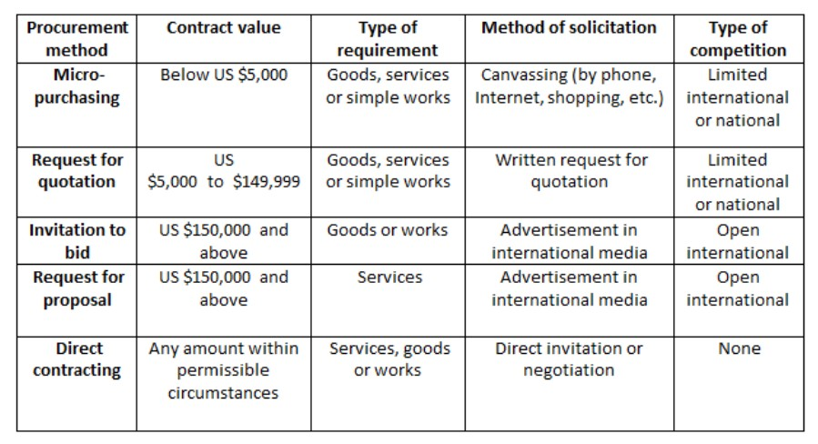

2. Prior or Post Review
The following UNDP prior or post review requirements apply to the various procurement and consultant recruitment methods used for the project.
 |  | Level 1 (Country Level): Contracts, Assets and Procurement Committee | Level 2 (Regional):  Regional Advisory Committee on Procurement  (country offices only) | Level 3 (HQ):  Advisory Committee on Procurement
Competitive procurement process
Any contract or series of contracts including amendments to be awarded to a vendor in a calendar year that in aggregate has a cumulative value: |  | Above US $50,000 (above US  $100,000 for Individual Contracts) and up to the standard delegated procurement authority – Direct Review by CAP Chairperson Above the standard delegated procurement authority and up to any increased delegated procurement authority – by CAP Committee | Above the delegated procurement authority and up to US $2 million (applies per year for Long-Term Agreements) | Country offices: above US  $2 million (applies per year for Long-Term Agreements)
Direct contracting
Any contract or series of contracts, including amendments to be awarded to a vendor in a calendar year that in aggregate has a cumulative value: |  | Above US $50,000 and up to 50 percent of the standard delegated procurement authority – Direct Review by CAP Chairperson  Above 50 percent of the standard delegated procurement authority and up to 50 percent of any increased delegated procurement authority – by CAP Committee | Above 50 percent of the delegated procurement authority and up to US $2 million (applies per year for long-term agreements) | Headquarters units: above 50 percent of the delegated procurement authority Country offices: above US  $2 million (applies per year for long-term agreements)
Amendment of all contracts
Any amendment or series of amendments to a contract which, in aggregate, increases the contract value by 20 percent or the delegated procurement authority, whichever is less: |  | Above US $50,000 and up to the standard delegated procurement authority – Direct Review by CAP Chairperson. Above the standard delegated procurement authority and up to the increased delegated procurement authority - by CAP Committee | Above the delegated procurement authority and up to US $2 million (applies per year for long-term agreements) | Country offices: above US  $2 million (applies per year for long-term agreements)
Ex ante review
Ex ante review refers to the review of the procurement strategy roadmap prior to commencement of the procurement process for complex procurement actions with a value: |  | N/A | Above US $1 million and up to US $2 million (applies per year for long-term agreements) | Above US $2 million (applies per year for long- term agreements)
Notes: | - The procurement support unit shall participate when requested in the committee review of ex ante submissions.  - An ex-ante review is not required if:  - The business unit has had a previous successful experience in the procurement of similar goods/services/works that was already subject to an ex-ante review; or  - There is sufficient specific corporate guidance and templates on the procurement of the said goods/services.  - Irrespective of the above, the procurement authority may submit the cases for ex ante review if significant risks are perceived.

Table 1: Expected Goods and Non-Consulting Services under the GEF project “National child project under the GEF Africa Mini-grids Program”, Sudan
No | General Description | Contract Value USD (cumulative) | Procurement Method | Procured by | No of Contracts | Advertisement Date (quarter/year) | Implementation Start date | Comments | Prior or Post review
 |  |  |  |  |  |  | (quarter/year) | Comments | Prior or Post review
1 | Contractual Services-Companies Light-handed regulations and full regulatory framework | 76,936 | Request for Quotation | UNDP | 1 | Q3 / 2021 | Q4 2021 or Q1 2022 | International | Post
2 | IT Equipment | 10,991 | Request for Quotation | UNDP | 1 | Q3 / 2021 | Q4 / 2021 | National | Post
3 | Travel and per diems for officials to MoEP and ERA travelling Regional workshops | 4,000 | Request for Quotation | UNDP | 1 | Q3 / 2021 | Q4 / 2021 | National | Post
4 | Travel and per diems of ERA official secondment programme | 6,000 | Request for Quotation | UNDP | 1 | Q3 / 2021 | Q4 2021 or Q1 2022 | National | Post
5 | Travel and per diems for International consultants travel for DREI analysis | 6,000 | Request for Quotation | UNDP | 1 | Q3 / 2021 | Q4 / 2021 | International | Post
6 | Catered venues for a series of local workshops (40 participants/ approx. 16 days) | 18,982 | Request for Quotation | UNDP | 1 | Q3 / 2021 | Q4 / 2021 | National | Post
7 | Multimedia for Events | 3,000 | Request for Quotation | UNDP | 1 | Q3 / 2021 | Q4 / 2021 | National | Post
8 | Travel and per-diem for preparatory work at pilot project sites | 5,000 | Request for Quotation | UNDP | 1 | Q3 / 2021 | Q4 / 2021 | National | Post
9 | Catering and venues for Workshops with selected bidders during CfP and after, workshop to present results on phase 1 of the pilots. | 5,000 | Request for Quotation | UNDP | 1 | Q3 / 2021 | Q4 / 2021 | National | Post
10 | Contractual Services-Companies market assessment on existing financing mechanisms and capacity assessment of local financing institutions. | 51,219 | Request for Quotation | UNDP | 1 | Q3 / 2021 | Q1 2022 | International | Post
11 | Professional services for audit of PMU | 2,000 | Request for Quotation | UNDP | 1 | Q2 / 2022 | Q3 / 2022 | National | Post
Table 2: Expected Consulting Services under the GEF project “National child project under the GEF Africa Mini-grids Program”, Sudan
No | General Description | Contract Value USD (cumulative) | Procurement Method | Procured by | No of Contracts | Advertisement Date (quarter/year) | Implementation Start date | Comments | Prior or Post review
 |  |  |  |  |  |  | (quarter/year) | Comments | Prior or Post review
1 | International consultant working on DREI analysis | 40,000 | Advertisement | UNDP | 1 | Q3 / 2021 | Q4 2021 or Q1 2022 | International | Post
2 | Local consultant working on DREI analysis | 3,500 | Advertisement | UNDP | 1 | Q3 / 2021 | Q4 2021 or Q1 2022 | National | Post
3 | Local consultants full time working with MoEP and ERA | 12,500 | Advertisement | UNDP | 1 | Q3 / 2021 | Q4 / 2021 | National | Post
4 | International consultant (ESMF) | 8,400 | Advertisement | UNDP | 1 | Q3 / 2021 | Q4 / 2021 | International | Post
5 | ESIA Consultant | 30,000 | Advertisement | UNDP | 1 | Q3 / 2021 | Q4 / 2021 | International | Post
6 | Senior Energy Mini-grid Expert embedded at MoEP | 98,000 | Advertisement | UNDP | 1 | Q3 / 2021 | Q4 2021 or Q1 2022 | International | Post
7 | Local consultant (Electrical Engineer) | 15,875 | Advertisement | UNDP | 1 | Q3 / 2021 | Q4 2021 or Q1 2022 | National | Post
8 | Local consultant (Institutional Engagement) | 15,366 | Advertisement | UNDP | 1 | Q3 / 2021 | Q4 / 2021 | National | Post

Table 3: Expected Works Contracts under the GEF project “National child project under the GEF Africa Mini-grids Program”, Sudan

NA

Annex 12: GHG Emissions Reductions and Project’s target contributions to GEF-7 Core Indicators

Annex 14: Additional agreements: such as cost sharing agreements, project cooperation agreements signed with NGOs (where the NGO is designated as the “executing entity”), letters of financial commitments etc..

Annex 13: GEF Core indicators

Core Indicator 6 | Greenhouse gas emission mitigated |  |  |  |  |  |  | (Metric tons of CO₂e )
 |  |  | Expected metric tons of CO₂e (6.1+6.2)
 |  |  | PIF stage | Endorsement |  | MTR |  | TE
 | Expected CO2e (direct) |  | 27,500 | 61,932
 | Expected CO2e (indirect) |  | 1,895,694 | 1,944,000
Indicator 6.4 | Increase in installed renewable energy capacity per technology
 |  | Technology | Capacity (MW)
 |  | Technology | Expected |  |  |  | Achieved
 |  | Technology | PIF stage |  | Endorsement |  | MTR | TE
 |  |  | 540kW |  | 2.5 MW
 |  |  | NA |  | 6.93 MWh
Core Indicator 11 | Number of direct beneficiaries disaggregated by gender as co-benefit of GEF investment |  |  |  |  |  |  | (Number)
 |  |  | Number
 |  |  | Expected |  |  |  | Achieved
 |  |  | PIF stage |  | Endorsement |  | MTR | TE
 |  | Female | 55,420 |  | 72,001
 |  | Male | 55,420 |  | 72,001
 |  | Total | 110,840 |  | 144,002

Annex 14: GEF 7 Taxonomy

Level 1 | Level 2 | Level 3 | Level 4
Influencing models
 | Transform policy and regulatory environments
 | Strengthen institutional capacity and decision-making
 | Convene multi-stakeholder alliances
 | Demonstrate innovative approaches
 | Deploy innovative financial instruments
Stakeholders
 | Indigenous Peoples
 | Private Sector
 |  | Capital providers
 |  | Financial intermediaries and market facilitators
 |  | Large corporations
 |  | SMEs
 |  | Individuals/Entrepreneurs
 |  | Non-Grant Pilot
 |  | Project Reflow
 | Beneficiaries
 | Local Communities
 | Civil Society
 |  | Community Based Organization
 |  | Non-Governmental Organization
 |  | Academia
 |  | Trade Unions and Workers Unions
 | Type of Engagement
 |  | Information Dissemination
 |  | Partnership
 |  | Consultation
 |  | Participation
 | Communications
 |  | Awareness Raising
 |  | Education
 |  | Public Campaigns
 |  | Behavior Change
Capacity, Knowledge and Research
 | Enabling Activities
 | Capacity Development
 | Knowledge Generation and Exchange
 | Targeted Research
 | Learning
 |  | Theory of Change
 |  | Adaptive Management
 |  | Indicators to Measure Change
 | Innovation
 | Knowledge and Learning
 |  | Knowledge Management
 |  | Innovation
 |  | Capacity Development
 |  | Learning
 | Stakeholder Engagement Plan
Gender Equality
 | Gender Mainstreaming
 |  | Beneficiaries
 |  | Women groups
 |  | Sex-disaggregated indicators
 |  | Gender-sensitive indicators
 | Gender results areas
 |  | Access and control over natural resources
 |  | Participation and leadership
 |  | Access to benefits and services
 |  | Capacity development
 |  | Awareness raising
 |  | Knowledge generation
Focal Areas/Theme
 | Climate Change
 |  | Climate Change Mitigation
 |  |  | Agriculture, Forestry, and other Land Use
 |  |  | Energy Efficiency
 |  |  | Sustainable Urban Systems and Transport
 |  |  | Technology Transfer
 |  |  | Renewable Energy
 |  |  | Financing
 |  |  | Enabling Activities
 |  | United Nations Framework on Climate Change | Nationally Determined Contribution
 | Rio Markers
 |  | Paris Agreement
 |  | Sustainable Development Goals
 |  | Climate Change Mitigation 0
 |  | Climate Change Mitigation 1
 |  | Climate Change Mitigation 2
 |  | Climate Change Adaptation 0
 |  | Climate Change Adaptation 1
 |  | Climate Change Adaptation 2

Annex 15: Principle for allocation of GEF investment (INV) funding

The following principles set direction and provides guidance to the IP for implementation of the GEF investment (INV) funding into the designed pilot projects to hybridize existing diesel stations operated by SEDC and STGC. Beyond what is written, designed and recommended in the section IV. Results and Partnerships in this document, this annex aims at summarizing the main principles for allocation of the GEF investment into the pilot project funding. A departure from these principles during implementation will involve a decision of the project’s board.

- Clear categorization of pilot (greenfield, productive use overlay, hybrid); initial guidance on delivery model of pilot.

The AMP program as a whole has defined three generic categories of pilot:
Greenfield solar-battery minigrids (which often will include productive use
Productive use overlays (on an existing solar-battery minigrid)
Hybridization of an existing diesel minigrid (with new solar-battery equipment)

For AMP Sudan, the pilot is a hybridization of existing diesel minigrids with solar PV and battery equipment. As outlined in the PILOT PROJECT ZOOM IN this has been designed in a phased-approach.

- Private sector involvement in pilots.

Each pilot will have a de facto delivery model it is demonstrating. The delivery model does not need to be finalized at the design stage and can wait until implementation.
However, in selecting the delivery model during implementation, a key principle should be stated that the delivery model for pilots should seek to incorporate private sector involvement to the degree possible. This will be on a spectrum from private sector for Engineering, Procurement and Construction (EPC), to private sector for Operations and Maintenance (O&M), to private sector for a build own operate model (BOO). While recognizing the importance of national context, market maturity and other factors, the AMP program is taking a normative position that private sector engagement in the minigrid sector is conducive to scaling-up minigrids.

For AMP Sudan, the pilot delivery model and private sector involvement has the following features:
- Built Own Operate and Transfer (BOOT) delivery model through a concession with private sector co-investment in the generation infrastructure
- Private sector co-investment in the solar PV power plant, based on the market understanding it is anticipated that around 50% of the CAPEX could be requested by the private sector for the first phase of the project, the hybridization with solar PV power plants

- Use of digital platforms for tendering

The use of digital platforms for tendering the pilots is a central element of the AMP. By using digital platforms for pilots, capacity of key stakeholders will be developed, which can then set the foundation for later using digital platforms for sector-wide large scale tenders.

For AMP Sudan the digital platform will be implemented for tendering and managing the request for proposals and request for co-financing for the two solar PV hybridization project pilots.

- Productive use: third party ownership model; limited technical assistance

Productive use is key to the program’s theory of change, where the economics of mini-grids can improve in a virtuous cycle of higher loads resulting in lower LCOEs.
Third Party Ownership Models for GEF INV. Pilots that provide financial support for the purchase of productive use equipment (GEF INV) should note that the project will only provide its support via a third-party ownership model, as opposed to a self-ownership model. Third party ownership models involve the minigrid asset owner purchasing the productive use equipment, and then effectively leasing it back to the end-user, as part of an energy as a service offer. This third-party ownership model is necessary to justify the use of climate finance, as the funding can be presented holistically as part of the overall system design required for an economic minigrid.

Limited TA. Projects may also provide TA building capacity for productive uses associated with the pilot investment. While this is not a principle, please note that the amount of GEF budget to technical assistance programs for general productive use should be limited and moderated. This is due to the related issue that climate finance should be directed to activities that specifically reduce emission reductions.

For AMP Sudan the initial thinking (to be confirmed and developed by the IP during the start of the project) is to request the private sector participants during the call for proposals to go to the sites, survey them and propose productive uses of electricity that could be developed during the construction of the solar PV power plant (in parallel) to increase the existing usage of electricity by PuE.

- Clear methodological basis for additionality for calculating the level of GEF INV/financial support.

It is very important to put in place protections for the efficient and appropriate use of GEF donor funding to the pilots. As such, project documents should state a clear methodological basis - to be applied during implementation - for which the level of GEF INV/financial support for its selected pilots will be determined. Examples of the methodology on additionality can be: to ensure LCOE parity with a reference tariff (specify which); based on willingness/ability to pay (which may be determined by a study during implementation). Such methodological assessments will be part of an overall package of financial due diligence/assessments that will be performed during the tender process to select pilot sites/developers.

- Digital data: obligation to report; inclusion of digital equipment.

In return for benefiting from GEF INV support as a pilot, the asset owner of the minigrid pilot will be obliged to share digital data from the minigrid’s performance with the AMP national project (refer Box 5 in Section IV, Output 2.1)

Relatedly, the project should specify the necessary digital hardware and software for minigrid pilots in order to be able to honor this requirement. This can typically be included as part the evaluation criteria and/or required specifications in the digital platform tender for the pilots. Depending on the circumstances, it is possible the project may specifically subsidize this.

Annex 16: Co-financing letters

https://www.worldbank.org/en/country/sudan/overview - accessed 5 October 2019.
Demographics of Sudan 2019. Countrymeters.info Sudan
Ibid
Multiple Indicator Cluster Survey Sudan 2014
SUDAN MENA Gender Equality Profile Status of Girls and Women in the Middle East and North Africa. UNICEF
https://sdgs.un.org/sites/default/files/2021-01/Dr.%20Amin%20Yasin_%D8%A7%D8%AE%D9%8A%D8%B1%20%D8%AF.%20%D8%A7%D9%85%D9%8A%D9%86.pdf
World Bank data: https://data.worldbank.org/indicator/EG.ELC.ACCS.ZS?locations=SD
GIZ (2018) Sudan: The Water-Energy-Food Security Nexus Country Profile.
Dina Ghandour (2016) Struggles for electrical power supply in Sudan and South Sudan, International Journal of Business and Management Study 3(2), 28-34.
1.1 million households for 2035, data provided by Mr. Yasir Abdalla (Ministry of Energy and Petroleum)
Sudanese Electricity Distribution Company (n.d.), ‘The Rural Area Electrification by Solar Energy Project’, Available from: http://www.sedc.com.sd/en/-4 – accessed 10 March 2021.
Based on the interviews the PPG Team Leader has conducted with MoEP and other key stakeholders in Q3 and Q4 of 2020
During the validation workshop of this project, ERA stressed that as part of this project they require training and capacity building activities in electricity law and pricing models
375 SDG to 1 USD has been used for the currency conversion, however the Sudanese pound has experience large fluctuations
https://www.middleeastmonitor.com/20210107-sudans-electricity-tariffs-increase-aims-to-cover-deficit-says-minister/
Diagnostic review of Sudan’s Electricity Sector, World Bank https://openknowledge.worldbank.org/bitstream/handle/10986/33702/From-Subsidy-to-Sustainability-Diagnostic-Review-of-Sudan-Electricity-Sector.pdf?sequence=1&isAllowed=y
Information gathered through the stakeholder bilateral consultations, mainly from Ministry of Energy and Mining and Practical Action
RCREEE, 2016
This is greatly due to fossil fuels being heavily subsidized by governments too
Based on risks identified in consultation with numerous stakeholders in the Derisking of Renewable Energy Investment studies conducted for utility scale and off grid solutions in a range of markets.
https://www.gsma.com/mobilefordevelopment/wp-content/uploads/2019/07/GSMA-State-of-Mobile-Internet-Connectivity-Report-2019.pdf
Such as Kenya, Nigeria or Tanzania where there are regulatory framework for mini-grids and donor results based finance programmes specific for mini-grids
The PPG Team Leader through consultations with the national consultants is not aware that mini-grids are mentioned in the new electricity act
As a preliminary idea Nigeria is one of the most suitable countries for this activity
https://pubs.naruc.org/pub/E1A6363A-A51D-0046-C341-DADE9EBAA6E3
Alternatively for minigrids below a certain installed capacity threshold (for example 500kW)
Initial TORs for these consultants are annexed to the project document
As such there will be two components to the AMP DREI flagship report produced and funded by the regional project – a full report in year 2 and an update note in year 4.
https://projects.worldbank.org/en/projects-operations/project-detail/P175040
Assessment based on PPG Team Leader during the consultations and documentation reviewed while preparing the project document
Sudan is in the process of restructuring its administrative and political boundaries from States into regions. Information provided by UNDP CO of Sudan
During the feasibility study (2.1.1.1) some information should be collected that will inform on the decision of how many customers will have their meters modernized. Final decision will be made by MoEP with SEDC
http://www.cedro-undp.org/content/uploads/publication/171206114847727~PVPLANTJULY16.pdf
Initial indicative period for the concession, the IP will need to decide the final number
https://www.energypeacepartners.com/prec
https://mobile-reuters-com.cdn.ampproject.org/c/s/mobile.reuters.com/article/amp/idUKL5N2NI1R6
Impact based on 1-5 scale (1 = Negligible 5 = Extreme), Probability based on 1-5 scale (1 = Not likely; 5 = Expected)
See https://www.thegef.org/gef/policies_guidelines
See http://www.undp.org/content/undp/en/home/operations/transparency/information_disclosurepolicy/
See https://www.thegef.org/gef/policies_guidelines
See https://popp.undp.org/_layouts/15/WopiFrame.aspx?sourcedoc=/UNDP_POPP_DOCUMENT_LIBRARY/Public/PPM_Project%20Management_Closing.docx&action=default.
Data collection methods should outline specific tools used to collect data and additional information as necessary to support monitoring. The PIR cannot be used as a source of verification.
See “SESP Summary” for detailed breakdown by event, cause, impact.
https://projects.worldbank.org/en/projects-operations/project-detail/P175040
Guidance to Advance Gender Equality in GEF Projects and Program 2017
Geography of Sudan www.britanica.com
World Bank 2019 Pl include full source
Demographics of Sudan 2019. Countrymeters.info Sudan
Ibid
Multiple Indicator Cluster Survey Sudan 2014
SUDAN MENA Gender Equality Profile Status of Girls and Women in the Middle East and North Africa. UNICEF
https://data.worldbank.org/indicator/SP.DYN.TFRT.IN?locations=SD
https://culturalatlas.sbs.com.au/north-sudanese-culture/north-sudanese-culture-family accessed on
Ibid
https://knoema.com/atlas/Sudan/Maternal-mortality-ratio# accessed on Jan 2021
Bedri N. , Sherfi H , Rudwan G. , Elhadi S. , Kabiru C. and Amin W. Shifts in FGM practice in Sudan: Communities Perspectives and Drivers. BMC 2019
ibid
Poverty and Equity Brief Sub-Saharan Africa, Sudan. World Bank Group. April 2020
World Bank 2019
Special Report 2019 FAO Crop and Food Supply Assessment Mission (CFSAM) To The Sudan 2019
Ibid
Sandugs are small number of people coming together to form saving and lending groups they trust each other for credit worthiness.
Case study: Using a Rural Financing mechanism -Sandug- to scale-up climate adaptation in Sudan. UNDP 2017
Rachel G.,Mashair S. and Sara A. Women at the forefront of Sudan’s political transformation. Working Paper ODI 2019
ibid
UN Women 2016
Ibid
Factsheet Sudan Women in Agriculture and Rural Development FAO
Empowering Sudan’s Women and promoting peace through equitable use of natural resource UN Environment Program 2019
FAO 2016
UNICEF New Horizon for Education in Sudan 2018
ibid
The role of microfinance institutions in supporting women microenterprises
“Sandugs” means a box for holding money
Using Rural Financing Mechanism “Sandug” to scale-up climate change and adaptation in Sudan. Canada-UNDP 2018
UNICEF 2017
FAO 2015, AfDB 2014
International Telecommunication Union(ITU)World Telecommunication and ICT indicators
Afrobarometer Regular Internet Usage by Gender|34 countries|2016/18 regular use as measured by everyday use.
Empowering Sudan: Renewable Energy Addressing Poverty and Development. UNDP 2020
World Bank, 2019
Stephen B., Nigel G., Johnatan G. etal Respiratory risks from household air pollution in low- and middle-income countries. Lancet Respir Med. 2014 Oct; 2(10): 823–860.
Sudanese Electricity Distribution Company (n.d.), ‘The Rural Area Electrification by Solar Energy Project’, Available from: http://www.sedc.com.sd/en/-4 – accessed 6 October 2019.
Beyond the grid Solar Sisters Solar Sisters Power Africa. USAID 2016

